SensusAccess: Guidelines for use
Please note users must not submit personal and/or sensitive data regarding themselves or others to be converted.
To begin, click on the link for SensusAccess which will open up the application:
https://www.sensusaccess.com:347/web3/ed/
1. Browse to select your file and then click on upload.
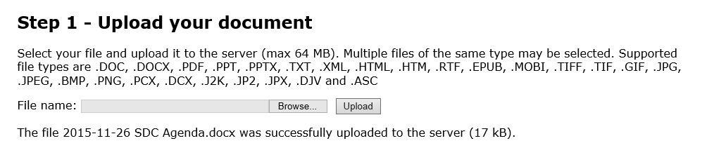
2. Select which format you wish the document to be converted to
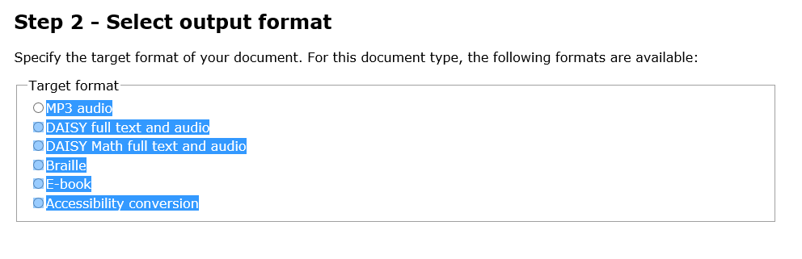
- Provide more details on the type of output you wish/specify options (note the options you see will depend on the type of document you selected above).
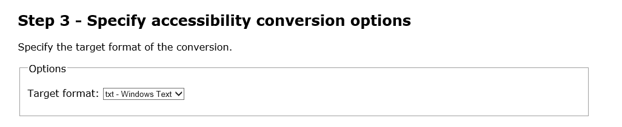

- Enter your email address for delivery of your converted document.
You should receive your converted document into your email inbox immediately.

