Student Disability Service
Annual Report 2013-2014
Challenging attitudes. Mainstreaming equality.

University of Edinburgh Student Disability Service

Our Vision: Challenging attitudes. Mainstreaming equality.

Our Mission: Supporting students with impairments to fulfil their academic potential. Working with academics and other University colleagues to support them to create an accessible learning and teaching environment.

Our Values: Contributing to an equal and positive learning experience. Communicating with staff, students and others. Professional and effective.

The Student Disability Service supports students by:

- Arranging pre-application visits
- Assessing students’ requirements – with each student
- Assessing assistive technology needs
- Liaising over building adaptations
- Producing individual Learning Profiles, detailing adjustments and support
- Matching students with student support assistants such as notetakers
- Screening for specific learning difficulties and referring on for assessment
- Negotiating exam arrangements
- Liaising with academics on student support and adjustment implementation
- Supporting students to apply for funding
- Supporting students with temporary impairments which impact on study
- Working strategically to mainstream accessible and inclusive learning
- Promoting disability issues via the Student Disability Committee.

The Annual Report

This annual report was produced in January 2015 and covers academic year 2013-14.
In order to give an up-to-date overview, key issues beyond July 2014 are also covered.

Contents
 | Contents |  |  |  | 1
1. | Quality of student support opportunities |  |  |  | 2
 |  | Table 1: |  | UCAS classification codes | 2
 | 1.1 | Key features of the service provision |  |  | 3
 | 1.2 | Users of the Student Disability Service (SDS) |  |  | 3
 |  | Table 2: |  | Numbers of disabled international students | 4
 |  | Table 3: |  | Number of students disclosing a disability (undergraduate and postgraduate) | 7
 |  | Table 4: |  | Disabled students – percentage of student population | 7
 |  | Table 5: |  | Breakdown of disabled students by College and School | 8
 | 1.3 | Effectiveness of partnerships |  |  | 9
 | 1.4 | Service Evaluation 2013-14 |  |  | 12
 |  | Table 6: |  | Evaluation Responses | 12
 | 1.5 | How the Student Disability Service supports our staff to enhance effectiveness in supporting students |  |  | 13
2. | Quality and standards |  |  |  | 15
3. | Enhancement and sharing of good practice |  |  |  | 16
 | 3.1 | Overview of promising/transferable practice for dissemination |  |  | 16
4. | Use of Technology |  |  |  | 18
5. | Forward look |  |  |  | 19
Appendix A |  |  | Student Disability Service Key Performance Indicators (KPIs) |  | 21
Appendix B |  |  | Top 10 adjustments recommended for disabled students, Jan 2015 |  | 22
Appendix C |  |  | Internal relationships and key involvement |  | 23
Appendix D |  |  | Internal and external relationships and key involvement |  | 24
Appendix E |  |  | SDS validation submission document |  | 25
Appendix F |  |  | Case Study 1: physical impairment |  | 34
Appendix G |  |  | Case Study 2: mental health |  | 35
Appendix H |  |  | Case Study 3: dyslexia |  | 36
Appendix I |  |  | Student Disability Service organisational chart |  | 37

What students said in 2013-14:
"Fantastic service. Wouldn't have managed to reach it this far without the support! Thank you"

If you require this report in an alternative format please contact the Student Disability Service on 0131 650 6828 or at disability.service@ed.ac.uk

- Quality of student support opportunities

Key strategic Student Disability Service goals, enablers and themes:
- Excellence in education
- People, infrastructure and finance
- Outstanding student experience
- Global impact
- Partnerships
- Widening equality and participation.

The Student Disability Service contributes to the University of Edinburgh’s vision and strategic goal of “excellence in education” and works towards an outstanding student experience supported by our vision, mission, values and service delivery. The Service takes a strategic approach to inclusion and equality and actively works towards the mainstreaming of individual recommended adjustments within the curriculum. The delivery of timely, effective support to disabled students, facilitated and provided by the Student Disability Service, is key to their fulfilling their potential and completing their studies.

Our vision reflects our aim to mainstream and embed equality for disabled students; we work in partnership with academic and other colleagues to challenge attitudes and practice to achieve this. The University implemented our Accessible and Inclusive Learning Policy in 2013, which mainstreams 7 areas of support previously recommended for disabled students: http://www.docs.sasg.ed.ac.uk/AcademicServices/Policies/Accessible_and_Inclusive_Learning_Policy.pdf

The Equality Act (2010) gives the work of the Student Disability Service (SDS) a legislative context which underpins the ethos and operational delivery of the service. Under the Equality Act, someone is considered to be disabled if they have a physical or mental impairment which has a long term and substantial adverse effect on their ability to carry out normal day to day activities.

The service is validated by the Scottish Government to carry out needs assessments for students applying for Disabled Students Allowance (DSA). Please see appendix E for relevant documentation.

The classification of disability type in higher education is covered by the Universities and Colleges Admissions Service (UCAS) codes:

Table 1: UCAS classification codes
Code | Description
A | No disability
B | Social communication impairment e.g. Asperger’s syndrome/autistic spectrum
C | Blind/serious visual impairment uncorrected by glasses
D | Deaf/serious hearing impairment
E | Long standing illness or health condition e.g. cancer, HIV, epilepsy
F | Mental health condition e.g. depression, schizophrenia or anxiety disorder
G | Specific learning difficulty e.g. dyslexia, dyspraxia or ADHD
H | Physical impairment or mobility issues
I | Disability or medical condition not listed above
J | Two or more impairments or disabling conditions

1.1 Key features of the service provision

The role of the Student Disability Service
The Student Disability Service (SDS) exists to support all disabled students (this now includes Office of Lifelong Learning (OLL) students), to fully access their chosen course of study. The service works across the University to embed an inclusive approach to supporting our disabled students.

Strategic development work continues to embed the University’s Accessible and Inclusive Learning Policy as a means of ensuring that disabled students can access support as a matter of course. This has become even more essential as the UK government’s proposals to reduce Disabled Students’ Allowance (DSA) funding support for English disabled students focusses on the role of the University to make accessible and inclusive provision for its own students.

Student numbers and trends
Disabled student numbers have increased year on year, since records began in 1993-94. Numbers are now almost fourteen times greater. This is reflected in the proportion of the student cohort which has disclosed a disability: 1.44% in 1993-94 increasing to 9.3% in 2013-14.

The trend continues upwards. Numbers of students accessing all aspects of the service continue to increase, particularly since the service moved into the Main Library Building in 2011.

1.2 Users of the Student Disability Service (SDS)

In academic year 2013-14, a total of 3,079 students disclosed a disability, 9.3% of the total student population at the University of Edinburgh. Although a snapshot in January 2015 shows a slight decrease in numbers disclosing, this is reversed when final statistics become available each July.

The most recent “Equality in higher education – statistical report, 2014” (Equality Challenge Unit) states that 9.5% of students in the UK and 8.5% in Scotland are known to have a disability. University of Edinburgh numbers exceed the Scottish average and are slightly under the UK average.

Key statistics at a glance…
- 3.9% additional disabled students in 2013-14
- 50.8% have specific learning difficulties (mainly dyslexia)
- 18.5% increase in students disclosing mental health problems
- 10% increase: international disabled students (UG)
- 42 % increase: student contact with SDS in 2013-14
- Disabled students submitted 19.5% of academic appeals, but 11% (11 appeals of 97) were directly related to the student’s impairment
- 20% (365) of students seen by the Student Counselling Service disclosed a disability
- SDS is currently supports 4% (78) of online distance learners.

The number of students disclosing disabilities continues on an upward trend, with an overall increase of 42% (based on Disabled Students Allowance needs assessment statistics) in students accessing the Student Disability Service in 2013-14. This compares to previous years:
- 2013-14 figures increased 42% from 2012-13
- 2012-13 figures increased 31% from 2011-12
- 2011-12 figures increased 15% from 2010-11
- 2010 -11 statistics showed a 10.7%
- 2009 -10 figures showed an increase of 14.7%

International Students
The number of disabled international undergraduates increased by 10% in 2013-14. Whilst this is a positive development, the increased numbers have a significant financial impact and present a challenge for the service, as European Union (EU) and international students are not entitled to claim Disabled Students Allowance (DSA), funding provided by the UK government. The Student Disability Service receives a fee per student assessment, from Scottish and UK governments for carrying out needs assessments for disabled students. We are not able to generate a similar income for international students. Income generated from needs assessments finances the department’s non-salary operational budget and our Disabled Student Support Fund (DSSF) which provides funding support for the students who are not entitled to DSA.

In 2013-14, 68% (increase from 63%) of students supported by our DSSF were international and EU students. The interim snapshot in January 2015, shows that 79% of the students supported by this fund are EU/International students (129 students).

Reflecting the general trend highlighted earlier on this report, the SDS supports a growing number of international students with significant mental health problems, mirroring the increase in the overall student population.

The International Student Barometer (ISB) SDS rankings are reported on page 15.

Table 2: Numbers of disabled international students
Undergraduate
 | 2008-09 | 2009-10 | 2010-11 | 2011-12 | 2012-13 | 2014-15
EU (non-UK) | 48 | 81 | 67 | 96 | 98 | 108
Outwith EU | 104 | 149 | 154 | 208 | 266 | 293
Taught Postgraduate
 | 2008-09 | 2009-10 | 2010-11 | 2011-12 | 2012-13 | 2014-15
EU (non-UK) | 17 | 23 | 18 | 45 | 68 | 34
Outwith EU | 30 | 31 | 42 | 86 | 96 | 67
Research Postgraduate
 | 2008-09 | 2009-10 | 2010-11 | 2011-12 | 2012-13 | 2014-15
EU (non-UK) | 19 | 21 | 16 | 25 | 30 | 30
Outwith EU | 23 | 36 | 31 | 54 | 52 | 53

The Student Disability Service regularly participates in a number of events aimed specifically at international students. These include:
- Induction for graduate students in the School of Education
- Presentations to the Butler Institute for Study Abroad, Pomona students, for visiting undergraduate students from the USA
- International Days, held in Induction Week.

Due to cultural differences in perception of disability we liaise regularly with the International Office on issues of mutual concern. A Depute Director from the International Office sits on the Student Disability Committee.

University of Delhi visit – the Student Disability Service worked closely with the International Office to recruit and support ten disabled students and two SDS Student Support Assistants to visit the University of Delhi in September 2014 as part of the International Education Excellence Programme for Disabled Students - 2014.

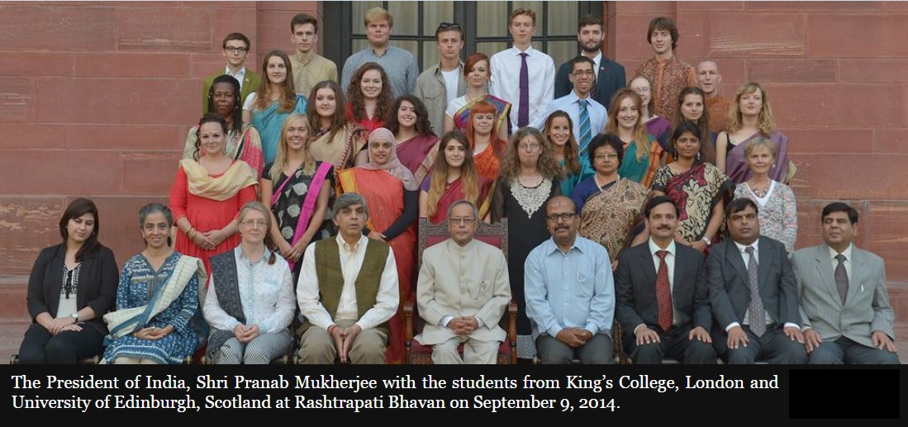

Online Distance Learners (ODL)
The Student Disability Service currently (in January 2015) supports 78 (3.4%) ODL students. The number fluctuates throughout the year and has increased by 32% since the same period last year.

In addition to supporting distance learners via Skype and/or email, work is ongoing to ensure that levels of support are equitable. Discussions have taken place with the Open University regarding their practice, particularly in supporting dyslexic students and the challenges of providing robust evidence of dyslexia, usually done by referral for an Educational Psychology assessment, which can’t currently be carried out remotely. We continue to explore the possibility of reciprocal arrangements and provision of alternative in-house procedures.

Current trends, demands and developments: mental health and Asperger Syndrome
There is a significant impact on the service of the increasing number of students we support who have mental health problems and those with Asperger Syndrome.

The number of students disclosing mental health problems on entry, year on year, shows:
- an increase of 18.5% in 2013-14 (358 students)
- an increase of 27.4% in 2012-13
- an increase of 44.37% in 2010-11
- an increase of 8% in 2011-12.

In academic year 2013-14, our five Mental Health Mentors (one permanent and four on a guaranteed hours contract) supported 117 students, an increase of 23% on the previous year. The gender split is marked, with 27% males and 73% female students.

There are 45 students – 22 of these new in academic year 2014-15 - with Asperger Syndrome being supported by the SDS. Twelve of these students are receiving additional support from a mentor (provided by Scottish Autism) and a “named contact person” in their School.

In summer 2014, we piloted a two-day transition event for prospective students with Asperger Syndrome, funded by the Student Experience Project and facilitated by two SDS Advisors.

This event was rated by all but one of the students as excellent/very good and these students stated that they now felt more confident about coming to university. It is intended to run this event on an annual basis.

What students said about the Transition Event for students with Asperger Syndrome:
“The whole experience has been excellent!”
“I think so many important aspects have been included, I’m happy with everything that was spoken about and thankful for the invite.”

We are aware that a significant number of students with mental health issues and who are on the autistic spectrum, do not disclose this initially (if at all) on their application forms, but may define themselves in the categories of Multiple Disabilities (two or more disabling conditions), Unseen or Other.

Appeals from disabled students
In 2013-14 students disclosing a disability comprised 9.3% of the total student population of the University of Edinburgh. Disabled students comprised 19.5% of academic appellants (19 from a total of 97 appeals), a decrease from the previous year.

Appeals from disabled students in last 3 years:

The number of appeals from disabled students is disproportionately higher – 19.5% of all appeals - than those from non-disabled students:
- in 2013-14, disabled students made 9.3% of the student population and 19.5% of academic appellants, although 8% of these appeals were on disability–related grounds (the latter data was not previously available)
- in 2012-13, disabled students made up over 9% of the student population and 20% of academic appellants
- in 2011-12 disabled students made up almost 9% of the student population and 11% of academic appeals

It is a positive development that appeal numbers have decreased in 2013-14. Whilst we could speculate on the reasons, the trend will be monitored going forward.

What students said:
“I was very pleased with how helpful everyone was, the reception and the person who gave me the dyslexia test, everything was great.”

Table 3: Number of students disclosing a disability (undergraduate and postgraduate)
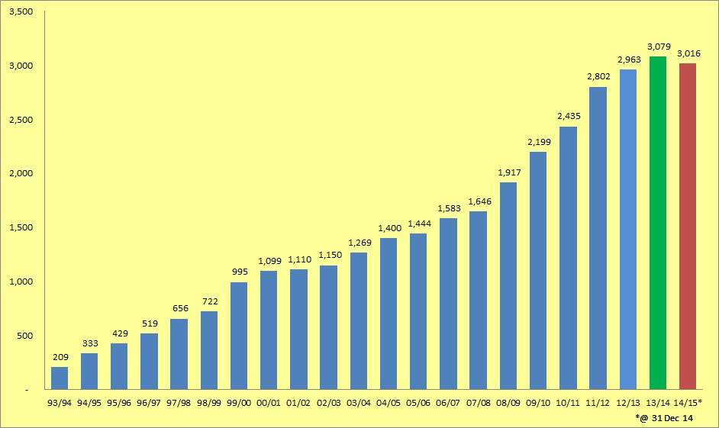
2014-15 figures are an interim snapshot from 31 December 2014. Final statistics are available in July each year – and always increase.

Table 4: Disabled students - percentage of student population
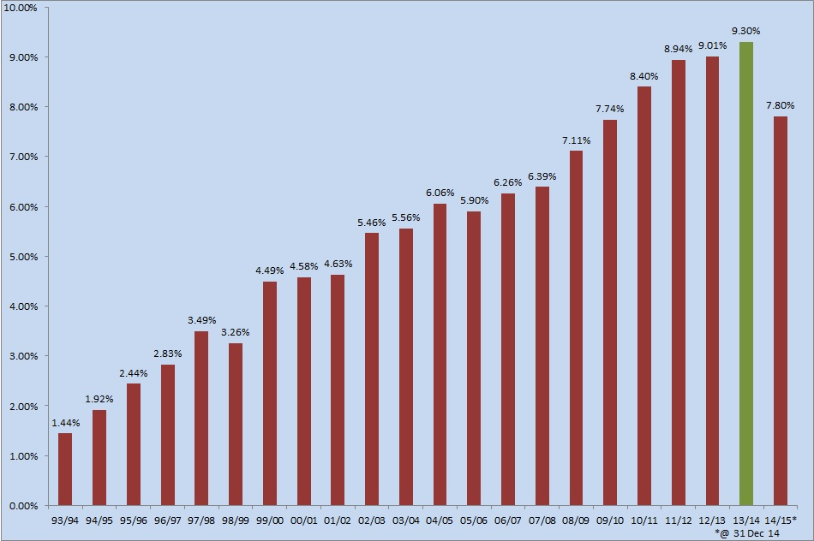

Table 5: Breakdown of disabled students by College and School
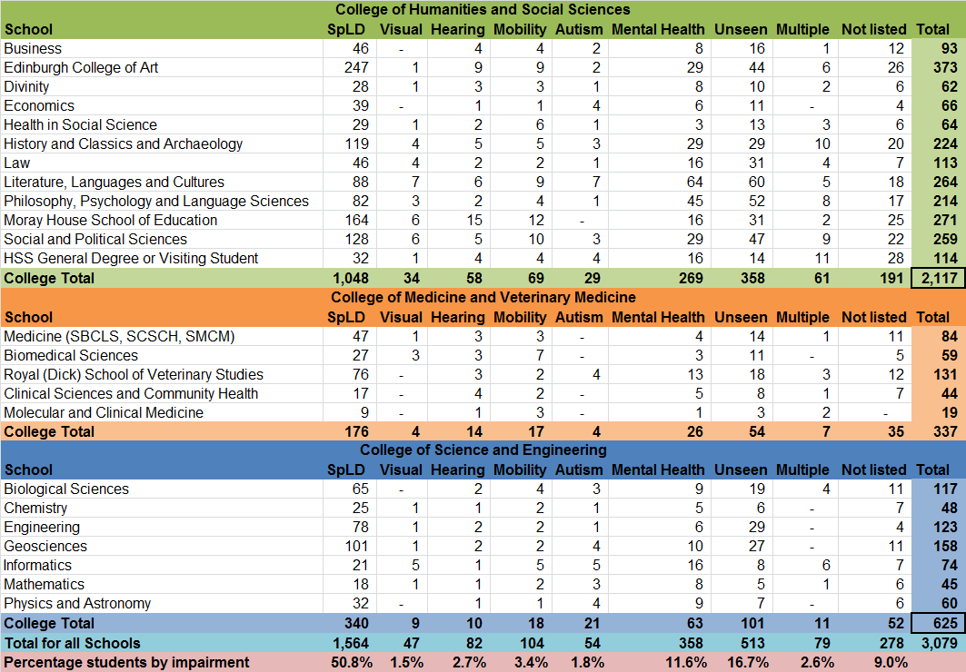

1.3 Effectiveness of partnerships
The Student Disability Service values partnership working as a key element of enhancing student support. Please see appendices C and D for an overview of our main internal and external areas of involvement.

Internal partnership working
As well as working in partnership with students and with the Edinburgh University Students Association (EUSA), we have developed effective relationships with academic colleagues over the years, both formally and informally. Key areas include regular meetings with colleagues in Medicine and Veterinary Medicine to clarify and move forward areas of mutual concern regarding specific recommended adjustments. Recent liaison has involved ECA and the School of Social and Political Science.

The Director works closely with academic colleagues, the Institute for Academic Development (IAD) and EUSA on the implementation of the University’s Accessible and Inclusive Learning Policy and has delivered presentations at several workshops on the mainstreaming of support/adjustments.

The service is represented on several internal University of Edinburgh working groups and committees, including the Equality and Diversity Committee, the Welfare Consultancy Group, Information Services Disability Advisory Group (ISDAG), the Disability Computing Support Group and Student Experience Services short life working groups on induction and communications.

We continue to meet twice a year with the Coordinators of Adjustments (key academic and support staff responsible for implementing support recommended by the SDS) in all Schools. We also meet regularly with Student Administration colleagues to discuss exams support. The primary focus of these meetings is to streamline systems for implementing student support and to ensure that support recommended by the SDS is put in place.

Accessible and Inclusive Learning/mainstreaming support
The University adopted the Accessible and Inclusive Learning Policy in June 2013, with additional guidance available on the Institute for Academic Development (IAD) website.

The policy has been equality impact assessed and is being reviewed to assess progress towards embedding change. Ongoing issues include:
- The refusal of some lecturers to use microphones
- The fact that microphones are not working
- Inconsistent approaches to putting lecture outlines on the virtual learning environment (VLE) at least 24 hours in advance
- Issues and misinterpretations around copyright.

Discussions are ongoing with EUSA, whose class reps are advised to report any microphone/technical issues direct to LTSTS (Learning and Teaching Spaces Technology Section).

What students said about the Accessible and Inclusive Learning Policy: “Having the lectures on powerpoint and then posted on Learn rather than having to try to copy everything allowed me to focus on the lectures themselves and take key notes. Having readings placed in order of importance helped me to ensure I read what was needed to be able to participate in discussions rather than trying to read everything all at once which would have been overwhelming.
Enhancing provision for students with specific learning difficulties (SpLD): removal of coursework stickers for dyslexic students
The Student Disability Service no longer recommends or provides stickers for dyslexic students to attach to their coursework (Exam stickers remain). This change in procedure was also equality impact assessed and a recent review has not thrown up any major issues. Guidance for academic staff was also produced at the time of the change: http://www.ed.ac.uk/polopoly_fs/1.120006!/fileManager/Marking%20Guidance%20July%202013.pdf

Enhancing assessment provision:

A: For students with Asperger Syndrome and A(D)HD
To enable the service to provide a quicker assessment of the above conditions – and thereby enabling us to put appropriate support in place more quickly for relevant students - we work in partnership with two clinical psychologists who are experts in their fields. They are also able to assist with the assessment of dyslexic students, which will enable us to support these students more quickly. This provision is under review after the first year of implementation.

B: For students whose first language is not English
After a trial period, we have introduced what we anticipate will be a more effective means of establishing whether some international students, whose first language is not English, can be assessed for indicators of dyslexia. The system will be reviewed after a year and has also been equality impact assessed.

The work of the Student Disability Committee
The SDS continues to support and service the University’s Disability Committee and its sub-groups, which cover:
- Access and Facilities
- Mental Health
- Technology, Information and Communication (a merger of the Accessible Information and Technology groups).

Some of the key issues under discussion in the last year include:
- Accessible and Inclusive Learning, the policy, guidance and embedding change
- Revised mental health guidelines for the University (replacing the Code of Practice), leading to the Mental health Strategy Group
- Proposed changes to Disabled Students Allowance (DSA) being introduced by the UK government for English students.

Dr Tina Harrison, Assistant Vice Principal for Academic Standards and Quality Assurance, who has been an academic champion of Accessible and Inclusive Learning is the convenor of the Student Disability Committee.

In addition to representatives from all three Colleges, Edinburgh University Students Association (EUSA) is represented on all disability-related working groups. The Director of the Student Disability Service meets regularly with EUSA staff, sabbaticals and representatives of Disability and Mental Wellbeing Liberation Group.

Disabled staff support
The SDS Director, along with colleagues from Careers, HR and Occupational Health and, recently the new Vice Principal for Equality and Diversity, have been actively working towards the establishment of more effective support for disabled staff. Positively, at the time of writing, HR are including a budget proposal for a staff member to support disabled staff.

External partnerships
In addition to internal partnership working, the Director continues to be active in working with colleagues in Scotland and throughout the UK on key issues for Disability Services and on equality issues. Disability Heads of Service in Scotland meet regularly and are represented by the SDS Director on the Scottish Government’s Disabled Student Advisory Group. The Director also represents the University of Edinburgh on the Russell Group Heads of Disability Services and on the Scottish Liaison Group of the Equality Challenge Unit (ECU).

The SDS Director was a member of the external panel reviewing the Trinity College Dublin Disability Service with colleagues from Student Services at the University of Cork and the Head of the University of Manchester’s Student Disability Service. The review took place over three days in November 2014 and recommendations were submitted in January 2015.

Reflection of effectiveness of the Student Disability Service where dependent on Schools

Implementation of recommended support (adjustments)
Much of the students’ support is provided via the implementation of adjustments (e.g. extra time in an exam) recommended by SDS Advisors for individual students in the context of their learning. The Learning Profile is a list of supports recommended by the Student Disability Service for implementation by Schools, Academic Registry and/or the Library, depending on the student’s course of study and disability-related needs. This information is distributed electronically to the student, key academic staff, the Personal Tutor/ Supervisor, Coordinator of Adjustments in the School and others.

A snapshot of the number of recommended adjustments in January 2015 reveals that the Student Disability Service has recommended 14,627 adjustments for current students. This includes mainstreamed adjustments (listed in the University’s Accessible and Inclusive Learning Policy), the number of which has remained constant, with a slight decrease of 0.5%. The total represents an overall increase of 10.8% in the number of recommended adjustments from the previous year.

Student feedback in the SDS 2013-14 student evaluation shows an increased response rate to 50% (from 42%) of respondents reporting that “I received all adjustments in all courses”. However, all other levels of support implementation showed a decrease.

It is a legal risk to the University that some students are not receiving the support to which they are entitled and which has been recommended by the Student Disability Service. It should also be noted that there are many examples of excellent practice and staff committed to supporting disabled students in Schools. However, provision is inconsistent across the University. See appendix B for top ten recommended adjustments as of January 2015.

The service also provides additional support if a student is assessed as requiring this to facilitate equal access to a course of study. This may be referral to a Mental Health Mentor, study skills tuition, specialist technology tuition, notetaking, proofreading or access to an Asperger Syndrome Mentor.

1.4 Service Evaluation 2013-14, key themes and issues arising
Accreditation:
The Student Disability Service is an accredited centre for the assessment of UK students claiming Disabled Students Allowance (DSA), the financial support provided by government to disabled students. The service is validated annually by the Scottish Government’s Lifelong Learning Directorate and is guided by the “Toolkit of Quality Indicators for Needs Assessment”. The Student Disability Service was re-validated by the Scottish Government to carry out DSA Needs Assessments, in January 2015.

SDS annual student evaluation
The Student Disability Service (SDS) evaluation survey is carried out by the University’s Communications and Marketing (CAM) team. The 2013-14 survey was sent to 2,737 students (208 people more than the previous year). We received 593 responses i.e. a 22% response rate, an increase in the numbers of respondents in 2012-13, when we had a 17% response rate. 36% of respondents were male and 64% female.

Key points:
- 82% of respondents were very satisfied or satisfied with the service (same as 2012-13)
- reported implementation of all course adjustments increased by 8% to 50% of respondents this year, although other implementation variations decreased
- 54% of respondents stated that they had heard of the Accessible and Inclusive Learning Policy
- 59% of those who had heard of the policy, thought that it had a positive impact on their learning experience
- the staff continue to be rated as the best element of the service.

Recommendations for future action include:
- introduction of more meaningful and relevant KPIs in relation to implementation of adjustments
- develop provision for online distance learners
- proactively develop relationships with Schools.

These areas are currently being addressed by the SDS management team and our recently appointed Assistant Director (Development).

Table 6: Evaluation responses

2013-14
Three services with most satisfaction |  | Three services with least satisfaction
Exam Arrangements |  | Asperger Syndrome Student Mentor Service
Assessment of Specific Learning Difficulties |  | Fire Evacuation Procedures
Support to apply for DSA |  | Physical Access Information

2012-13
Three services with most satisfaction |  | Three services with least satisfaction
Assessment of Specific Learning Difficulties |  | Asperger Syndrome student mentor service
Exam Arrangements |  | Fire evacuation procedures
Support to apply for DSA |  | Specific Learning Difficulties tutoring

2011-2012
Three services with most satisfaction |  | Three services with least satisfaction
Examination arrangements |  | Asperger Syndrome student mentor service
Assessment of Specific Learning Difficulties |  | Specific Learning Difficulties tutoring
Support to apply for DSA |  | Fire evacuation procedures

2010-2011
Three most important services |  | Three services with least satisfaction
Mental Health Mentor |  | Physical access
Examination arrangements |  | Liaison with other staff
Finding student support assistants |  | Fire evacuation procedures

2009-2010
Three most important services |  | Three services with least satisfaction
Exam arrangements |  | Links with Accommodation Services
Assessment of Specific Learning Difficulties |  | Fire evacuation procedures
Disabled Student Allowance Application |  | Study skills advice

The full evaluation report can be found on the Student Disability Service website at:
http://www.ed.ac.uk/schools-departments/student-disability-service/about/feedback-evaluation

Mechanism for gathering feedback
In addition to the annual service evaluation, the service gathers feedback in a range of formal and informal ways:
- International Student Barometer (ISB)
- Edinburgh Student Experience Survey (ESES): 69% satisfaction rate in 2013-14, increased from 55%
- Mid year contact with students to find out if their recommended support has been implemented
- Mental health mentor feedback forms
- Training evaluation feedback
- Using the student Information Points (SIPs) as a communication tool
- Feedback form on SDS website
- Feedback box in the SDS/SCS waiting area.

The Student Disability Service is about to undergo an internal periodic review (March 2015) which we hope will be a positive experience leading to further service enhancement.

1.5 How the Student Disability Service supports our staff to enhance effectiveness in supporting students

Staffing levels
The Student Disability Service currently (January 2015) employs 68 staff:
- 19 core staff = 16.8FTE (full time equivalent) – an increase of 1.9FTE from 2012-13
- 35 Student Support Assistants (specialist tutors, notetakers, mental health mentors etc) on guaranteed hours or self-employed contracts. Government funding is available to pay for this support for UK students.
- 8 educational and clinical psychologists to assess students for dyslexia, ADD and AD(H)D.

Please see the SDS organisational chart at Appendix I

Student Disability Service restructure project - Providing an Integrated and Effective Service (PIES)
The service is currently undergoing restructure, and is in the final implementation stage of a change project “Providing an Integrated and Effective Service” which aims to provide more effective support to disabled students by utilising and developing the skills of our Advisory staff. The overall aim is to future –proof the SDS and position the service more effectively to cope with the changing demographic of disabled students, funding constraints and the shifting higher education context.

This change to service delivery will enable Advisors to see all students, not only certain students with specific impairments. This will enable us to maximise resources and support students even more effectively. Specialisms will continue to be maintained and shared throughout the team.

The management team has been restructured to bring together all Advisors under one line manager (Assistant Director), which will facilitate consistency of approach to disabled student support. In addition all sessional student support staff or non-medical personal helpers (apart from sessional Mental Health Mentors) will be line managed by the same Assistant Director. We have appointed a new post of Assistant Director (Development) which will enable the SDS to maximise opportunities of working with key stakeholders throughout the University and to promote the service, via a structured training programme for staff and for disabled students.

A new post of trainee Advisor has been created and a detailed training and induction programme created and implemented for the postholder, including the support of an SDS “buddy” (an experienced Advisor). We are pleased to have made an internal appointment to this post and anticipate that this method of inducting new Advisory staff will be very successful. (The post attracted over 400 applications when advertised.)

A training programme for all Advisors to support the service restructure has been arranged which includes:
- Training in the recommendation of ergonomic furniture and equipment
- Training in supporting students with visual impairments (specifically focussing on specialist assistive technology)
- Training on supporting students with hearing impairments
- Training on the virtual learning environment at the University of Edinburgh
- Training on assessing students with Asperger syndrome and AD(H)D
- Mental health conditions
- Case study discussions.

Location and premises
The central location of the service and premises in the Main Library building continues to ensure that the service is highly visible.

Despite the major challenges around lack of space, SDS service delivery has now extended to four sites. In addition to the main location in the Library, sessional staff are now working from Moray House, eca and Kings Buildings.

However, problems with lack of space are limiting some aspects of service delivery. There are ongoing challenges around physical access, with some misuse of parking bays and toilets for disabled people. We continue to work with colleagues to address these issues.

Staff Training
The Student Disability Service continues to provide a range of training throughout the University, which can be tailored on request for any School or support service, including:
- training for Personal Tutors and Student Support Officers (various)
- Disability Equality Training for IS and Estates and Buildings staff
- training on mental health issues (with Student Counselling)
- Supporting students with Asperger Syndrome
- training on the Equality Act 2010
- “Living with Dyslexia” (delivered with Student Counselling)
- sessions on dyslexia and Asperger Syndrome
- Post Graduate Certificate in University Teaching (Diversity model)
- Presentations in support of international students.

Students are involved in delivering many of our training sessions.

The Director has presented on the issue of mainstreaming adjustments and the Equality Act at Accessible and Inclusive Learning implementation workshops.

The SDS also has regular input into:
- Open Days
- International Day
- New staff induction events.

- Quality and standards

Approach to setting and maintaining standards
The Student Disability Service is committed to providing a high quality service and works to continuously enhance provision in a range of ways, outlined in previous sections of this report. These include:
- the annual service evaluation survey
- The Edinburgh Student Experience Survey (ESES) where the service rating increased by 14% to 69% in 2014 from the previous year
- The International Student Barometer (ISB) provides an element of international benchmarking.

In the most recently available (autumn 2013) ISB the Student Disability Service achieved a satisfaction rating of 95.2%, the same as the previous year.

We are rated:
- 2nd in Scotland (up from 3rd in previous year)
- 3rd in the Russell Group (up from 4th)
- 6th in UK (previously 9th)
- 10th in the full ISB rankings (same ranking as previous year) of 178 universities in 13 countries.

In the context of performance management, the Student Disability Service achieves a 100% rate for annual appraisal of eligible staff. All staff have regular supervision meetings with their line managers and management and team meetings are held regularly, in addition to planning events and an annual full team Away Day.

The service works to Key Performance Indicators (KPIs), which are currently under revision. Please see appendix A for current and previous years’ KPIs and statistical data.

There are no formal benchmarking systems for the service, but we participate in regular informal benchmarking with colleagues in other Scottish institutions and the Russell Group. It can be a challenge to compare disability services as they are delivered in different ways, depending on size of institution, specialisms in advisory teams and IT focus.

As outlined previously the service is validated annually by the Scottish Government (most recently in January 2015) to carry out needs assessments for Disabled Students Allowance (DSA).

Please see appendix E for the SDS validation submission documentation.

- Enhancement and sharing of good practice

  - Overview of promising/transferable practice for dissemination
- Accessible and Inclusive Learning: working to embed the University’s policy. The introduction of the policy has attracted positive comment and attention from Heads of Disability Services in the Russell Group and amongst colleagues in Scottish institutions. Several institutions have requested to reference our documentation as a basis for in-house discussion.
- Removal of coursework stickers: for dyslexic students - a number of other universities have expressed interest in the guidance the SDS produced for academics and have requested that they use them as a basis for recommending change in their own institutions.
- Providing an integrated and effective service: the service restructure will maximise existing resources, reduce waiting times for students and develop the skills and expertise of SDS Advisory staff. In addition the merger of two Advisory teams and the appointment of an Assistant Director with specific development responsibilities enables the service to increase outreach work and raise our profile.
- Transition Event for students with Asperger Syndrome: this two-day pilot held in July 2014 was very well received by the students who attended. The event will now become a regular annual SDS event.
- Trainee Advisor post: has enabled us to provide an exciting opportunity for an existing staff member and develop this role in-house.
- SDS Advisor’s Guide: Advisory staff have produced a substantial in-house reference guide for their (complex) role, which serves as an essential induction and signposting tool for new colleagues
- Supporting disabled students in the University of Edinburgh’s partnership with the University of Delhi: following last year’s hosting of a visit from students from Delhi, SDS was pleased to work with the International Office to recruit and select ten disabled students and two Student Support Assistants to visit Delhi University
- Mental Health Strategy: SDS is involved in working with colleagues throughout the University to develop a new Mental Health Strategy and Fitness to Study Policy. In addition, SDS staff are working regularly with Student Counselling colleagues to deliver mental health training to academic colleagues.
- SDS videos: the SDS website currently hosts a series of videos of students (see below) talking about their mental health issues and the support they received: http://www.ed.ac.uk/schools-departments/student-disability-service/student-support/mental-health-experiences-videos
We are very grateful to the students for being open and honest about their issues.

At the time of writing, additional student videos are being produced to raise awareness of the range of supports which the SDS can provide or facilitate access to.
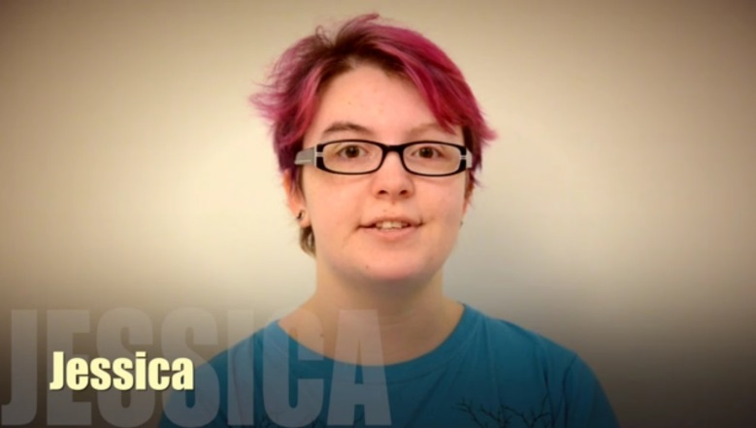 | 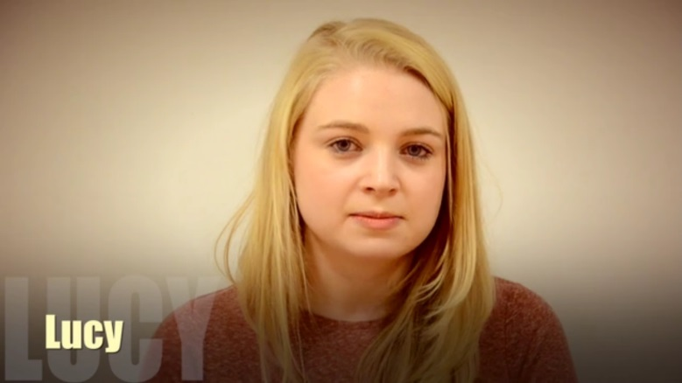
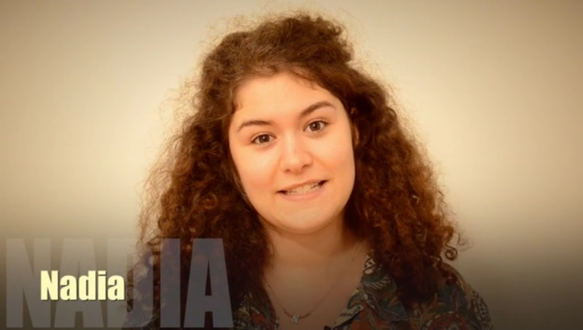

Steps taken to enhance the quality of the service:
- All staff work together to define service and personal objectives alongside carrying out operational planning
- Management team and core staff group team events are held annually.
- The SDS has a 100% annual appraisal rate of eligible staff, in addition to regular one to one meetings for staff and team meetings.
- Liaison with Schools: we are in contact with all 22 Schools and SDS continues to push forward on more effective liaison and joint working with the Student Disability Service. Each of our Advisors has a responsibility to liaise with and develop in-depth working knowledge of specific Schools, to enhance our scope for supporting students. Meetings are held with a range of School staff on a variety of issues e.g. adjustments, mental health, fitness to study.
- SDS Advisory staff are all members of professional organisations such as the National Association of Disability Practitioners (NADP), the Association of Dyslexia Specialists in Higher Education (ADSHE), the Assistive Technology Advisors network (ATANET) and the Association of Managers of Student Services in Higher Education (AMOSSHE).
- Staff development: all staff are encouraged to further their professional skills and are engaged in a range of continuing professional development, especially in relation to service restructure.

- Use of Technology

“Operations” Technology
The Student Disability Service employs technology for student support in a number of areas:
- Kelso and Radium are the main databases which are used to record and communicate student support in the form of Learning Profiles, which are electronically sent to the student, the student’s Personal Tutor, the Coordinator of Adjustments in the relevant School
- Three other systems for financial and timesheet recording are essential for SDS to be able to pay our guaranteed hours (sessional support) staff and to raise income from funding bodies.

These systems are out of date and no longer fit for purpose and, SDS has submitted a major project proposal to develop and enhance these systems, enabling future efficiencies and more effective and user-friendly access, possibly using EUCLID.

Skype
Skype is used to conduct some discussions and appointments and we aim to further develop use of Skype and to investigate alternative methods which may enhance support to distance learners, students on other campuses and conversations with colleagues overseas. Potential areas for further development may include online tutoring and mental health mentoring.

Paper-Light
The service is also working on a “paper light” project to have all essential information online, enabling further streamlining of process and enabling access to relevant scanned documentation by staff if working from a different campus.

Assistive Technology (AT) support for students
SDS provides training in assistive technology to enhance the learning skills of disabled students. Our Technology Advisor provides training to students on, specialist software such as Mindgenius and TextHelp (also available on University of Edinburgh computers) to equipment for students with visual, and other, impairments.

SDS operates a service level agreement with a technology equipment provider, currently iansyst, who provide a range of equipment (e.g. laptops) and software to students. The equipment is recommended for learning by SDS Advisors and funded by Disabled Students Allowance and the Disabled Students Support Fund (for students not entitled to DSA).

Technology Information and Committee (TIC) Group
TIC is a sub-group of the Student Disability Committee, which works to enhance and mainstream accessible technology support across the University and to monitor and research new software and support for disabled students. It is anticipated that the group, convened by Dr Jessie Paterson from the Vet School, will have a key role to play in moving forward the technology aspects of the inclusion agenda, especially in light of developments to remove (DSA) funded aspects of IT provision by the UK government for English students, with the intent of putting key responsibilities on to individual institutions.

Website
The SDS website is currently under review with the objective of enhancing content and useability. We will be adding more student videos (filming taking place in February 2015), streamlining content and developing the section aimed at staff supporting disabled students.

Technology to enhance mainstreaming (Accessible and Inclusive Learning)
Issues around non-use of technology e.g. use of microphones by lecturers, and equipment which isn’t working, continue to present a challenge to disabled students. The inconsistency of the approach to providing lecture outlines at least 24 hours in advance also continues to present problems.

The technology exists to ensure that teaching is more inclusive, but more work needs to be done to ensure that best practice is promoted. (See above re role of the TIC.)

- Forward look

Specific priorities identified in last year’s annual report have been achieved or are ongoing, as follows:
- Removal of coursework stickers for dyslexic students: equality impact assessed and further reviewed (no change proposed)
- SDS restructure: ongoing, with implementation date of September 2015. Management Team restructured with new Assistant Director (Development) post. Trainee (generic) Advisor in post and Advisory teams merged
- IT: some systems enhancements completed, but work ongoing to research options for more robust student support and finance systems. This will be a major project.
- SDS website review and enhancement, to include a series of student videos highlighting the support available from the service
- Review of acceptable dyslexia assessment reports carried out and processes amended to accept high quality reports from specialist teachers, as well as from educational psychologists: http://www.ed.ac.uk/schools-departments/student-disability-service/new-students/evidence-of-spld
- Successful pilot of the transition project for students with Asperger Syndrome in July 2014, now being built in to SDS annual programme
- Review and increase service locations: SDS is currently providing support from sessional staff from four locations (Main Library Building, eca, Kings Buildings and Moray House).

There remain a number of key challenges for the SDS going forward. The most significant are listed below:
- Service Restructure: moving into the final phase, to be fully implemented by September 2015. This has been challenging for some staff, but training and support is provided to enable staff to develop additional skills and knowledge.

- Disabled Students Allowance (DSA) changes: the Department for Business, Innovation and Skills (BIS) has drafted new guidance for the support of disabled English students, which removes funding for some technologies in 2015-16 and funding for non-medical personal helper (notetaker, proofreaders) support from 2016-17. (Proposals for how the University of Edinburgh should deal with these changes are being put to committee in March 2015). It will be essential to monitor the provisions for Scottish students as further amendments to support may have to be revised in the future. Impact is likely to be financial and operational.

- SDS student support systems: These need to be fit for purpose. Work is ongoing, in partnership with Student Systems and Information Services, to research and determine the most effective options for the SDS’s five IT systems which facilitate communication of student support needs (Learning Profiles), timesheet administration and waiting list management.

- Accessible and Inclusive Learning Policy: the policy needs to be further and fully embedded, with a view to extending the University’s mainstreamed and inclusive approach, especially in light of the forthcoming DSA changes and to ensure the optimum student experience for both disabled students and all students. Areas for future focus include audio-captioning/lecture capture, recording all lectures and clarification of copyright issues.

- Space: the ongoing challenge presented by lack of physical space should not be underestimated. Although using technology enabling student contact online or remotely is increasing, this is unlikely to make a major impact on the space issue. The problem is not experienced solely by the Student Disability Service – and not only by this University – but it remains real and constant.

- The impact of online distance learners is gradual, although current numbers of students (January 2015) being supported has increased by 32% in the past year to 78 online distance learners. Although the Distance Learning Initiative may attract a disproportionately high number of disabled students, it appears that they may have fewer support requirements if working online. We are continuing to explore the most effective means of supporting this students cohort e.g. provision of Educational Psychology assessments and acceptable evidence of impairment.

- SDS involvement in development of the University’s Mental Health Strategy is ongoing and will continue in the provision of services (Advisory and Mental health Mentoring), training delivery partnership with colleagues in the Student Counselling Service and via the auspices of the Student Disability Service.

- The physical accessibility of the University’s estate continues to present major challenges for some students, particularly those who use wheelchairs, as does the issue of ensuring that equipment such as lifts are maintained in working order.

A student quoted from the Edinburgh Student Experience Survey (ESES):
“The Student Disability Service have been brilliant. I have received so much support, help and advice from them. My advisor has been great, answering all my queries quickly and efficiently, and negotiating with academic staff for me when needed.

APPENDIX A: Student Disability Service Key Performance Indicators (KPIs)

Student Disability Service KPIs | 2007-08 | 2008-09 | 2009-10 | 2010-11 | 2011-12 | 2012-13 | 2013-14
Number of enquiries from students | 5,761 | 6,910 | 9,194 | 13,478 | 17,026 | 18,491 | 20,731  (+12%)
Number of enquiries from staff and others | 4,724 | 6,291 | 7,825 | 9,869 | 13,543 | 14,217 | 13,331
Unique visitors to SDS website | 73,745 | 59,682 | 66,811 | 34,150 | 22,508 | 24,349 | 27,730  (+14%)
Number of new needs assessments for Disabled Students Allowance (DSA) | 195 | 222 | 264 | 250 | 223 | 293 | 415  (+42%)
Number of students supported via DSA | 512 | 585 | 574 | 707 | 561 | 570 | 854  (+50%)
Number of students supported by the University’s Disabled Student Support Fund (mostly international students) | 131 | 193 | 212 | 220 | 279 | 259 | 339  (+31%)
Number of students using student support assistants (note takers, tutors etc) | 221 | 217 | 266 | 291 | 381 | 448 | 491  (+10%)
Number of Learning Profiles produced (new/total) – * 2011-12 totals reflect impact of eca merger | 366/681 | 469/855 | 615/870 | 459/915 | 814/1220* | 784/427 | 832/1314  (+6%)
Items of equipment loaned (digital recorders, laptops etc) | 138 | 129 | 124 | 127 | 186 | 163 | 154
Number of visitors to the Student Disability Service (reception area shared with the Student Counselling Service) | - | - | - | - | 12,252  Jan – Jul | 24,435 | 27,163  (+11%)

APPENDIX B: Top 10 adjustments recommended for disabled students, January 2015
Recommended adjustment | No of students with adjustment | % total adjustments (14,627)
Lecture outlines or PowerPoint presentation slides for lectures/seminars shall be made available to students at least 24 hours in advance of the class. Now mainstreamed. | 1,326 | 9.1%
25% additional time in examinations. Student may use this extra time for writing or to take rest breaks throughout the exam. | 1,262 | 8.6%
Students shall be permitted to audio record lectures, tutorials and supervision sessions using their own equipment for their own personal learning. Now mainstreamed. | 1,167 | 8%
This student has specific learning difficulties. He/she should incur no penalties for poor spelling, grammar, punctuation and structure in examination scripts, unless these are being directly assessed and are core to an understanding of the course. | 932 | 6.4%
Provide double loan time on reserve/short loan books. | 929 | 6.4%
Reading lists shall indicate priority and/or relevance. Now mainstreamed. | 730 | 5%
Student requires prior sight (15 minutes) of the paper for the purposes of reading and highlighting. | 697 | 4.8%
Student not to sit two three-hour exams in one day (where possible Registry will schedule examinations to avoid this; however where not possible additional adjustments may be required) | 562 | 3.8%
All students are expected to submit work to specified deadlines. However, on occasions some students may not be able to meet submission deadlines as a direct consequence of their disability or health condition. Requests for late submission should be made by the student following the School’s guidance procedures. It may not always be possible to accommodate extensions. The recommended extension time is 3-5 days however, any late submission approved by the School may vary depending on individual circumstances. This recommendation does not apply to weekly hand-ins for formative or summative continual assessment. | 425 | 2.9%
Provide student with a standard PC in exams and in-course assessment | 456 | 3.11%

APPENDIX C: Internal relationships and key involvement
Area | Relationship and Example Activities
Student Counselling Service | Jointly managing frontline services. Preparing and running several mental health awareness workshops for staff and contributing to the Student Disability Committee
Edinburgh University Students Association (EUSA) | Active contributor to the Student Disability Committee and its sub-groups. Liaison with sabbaticals and EUSA staff.
Accommodation Services | Arranging suitable accommodation for disabled students, and contributing to the Student Disability Committee
Student Administration (Exams) | Advising on policy, discussing, resolving exam adjustments and inputting to student appeals. Putting in place examination arrangements for students.
Student Recruitment and Admissions/International Office | Working together on Widening Participation, establishing procedures for international/visiting students, and contributing to the Student Disability Committee
Health Service | Liaising with GPs for advice, and contributing to the Student Disability Committee
Careers Service | Contributes data on the first destinations for graduating disabled students, and contributing to the Student Disability Committee
Chaplaincy | Students are referred both from and to the Chaplaincy; the Chaplain sits on the Student Disability Committee
Information Services | Contributing to the IS Disability Computing Support Group, advising on best practice and actions required to improve accessibility. IS represented on the Student Disability Committee.  SDS Assistant Director sits on Information Services Disability Advisory Group (ISDAG).
College, Schools, academic colleagues | Streamlining the adjustment process through consultation with Colleges and Schools
Coordinators of Adjustments | Discussing suitability of adjustments with each School's context, and working on establishing monitoring systems to ensure students have the opportunity to give feedback.
Institute for Academic Development (IAD) | Contributing to Postgraduate Certificate in University Teaching, and guidance documents. Liaison on study skills support to disabled students.

APPENDIX D: Internal and external relationships and key involvement
Area | Relationship and Example Activities
Equality and Diversity Committee | Director is involved in this committee and in producing relevant equality plans.
Russell Group Heads of Disability Services | Director represents the University of Edinburgh
Accessible and Inclusive Learning initiatives | Director involved in taking forward the University’s accessible and inclusive learning implementation and providing training.
Welfare Consultancy Group | SDS, Careers, Student Counselling, Accommodation, Health Services, EUSA and International Office
Library MOBUG (Multiple Occupancy Building User Group) | SDS Office Manager sits on this group
Disability Heads of Service, Scotland | Director represents University of Edinburgh
Equality Challenge Unit (ECU) | Director represents the University with a representative from HR on the Scottish Liaison Group
National Association of Disability Practitioners (NADP) | All SDS Advisory staff are members and contribute to online discussion on a UK-wide basis
Association of Dyslexia Specialists in Higher Education (ADSHE) | All SDS SpLD staff are members
Association of Managers of Student Services in Higher Education (AMOSSHE ) | Director is a contributing member of AMOSSHE – a forum for sharing information, experience and good practice.
Disabled Students Advisory Group (DSAG) | Director represents Scottish Disability Heads of Service (higher education) on this Scottish Government advisory group
Student Disability Committee and 3 working sub-groups | SDS services these committee/groups and has representation on all four.
Student Recruitment and Admissions EQIA | SDS sits on this group, looking at equality impact assessment of SRA processes
PTAS (Principal’s Teaching Award Scheme) panel | SDS Assistant Director sits on PTAS

APPENDIX E: SDS validation submission document

Disabled Students Allowance (DSA)
Application to Conduct Assessments

In order to be approved by the Scottish Ministers to conduct assessments for the purposes of supporting DSA applications, Institutions must satisfy the criteria described in the “Toolkit for Quality Indicators for Needs Assessment, January 2013” which can be found on SharePoint or at the following link: <link>

The criteria are:

- The assessment process should be adequately resourced

- The assessors should have the knowledge and skills to make well-informed decisions about study aids and support strategies

- The tasks the student will be expected to perform and the learning environments in which the student will be operating , are always taken into account

- When study aids and support strategies are considered, the focus is on their appropriateness for the individual student on a particular course

- A continuum of study aids and strategies is explored

- Decisions regarding the support needs of the student are made in a timely manner and communicated to relevant stakeholders

- Feedback about the appropriateness of the assessment recommendations is routinely sought and the data analysed

In applying (or re-applying) for approval, please complete the seven sections contained in this form by describing how your Institution meets each of the criteria set out above.

Applications should be submitted electronically to dssgvalidation@scotland.gsi.gov.uk by the date shown in the letter accompanying this form. We aim to announce approval decisions within two weeks of the panel date.

The Scottish Government
February 2013
1. The resourcing of the assessment process
Issues this section might cover include: Accommodation
Staff Numbers
Time commitment
Equipment
The assessment process is resourced by the University of Edinburgh via our Student Disability Service (SDS) budget, funded from central University monies. Educational Psychology assessments for dyslexic students (and currently some clinical psychology assessments) are now covered by an increase to the core SDS budget as the University’s Discretionary Fund, which was previously accessed for this purpose, indicated that their resources were under greater pressure from students.

Income from SAAS, SFE, research councils and other funding bodies for carrying out Disabled Students Allowance (DSA) needs assessments also contributes to the effective running of our service. Income generated is used for funding Advisory hours. The University resources the Student Disability Service to enable the SDS to cover the support costs of disabled students, including a significant number of international students, who are not entitled to DSA.

Disabled student numbers at the University of Edinburgh exceeded 3,000 for the first time in academic year 2013-14, with 3079 students disclosing an impairment. This represents around 9.3% of the total student cohort and exceeds the UK and Scottish totals of 7.9% and 8.8%* respectively. (*Equality Challenge Unit statistical report 2013).

The Student Disability Service currently employs 64 staff which includes18 core staff. This consists of 15.9 full time equivalent (FTE) staff and currently, 46 non-medical personal helpers (known as Student Support Assistants) and sessional psychologists. The Student Disability Service currently employs 9.3 FTE Advisory staff.

Information for students is provided in a variety of formats and locations in addition to face to face interaction between students and their Disability Advisors e.g. website, leaflets, training/information sessions, often in partnership with Edinburgh University Students Association (EUSA). The service takes a proactive approach to working with and providing training for academic and other colleagues. Training is provided in open sessions, advertised on the University’s website and in targeted sessions. Training provision includes general disability awareness/equality, impairment specific sessions eg supporting students with Asperger Syndrome, dyslexia and dyspraxia and a revised and updated programme of training on supporting students with mental health problems, delivered jointly with the Student Counselling Service.

Students usually have an initial appointment with an Advisor within a week of making contact with the service. It may take longer to arrange for a DSA needs assessment but we provide equipment on loan and non-medical personal helpers until funding is secured. Depending on the purpose of the appointment, times may take from 15 minutes to over 2 hours for a DSA needs assessment.

The Student Disability Service works from accessible premises on the third floor of the University’s Main Library Building on the main campus in George Square. The students are appreciative of our central location, the fact that the service is co-located with the Student Counselling Service and the Careers Service and the high quality of the premises. Some provision is available at other sites, currently at the School of Education (Moray House), the Edinburgh College of Art campus and the Kings Building campus.

Student support is provided via face to face interviews, by Skype, email and/or telephone, when appropriate.

This is a full description and updates to previous submissions*

2. Knowledge and Skills of assessors
Issues this section might cover include: Qualifications
Experience
Sources of further advice/expertise CPD
Sharing of experience/best practice
All of our assessors are Disability or Specific Learning Difficulty Advisors or Assistant Directors. The majority of these staff have completed the BRITE training and have been given access to additional training eg on specific learning difficulties, Asperger Syndrome and mental health issues to enhance their skills and experience. We have also now recruited a trainee Advisor, in recognition of the difficulties which we have experienced in recruiting Advisors from a limited pool.

Our Advisors have written a substantial inhouse, 2 part “Advisor’s Guide”, the first part covering general principles and internal processes, the second part specific to technology. These supplement the relevant SAAS and SFE Assessor’s guidance. These documents can be made available on request.

Training is provided in-house on assistive technology and new equipment (including open source software and relevant apps) to enable staff to keep pace with innovation. We also bring in external trainers where relevant eg we have arranged training on ergonomics and audio transcription this year.

Assessors are also subject to a robust internal training process before they can carry out a DSA needs assessment. All needs assessments are quality assured by experienced colleagues. We have looked at this process and are making significant moves towards developing greater consistency of approach and delivery via regular Advisors’ case study meetings, discussion of assessment reports and shadowing colleagues.

The Student Disability Service seeks advice and input from external organisations where appropriate. We reviewed our service level agreement with the RNIB and now intend to develop inhouse expertise to carry our DSA needs assessments for students with visual impairments. Students with hearing impairments are currently referred to specialist Advisors at the Edinburgh College Access Centre.

We have a number of service level agreements (SLAs) in place, which are reviewed annually, with the following bodies:
- Scotland’s Rural College (previously the Scottish Agricultural College) to support their students
- Scottish Autism to provide student support via provision of Asperger Mentors
- iansyst, currently our preferred IT provider (to be reviewed in 2015)
- the University’s Office of Lifelong Learning (OLL) to support matriculated students
- RR (Robinson Ruthenberg), clinical psychologists providing inhouse assessments for students with Asperger Syndrome (AS) and AD(H)D.

We have introduced and reviewed codes of practice for our sessional Educational Psychologists, Clinical Psychologists, SpLD Tutors, proofreaders and notetakers.

In the previous academic year, we piloted inhouse assessments for students with AS and AD(H)D, currently under review and discussion with the University’s GP practice.

Service level agreements can be made available to the Validation Panel on request.

All relevant staff are members of their professional bodies eg Association of Dyslexia Specialists in Higher Education (ADSHE), National Association of Disability Practitioners (NADP), Disability Heads of Service, Association of Managers of Student Services in Higher Education (AMOSSHE), Russell Group Disability Heads and Russell Group Equality Forum, ATANET (for Technology Advisors) and University Mental Health Advisors Network (UMHAN).

The Student Disability Service holds regular team meetings – for all staff and for each discrete team; supervision takes place within a performance management framework with 6 weekly one to one meetings between staff and their line manager and annual performance reviews. The management team and the full staff team take part in other joint discussions such as the consultation response to the DSA review and participate in annual staff Away Days.

Advisory staff liaise regularly with academic colleagues and staff from other key student support services including the Student Counselling Service, Careers, Academic Registry, Information Services and the Library and with academic colleagues.

The SDS is currently undergoing a restructure to enable the service to work in a more integrated and effective way. We currently have 2 separate teams supporting students with certain impairments. The teams are being merged and Advisors trained to support a wider range of students. This will reduce waiting times eg a student with dyslexia and mental health issues will no longer be seen by 2 Advisors and this will ensure that students receive a more streamlined service.
This is a full description and an update relating to a previous submission*

3. Expectations placed on students and the learning environment
Issues this section might cover include: Examples of study aids
Student support strategies
Recognition of legal obligations Review policies
In June 2013, the University of Edinburgh introduced an Accessible and Inclusive
Learning Policy, which mainstreamed 7 adjustments, previously recommended only for disabled students:
http://www.docs.sasg.ed.ac.uk/AcademicServices/Policies/Accessible_and_Inclusive_Learning_Policy.pdf

Additional policy and explanatory guidance for academic colleagues was also produced:
http://www.ed.ac.uk/schools-departments/institute-academic-development/learning-teaching/inclusive/accessibility

Our most SDS recent student evaluation showed that 54% of respondents are aware of the “new” policy, although it is clearly not yet fully embedded in teaching practice. Efforts will continue to embed the policy and the SDS Director is working with key staff and EUSA (Edinburgh University Students Association) representatives to do so.

Also in advance of academic year 2013-14, the Student Disability Service consulted with dyslexic students and with academic staff on the removal of coursework stickers for dyslexic students. The removal of coursework stickers was subject to an equality impact assessment and the stickers were then removed. Exam stickers remain in use. This has been very successful, after an initial flurry of enquires, mainly from academic colleagues and is now embedded.

Marking guidance was produced for academic colleagues and sent to them via their individual Schools. It is also available on the staff section of the SDS website:
http://www.ed.ac.uk/polopoly_fs/1.120006!/fileManager/Marking%20Guidance%20July%202013.pdf

All Advisory staff discuss individual students’ support needs with the student, in relation to and in the context of their course of study and increasingly, with regard to mainstreamed resources available to all students attending the University. Mainstreamed assistive Technology software is primarily mindmapping and Texthelp software which is now available on all University computers. Disabled students have access to tutoring (mainstream and specialist, but not subject-specific) from the University’s Institute of Academic Development (IAD).

Advisors regularly seek out the advice and expertise of the IT Advisor on specific pieces of assistive technology and software, including open source (Open Access) materials, which is also available on computers at all University libraries. Our Mental Health Mentors (one permanent, 4 sessional) also act as a specialist resource to colleagues. This is particularly valued due to the increasing number of students disclosing (often complex) mental health issues.

The University’s Information Services provide laptop clinics and a helpdesk service; the Library provides a number of accessible study rooms, reserved for the use of certain disabled students, as recommended by their Advisor/Needs Assessor. Three of these study rooms contain equipment which includes a Braille printer, ergonomic furniture and ergonomic mice – they also include a wide range of other assistive software:
http://www.ed.ac.uk/schools-departments/information-services/services/help-consultancy/accessibility/assistive-technology/pcs-campus.

Accessible software is available on some computers across the University and has been publicised via leaflets and plasma information screens in library locations.
The IT Advisor works with colleagues throughout the University to mainstream good practice, where feasible, and relevant technology, as well as providing training sessions with for staff – and for students, subsequent to their needs assessment for DSA.

The Disability Computing Service ensures that relevant exam tech support is put in place.
This is a full description and includes updates to previous submissions*

4. How study aids and support strategies are developed with reference to the needs of the individual and the demands of the course
Issues this section might cover include: Use of pre-application information
3rd party evidence
Review of study aids
Each individual student has the opportunity to discuss their support needs with an Advisor either pre-arrival or as soon as the student self-refers to the service. All aspects of support are discussed, including support in assessment/exams, need for support from a non-medical personal helper (NMPH), specialist assistive software or hardware, study skills, support from a Mental Health Mentor, proofreader etc.

During the DSA needs assessment process, course requirements and demands are researched by Advisors and discussed with students to ensure that relevant strategies are recommended. Follow up contact is maintained with students, regarding implementation of recommended support (by Schools via the system of appointed Coordinators of Adjustments), via an e-mail sent to all relevant students in early semester two. Ongoing contact is maintained more formally with some students with Asperger Syndrome (AS), depending on their assessed support need. Some of these students are supported weekly or fortnightly by Mentors from Scottish Autism.

The Student Disability Service piloted a 2 day residential transition event for students with Asperger Syndrome in July 2014, which received very positive feedback (rated by all as “excellent” or “very good”). It is intended that this event become a regular annual support for this group of students.

We have reviewed the provision of supporting evidence (primarily for dyslexia) and have now amended our practice to accept reports from specialist teachers as well as from educational psychologists, as long as the relevant specific adult tests are used:
http://www.ed.ac.uk/schools-departments/student-disability-service/new-students/evidence-of-spld

Each of our Advisors has responsibility for liaison with specific Schools to our increase knowledge of individual School practices, thereby enhancing our support to students.

The guidance for Coordinators of Adjustments (CoAs), the key academic and support staff responsible for implementing student support in Schools and support services, has been revised and updated. This guidance was welcomed by the CoAs as clear and helpful. It is accessible from the staff section of the SDS website. The SDS also hosts a twice yearly meeting with CoAs to discuss issues and enhance good practice.

Please see link:
http://www.ed.ac.uk/schools-departments/student-disability-service/staff/supporting-students/coordinators-of-adjustments

This is a full description and an update relating to a previous submission*

5. How consideration is given to the continuum of study aids and strategies
Issues this section might cover include: Range of support strategies
Periodic Review
Trying out equipment
All of our assessors/Advisory staff actively considers each student as an individual and specific case, taking into account the relevant key information, such as an Educational Psychologist assessment, medical details, information from discussions with the student and any relevant aspects of the course of study which should be taken into account.

Not every student is automatically assessed for Disabled Students Allowance – a significant proportion of the students we support can access mainstreamed provision within the University e.g. all library computers have Inspiration on them and open source software is available in all University libraries. However, it is acknowledged that this is not accessible or workable for all disabled students and that students still require the software recommended in DSA needs assessments.

Much of the support is arranged in the student’s School via the School’s implementation of the recommended adjustments on the student’s Learning Profile, prepared and distributed by the Advisor and the Co-ordinator of Adjustments in each School, following discussion with the student.

During the DSA needs assessment process, the changing demands over the duration of the student’s course of study are discussed and future implications considered and accommodated and reflected in the overall student support.

We have reviewed the assessment methodology of students whose first language is not English and have now implemented, following an equality impact assessment, a new internal international student screening process. This is based on a number of different approaches. More detail can be made available if required.

Students are able to try out equipment (mainly technological or ergonomic) or have it demonstrated to them by an Advisor or the IT Advisor here at the Student Disability service.
This is a full description and an update relating to a previous submission*

6. An explanation of the assessment timetable adhered to by the institution including how the various stages are communicated
Issues this section might cover include: Assessment timeline Sharing of information with students
Information on process and timescale is provided on the Student Disability Service website. Please see the following link:
http://www.ed.ac.uk/schools-departments/student-disability-service/new-students

We have produced a series of Student Disability Service factsheets, reviewed and updated annually, also available on our website, on students’ rights and responsibilities, as the process and stages of support, for example of a full dyslexia screening and assessment, are not always fully grasped by students.

Please see:
http://www.ed.ac.uk/schools-departments/student-disability-service/student-support/factsheets/download-factsheets

Pre-arrival information is sent out to students urging them to contact the service as early as possible, so that support can be recommended and put in place. A range of reminder emails is sent to students throughout the year eg to urge them to visit the service if they may need support, to remind them of the exam deadline.

The service receives a monthly report from Student Recruitment and Admissions, of all prospective undergraduate students, who have accepted offers of places to study at the University and who have disclosed a physical impairment/mobility issues, hearing impairment and/or a visual impairment.

In addition we are able to generate reports from the main student record system which provide us with the names, courses and email addresses of all students who have recorded any disability on application. These reports show both undergraduate and postgraduate students who are unconditionally and firmly accepted to study at the University. We then use the data from this report to contact the students advising them of the support that our Service can provide and inviting them to make contact with us at their earliest convenience, should they wish to discuss their support needs with us.

If a study aids and support strategies (needs) assessment is recommended, students are added to our waiting list and advised of likely waiting times. This information is also publicised via the news section on the home page of our website.

We have used the University’s new Student Information Points’ Facebook and Twitter feeds to advise students of deadlines for exam support. We also utilise the plasma information screens throughout the University to publicise the service and what we can offer.

The Student Disability Service Advisory staff have produced a new inhouse Advisor’s Guide, primarily aimed at new staff, but also beneficial to existing staff, which outlines all aspects of the Advisor/Assessor’s role and also give key information and relevant links to internal sources of information, including the SDS wiki. The guide will be reviewed and updated on an annual basis.

This is a full description and includes updates to previous submissions*

7. How Feedback is sought and acted upon
Issues this section might cover include: Supplier agreements
Mechanism for seeking feedback
Complaints procedure
The SDS has iansyst as our preferred IT supplier and has signed a service level agreement with the company. We meet them regularly to discuss key issues and enhance provision. The service level agreement was reviewed and updated in August 2014 and a number of key issues and areas for improvement were highlighted to the company. This arrangement lasts for 3 years and is due to be reviewed in 2015.

The students are sent a draft of their needs assessment for their feedback and comment. Only when changes are agreed, is the document signed and submitted.

We seek annual feedback from students and from non-medical personal helpers (Student Support Assistants) on the quality of support delivered and the relationships between the parties (primarily notetakers, Mental Health Mentors and befrienders for students with Asperger Syndrome).

The Student Disability Service carries out an annual evaluation, sent to all disabled students (whether or not they have used the service) to seek their views, comments and suggestions. The evaluation is e-mailed to students in April so that we have feedback and comment in time to implement positive change for the next academic year. The University has also introduced a Student Experience Survey for students not eligible to take part in the National Student Survey (NSS).

SDS evaluations cover the quality of the service, whether or not students receive the support which has been recommended for them via DSA needs assessments, as well as other support and satisfaction levels with Student Support Assistants.

The response rate for the most recent evaluation was 22%, an increase from 17% in the previous year. Student satisfaction with the service and with support provided was rated at 82%, a slight increase on the previous year, with a significant increase in numbers reporting that they were “very satisfied” with SDS services.
All evaluation responses, including those from previous years are available on our website:
http://www.ed.ac.uk/schools-departments/student-disability-service/about/feedback-evaluation/evaluation

There is also a facility on our website for feedback, in addition to a “suggestions box” in the waiting area of our reception. We e-mail students in the early part of semester 2 asking them to let us know if they are having any issues with support or implementation of their recommended adjustments. We also give clear guidance on our website for students who may wish to complain about this service and we provide links to the University’s appeals and complaints procedures.

The growing number of disabled international students using our service also has the facility to comment on our service via the International Student Barometer (ISB). The 2013 (summer) ISB satisfaction scale ranks this service 10th of all participating intuitions (the same as previous year), 2nd in Scotland (up one place), 6th in the UK (up two places) and 3rd in the Russell Group institutions (up two places).

The Student Disability Service is also subject to an annual quality review within the university. Full and additional information is also available in our most recent annual report, also available on the SDS website:
http://www.ed.ac.uk/schools-departments/student-disability-service/about/annual-reports/annual-report-2012-2013

Notes
This is a full description and includes updates on previous submissions.

Sheila Williams, Director, Student Disability Service, University of Edinburgh
Submitted 15/10/14

APPENDIX F: Case Study 1:

Supporting a student with a physical impairment

Student studying for a BA(Hons) Fashion.

Jessica had a benign spinal tumour surgically removed and titanium plates and screws inserted to stabilise her vertebrae. Extensive physiotherapy was carried out to strengthen the back but her back will never be as strong as it was prior to surgery.

The student finds sitting very uncomfortable. She explained that it feels like a pressure starts in her back which then escalates. She can end up in extreme pain and discomfort and any additional stress or movement to her back serves to increase the intensity of pain. She cannot get into a comfortable sitting position therefore fidgets a lot during lectures which impacts on her ability to remain focussed and concentrate on what is being said. Fortunately, now in her 3rd year, Jessica does not have many lectures to attend as most of her degree course involves studio based projects.

The practical studio work that a Fashion student undertakes is quite intense and time consuming. Jessica can be sitting at a desk doing computer based work, using a sewing or knitting machine, sketching by hand or standing up leaning over a work bench laying and cutting out metric patterns, cutting out fabrics, dressing mannequins. These tasks, whether sitting or standing, cause addition pressure on her back, but more so when Jessica adopts the standing and “leaning over” position at the cutting table, as this really exacerbates her back pain and ultimately affects her concentration and the pace she can work at.

Recommended support for this student came with the provision of ergonomic furniture. Jessica was awarded funding to purchase an adjustable height desk for use at home, where she can vary her work position between seated and standing depending on what tasks she is undertaking as well, as responding to how her back is feeling. It was also arranged for the student to have a trial loan of a ‘saddle’ seat which has a unique advantage for use with height adjustable worktables. The seat can be straddled and can vary between low and high working positions, right up to a standing position. It can also be used ‘back to front’ so the back panel supports the chest whilst leaning forward. After the trial period of 8 weeks Jessica advised that this seat accommodates her needs very well. Funding was arranged for the student to purchase the saddle chair for use at home and the School of Art purchased the same type of seat for Jessica to use in her studio classes.

Jessica required very little academic support. Her Learning Profile (list of learning support needs) recommended extensions to coursework deadlines as she often had to work at a slower pace when she was in a lot of pain. Library support was recommended to assist her to locate texts books, as reaching for heavy text books on high and low shelves was difficult for her. Double loan time on reserve/short loan books, where multiple copies are available was also recommended, as Jessica had to pace herself when reading as often sitting reading for long period became intolerable.

APPENDIX G: Case Study 2:

Supporting a student with mental health problems

Steven, a third year student studying for an honours degree was treated by his GP for depression with medication. His Personal Tutor recommended he attend the Student Disability Service where he met with an Advisor. Steven described the impact which his depression was having on his studies, particularly his attendance. The Advisor produced a Learning Profile recommending that Steven was not penalised for non-attendance and quickly referred him to the Student Disability Service’s Mental Health Mentors.

In initial meetings with the Mental Health Mentor (MHM), Steven spoke about experiencing low mood and significant feelings of anxiety. He felt extremely uncomfortable going into lectures and tutorials. When trying to walk into classes he felt self-conscious and imagined everyone was staring at him. Steven was experiencing the physical symptoms of anxiety and panic; he could hear his heart beating very quickly, his breathing was shallow and fast, he was pale and sweaty. At these times Steven thought he was going to have a heart attack and may die. These physical sensations and the psychological impact prevented Steven from walking into classes. He froze and only began to recover on returning quickly home. Steven strongly regretted being unable to attend classes. These regrets added to his low mood, a sense of hopelessness and a lack of motivation.

The Mental Health Mentor helped Steven understand the relationship between the physical sensations he experienced at times of high stress, the thoughts he had and the overwhelming feelings that prevented him from going into class. The Mentor also introduced Steven to practical exercises aimed at reducing feelings of anxiety. As a result of the significant impact this had on Steven’s studies and his ongoing treatment for depression, it was recommended that Steven arrange an appointment with his GP to discuss a referral to specialist NHS mental health services for a review of his treatment.

Steven and the MHM met weekly, worked together and introduced a number of study support and strategies aimed at helping Steven to attend classes. He practiced these regularly and gradually his attendance improved. Working collaboratively they reviewed Steven’s experience attending lectures and tutorials, identifying the gains he made, introducing changes as required. Steven’s confidence improved although he did at times experience difficulties with anxiety he began to recognise them at an earlier stage. He was then able to manage uncomfortable feelings reducing the negative impact on his attendance and overall studies. Steven successfully graduated with an honours degree.

APPENDIX H: Case Study 3:

Supporting a student with dyslexia

John is a mature student in his thirties who came to us in the 2nd year of his 4-year degree programme. He had previously worked in banking but he was unable to continue in the role because of difficulties with short term memory which caused him to transpose numbers when entering data. He completed a HNC for which he achieved a distinction, before progressing to University to complete a degree in a related field.

At his initial appointment with the Student Disability Service, John reported difficulties with reading, taking notes in lectures and organisation; he also reported that his exam and assignment results did not demonstrate the amount of work that he was putting into his studies. Feedback from tutors included negative comments on spelling, grammar, punctuation and structure. He had experienced similar difficulties throughout school and also throughout his HNC; his father and sister are both dyslexic.

As a result of the information gathered, John was screened for specific learning difficulties in December 2013 and the screening showed that he was at risk of having dyslexia. As a result he was referred to a Chartered Educational Psychologist working with the Student Disability Service and this diagnosis was confirmed in February 2014. A learning profile (list of the student’s learning support needs) was then created for John, including in-course and exam support. In May 2014 he had a full needs assessment for Disabled Students Allowance (DSA) and was granted equipment and software to support him throughout the remainder of his studies. He was also granted 1:1 specialist Tuition, proofreading support and IT tuition.

John has stated that “being offered support has been immensely rewarding. Not only has it allowed me to see that there is a reason behind my grades, other than effort I put into my degree, but it has shown me that I had been coping at a high level for many years until University showed my needs for development in starker contrast. Despite the lengthy, yet thorough screening process […] it has been rewarding to be offered support, such as a Proofreading, […] tuition to improve reading and organisational ability, as well as IT tuition. I do feel embarrassed to read in front of someone, but I am focused on the reward at the end of the line. Being offered equipment, specifically a voice recorder, has been immensely helpful, as it allows me to revisit a lecture and instruction and match up with notes that I have made, and also takes away doubt between how I've interpreted the information I've heard, to what is expected of me. […] I was grateful to everyone for their support, as everyone dealt with me in a very professional way and there was no condescending look of comment despite my age.”

APPENDIX I: Student Disability Service organisational chart
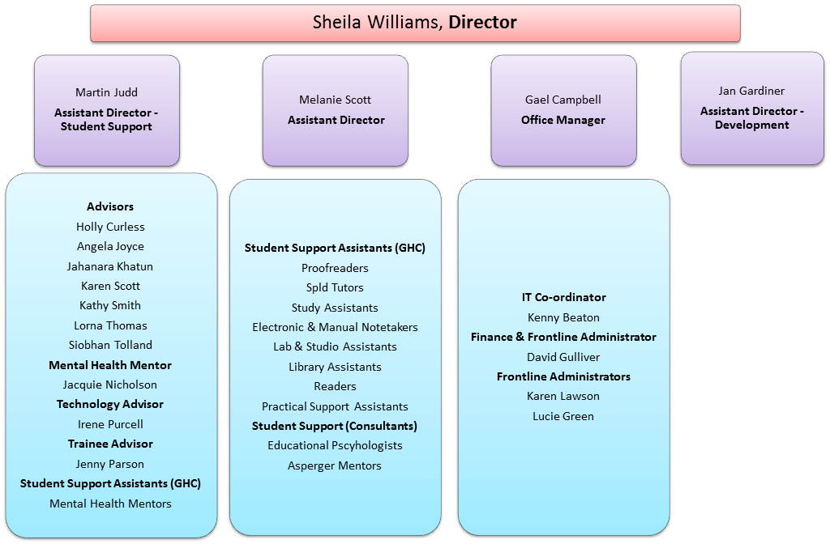
Student Disability Service
Annual Report 2013-14

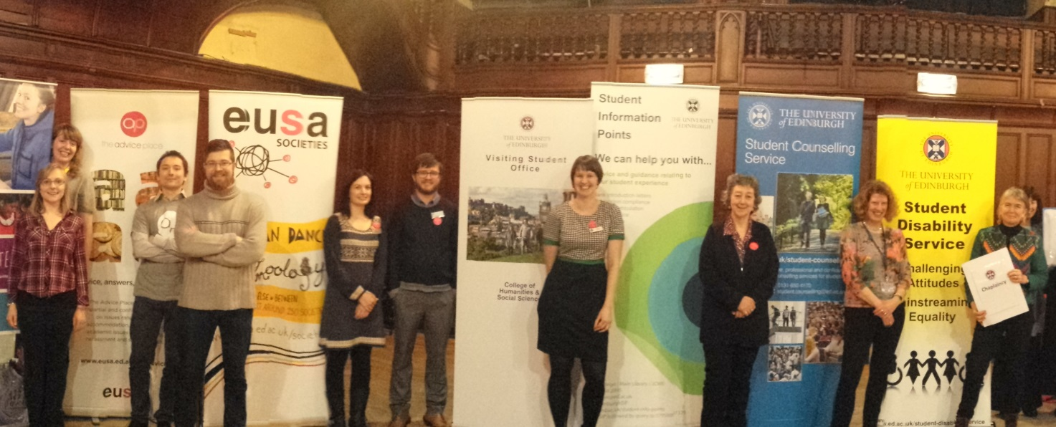
SDS participation at the Student Services Fair for Visiting Students, January 2015

Challenging attitudes. Mainstreaming equality.

Our Vision: Challenging attitudes. Mainstreaming equality.

Our Mission: Supporting students with impairments to fulfil
their academic potential. Working with academics and other
University colleagues to support them to create an accessible
learning and teaching environment.

www.ed.ac.uk/student-disability-service

