|  |  |
| --- | --- |
| Student Disability Service  Annual Report 2012-2013 | LogoUniEdinburgh |

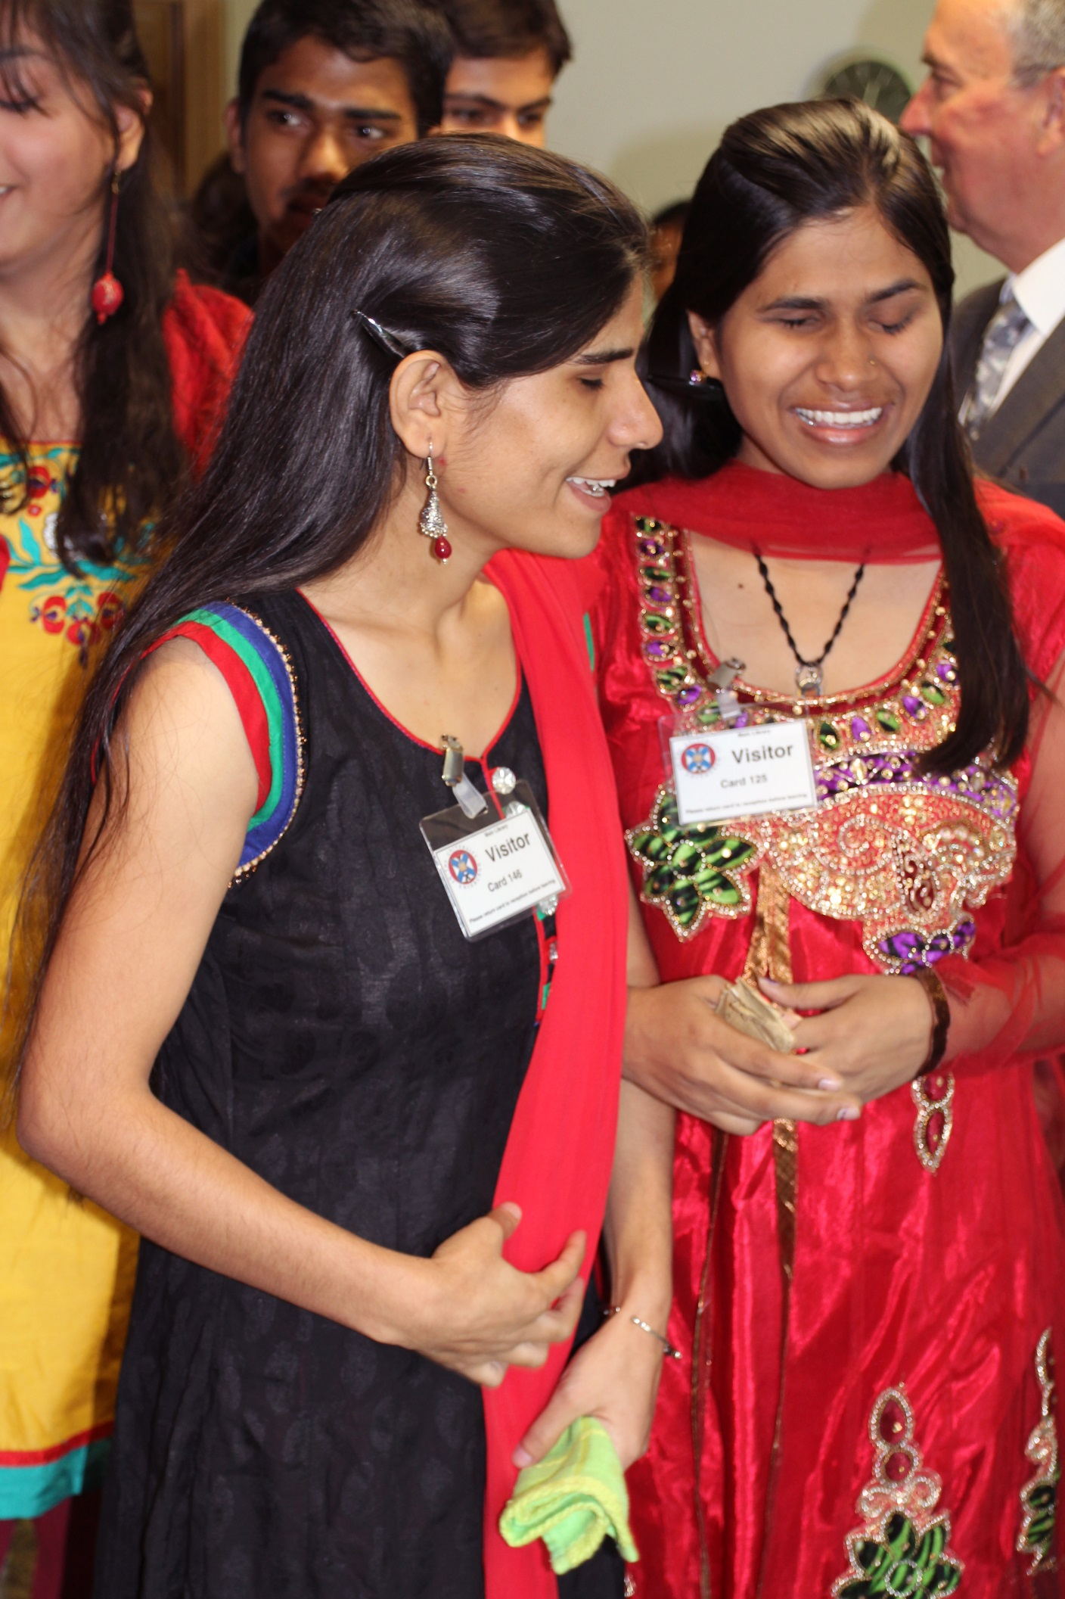

|  |
| --- |
| Challenging attitudes. Mainstreaming equality. |

**University of Edinburgh Student Disability Service**

**Our Vision:** Challenging attitudes. Mainstreaming equality.

**Our Mission:** Supporting students with impairments to fulfil their academic potential. Working with academics and other University colleagues to support them to create an accessible learning and teaching environment.

**Our Values:** Contributing to an equal andpositive learning experience. Communicating with staff, students and others. Professional and effective.

The Student Disability Service supports students by:

* Arranging pre-application visits
* Assessing students’ requirements – with each student
* Assessing assistive technology needs
* Liaising over building adaptations
* Producing individual Learning Profiles, detailing adjustments and support
* Matching students with student support assistants such as notetakers
* Screening for specific learning difficulties and referring on for assessment
* Negotiating exam arrangements
* Liaising with academics on student support and adjustment implementation
* Supporting students to apply for funding
* Supporting students with temporary impairments which impact on study
* Working strategically to mainstream accessible and inclusive learning
* Promoting disability issues via the Student Disability Committee.

The Annual Report

This annual report was produced in January 2014 and covers academic year 2012 -13.

In order to give an up-to-date overview, key issues beyond July 2013 are also covered.

Contents

|  |  |  |  |  |  |  |
| --- | --- | --- | --- | --- | --- | --- |
|  | **Contents** | | | | | 1 |
| 1. | Quality of student support opportunities | | | | | 2 |
|  |  | Table 1: | | UCAS classification codes | | 2 |
|  | **1.1** | **Key features of the service provision** | | | | **3** |
|  | **1.2** | **Users of the Student Disability Service (SDS)** | | | | **5** |
|  |  | Table 2: | | Numbers of disabled international students | | 6 |
|  |  | Table 3: | | Number of students disclosing a disability (undergraduate and postgraduate) | | 9 |
|  |  | Table 4: | | Disabled students – percentage of student population | | 9 |
|  |  | Table 5: | | Breakdown of disabled students by College and School | | 10 |
|  |  | Case Study: | | | Supporting a deaf student | 11 |
|  | **1.3** | **Key features of partnerships** | | | | **12** |
|  | **1.4** | **Service Evaluation 2012-13** | | | | **14** |
|  |  | Table 6: | | Evaluation Responses | | 15 |
|  |  | Case Study: | | | A dyslexic student in Engineering | 16 |
|  | **1.5** | **How the Student Disability Service supports our staff to enhance effectiveness in supporting students** | | | | **17** |
| 2. | Quality and standards | | | | | 19 |
|  | **2.1** | **Approach to setting and maintaining standards** | | | | **19** |
|  |  | Table 7: | | Student Disability Service Key Performance Indicators (KPIs) | | 20 |
|  | **2.2** | **Approach to monitoring and quality assurance** | | | | **21** |
| 3. | Enhancement and sharing of good practice | | | | | 22 |
|  | **3.1** | **Extent to which the service takes steps to manage quality enhancement** | | | | **22** |
|  | **3.2** | **Overview of good practice for dissemination** | | | | **22** |
| 4. | Projects and drivers | | | | | 24 |
| 5. | Forward look | | | | | 26 |
| **Appendix A:** | | | **Top 10 adjustments recommended for disabled students, January 2014** | | | **28** |
| **Appendix B:** | | | **Internal relationships and key involvement** | | | **29** |
| **Appendix C:** | | | **Internal and external relationships and key involvement** | | | **30** |
| **Appendix D:** | | | **Student Disability Service organisational chart** | | | **31** |

**What students said in 2012-13:**

“The suggestions and ideas made by staff have been very helpful and useful to me in helping me study with my disability.”

If you require this report in an alternative format please contact the Student Disability Service on 0131 650 6828 or at disability.service@ed.ac.uk

**Cover photo: students from the University of Delhi, July 2013** Quality of student support opportunities

**Key strategic Student Disability Service goals, enablers and themes:**

* Excellence in education
* People, infrastructure and finance
* Outstanding student experience
* Global impact
* Partnerships
* Widening equality and participation.

The Student Disability Service contributes to the University of Edinburgh’s vision and strategic goal of “excellence in education” and works towards this in every aspect of our vision, mission, values and service delivery. The Service takes a strategic approach to inclusion and equality and actively works towards the mainstreaming of individual recommended adjustments within the curriculum. The delivery of timely and effective support to disabled students, facilitated and provided by the Student Disability Service, is key to their fulfilling their potential and successfully completing their course of study.

Our vision reflects our aim to mainstream and embed equality for disabled students and we work in partnership with academic and other colleagues to challenge attitudes and practice to achieve this.

The **Equality Act** (2010)gives the work of the Student Disability Service (SDS) its legislative context and underpins the ethos and operational delivery of the service.

Under the Equality Act, someone is considered to be disabled if they have a physical or mental impairment which has a long term and substantial adverse effect on their ability to carry out normal day to day activities.

The classification of disability type in higher education is covered by the Universities and Colleges Admissions Service (UCAS) codes:

**Table 1: UCAS classification codes**

|  |  |
| --- | --- |
| **Code** | **Description** |
| **A** | No disability |
| **B** | Social communication impairment e.g. Asperger’s syndrome/autistic spectrum |
| **C** | Blind/serious visual impairment uncorrected by glasses |
| **D** | Deaf/serious hearing impairment |
| **E** | Long standing illness or health condition e.g. cancer, HIV, epilepsy |
| **F** | Mental health condition e.g. depression, schizophrenia or anxiety disorder |
| **G** | Specific learning difficulty e.g. dyslexia, dyspraxia or ADHD |
| **H** | Physical impairment or mobility issues |
| **I** | Disability or medical condition not listed above |
| **J** | Two or more impairments or disabling conditions |

* 1. **Key features of the service provision**

**The role of the service**

The Student Disability Service (SDS) exists to support all disabled students to fully access their chosen course of study. The service works across the University to embed an inclusive approach to supporting our disabled students. This is currently being taken forward via the University’s Learning and Teaching Committee and the implementation – and embedding - of the Accessible and Inclusive Learning Policy.

The service provides support to students attending Scotland’s Rural College (previously the Scottish Agricultural College (SAC), to online distance learners and to Office of Lifelong Learning (OLL) students.

Much of the support is provided by the implementation of adjustments (e.g. extra time in an exam) recommended by SDS Advisors for individual students. This information is distributed electronically to the student, key academic staff, the Personal Tutor/ Supervisor, Coordinator of Adjustments in the School and others, in a Learning Profile. The Learning Profile is a list of supports recommended by the Student Disability Service for implementation by Schools, Academic Registry and/or the Library, depending on the student’s course of study.

**Implementation of recommended support (adjustments)**

A snapshot of the number of recommended adjustments in January 2014 reveals that the Student Disability Service has recommended 13,198 adjustments for current students. (This represents a reduction of 2% in the number of recommended adjustments from the previous year. It does not yet reflect the reduction which will occur following the effective implementation of the 7 mainstreamed adjustments specified in the University’s Accessible and Inclusive Learning Policy.)

Student feedback in the SDS 2012-13 student evaluation reports a **7% decrease** in all adjustments being implemented since the previous year and a reported decrease for the second year in succession.

It is a legal risk to the University that some students are not receiving the support to which they are entitled and which has been recommended by the Student Disability Service. It should also be noted that there are many examples of excellent practice and staff committed to supporting disabled students in Schools. However, provision is inconsistent across the University. See Appendix A for top ten recommended adjustments as of January 2014.

The service also provides additional support if a student is assessed as requiring this to facilitate equal access to a course of study. This may be referral to a Mental Health Mentor, study skills tuition, specialist technology tuition, notetaking, proofreading or access to an Asperger Syndrome Mentor.

**Accreditation**

The Student Disability Service is an accredited centre for the assessment of UK students claiming Disabled Students Allowance (DSA), the financial support provided by government to disabled students. The service is validated annually by the Scottish Government’s Lifelong Learning Directorate and guided by the “Toolkit of Quality Indicators for Needs Assessment”. The majority of our advisory staff have the Beattie Resources for Inclusiveness in Technology and Education (BRITE) accreditation and/or relevant dyslexia and disability-related qualifications.

**The Student Disability Service was re-validated by the Scottish Government to carry out DSA Needs Assessments, in June 2013. Examples of our practice will be used by the Student Awards Agency Scotland (SAAS) as a model for the higher education sector in Scotland.**

**Student numbers and trends**

Disabled student numbers have increased year on year, since records began in 1993-94. Numbers are now over thirteen times greater. This is reflected in the proportion of the student cohort which has disclosed a disability:

* **1.44%** in 1993-94 increasing to **9.01%** in 2012-13.

The trend continues upwards. Numbers of students accessing all aspects of the service continue to increase, particularly since the service moved into the Main Library Building in 2011.

**Staffing**

The Student Disability Service currently (January 2014) employs **64** staff:

* 17 core staff = 14.9FTE (full time equivalent) – a **decrease** of 1FTE from 2011-12
* 47Student Support Assistants (tutors, notetakers, mental health mentors) and Educational Psychologists. Government funding is available to pay for this support for UK students.

**Location and premises**

The central location of the service and premises in the Main Library building has been very positively received by students, following our move. We are now experiencing problems with lack of space. There are ongoing challenges around physical access, with some misuse of parking bays and toilets for disabled people. We are working with relevant colleagues to address these issues.

**What students said:**

“Exam and coursework arrangements put in place immediately after (DSA) needs assessment, and have been immensely helpful.”

The service continues to be delivered from one site, apart from some tutoring provided from Moray House and Mental Health Mentor support delivered at the Vet School, Easter Bush. Shortage of space throughout the University has mitigated against the development of increased provision on other campuses, although we may yet access additional rooms at Moray House during the current academic year.

Staff will meet students elsewhere as necessary. We will also tailor student contact to the student’s needs by communicating by e-mail, text or phone, as preferred. We use Skype as an additional accessible means of communication, although take up by students has been low.

The physical space is fully accessible, as long as the library lifts are fully operational. The reception area has a loop system for deaf visitors who use relevant hearing aids.

**The Student Disability Committee and sub-groups**

The Student Disability Service supports and services the University’s Student Disability Committee and its 3 working sub-groups on Mental Health, Access and Facilities and Technology, Information and Communication. These groups generally meet 3 times per year and have been restructured to maximise influence and effectiveness.

We are delighted that Assistant Vice-Principal for Academic Standards and Quality Assurance, Dr Tina Harrison, has taken on the convenorship of the Student Disability Committee (from November 2013). Grateful thanks to Viki Galt, Disability Officer from Information Services for convening the committee for the last 2 years. The committee now reports into the University’s Equality and Diversity Committee, where previously it reported to the Senatus Quality Assurance Committee. Key areas covered and progressed by the committee and sub-groups are outlined in section 1.3.

* 1. **Users of the Student Disability Service (SDS)**

In **2012-13**, a total of **2963** students disclosed a disability, **9.01%** of the total student population at the University of Edinburgh. Although a snapshot in January 2014 shows a decrease in numbers disclosing, this is usually reversed when final statistics become available each July. In addition, the trend remains upwards and increased numbers (**31%**) of students are accessing the service and receiving support.

The most recent “Equality in higher education – statistical report, 2013” (Equality Challenge Unit) states that **8.6%** of students in the UK and **7.9%** in Scotland are known to have a disability. University of Edinburgh numbers exceed both national averages and our statistics are **3rd** highest in the Russell Group for first degree students (EDMARC statistics April 2013).

|  |
| --- |
| **Key** **statistics at a glance…**   * **6%** additional disabled students in 2012 -13 * **54%** have specific learning difficulties (mainly dyslexia) * **27%** increase: students with mental health problems * **19%** increase: international disabled students * **31%** increase: student contact with SDS in 2012-13 * Disabled students submitted **20%** of academic appeals * **22%** of students seen by the Student Counselling Service disclosed a disability * SDS is currently supporting **3.4%** (59) of online distance learners. |

The number of students disclosing disabilities continues on an upward trend, with an overall increase of **31**% (based on DSA needs assessment statistics) in students accessing the Student Disability Service in 2012-13. This compares to previous years:

* 2011-12 figures increased **15%** from 2010-11
* 2010 -11 statistics showed a **10.7%**
* 2009 -10 figures showed an increase of **14.7%**

**International Students**

The number of disabled international students **increased by 19%** in 2012-13**.** Whilst this is a positive development, the increased numbers have a significant financial impact and present a challenge for the service, as European Union (EU) and international students are not entitled to claim Disabled Students Allowance (DSA), funding provided by the UK government. The Student Disability Service receives a fee per student assessment, from Scottish and UK governments for carrying out needs assessments for disabled students. We are not able to generate a similar level of income for international students. Funding to support students who are not entitled to DSA, which includes EU and international students, is provided by the University and administered by the SDS via our Disabled Students Support Fund (DSSF).

In 2011-12, **63%** (increase from 60%) of students supported by our DSSF were international and EU students. The interim snapshot in January 2012, shows that **80%** (increase from 76%)of the students supported by this fund are EU/International students. This is reflected in the growing financial demands on the DSSF.

Reflecting the general trend highlighted earlier on this report, the SDS supports a growing number of international students with significant mental health problems, mirroring the increase in the overall student population.

**International Student Barometer (ISB)**

The ISB (autumn 2013) Student Disability Service satisfaction rating was **95.2%**, the same as the previous year. SDS was ranked**:**

* **2nd**in Scotland (up from 3rd in 2012)
* **3rd**in the Russell Group universities (4th)
* **6th** in UK (9th)
* **10th** in the full ISB rankings (10th) of 178 universities over 13 countries.

**Table 2: Numbers of disabled international students**

|  |  |  |  |  |  |  |
| --- | --- | --- | --- | --- | --- | --- |
| **Undergraduate** | | | | | | |
|  | **2007-08** | **2008-09** | **2009-10** | **2010-11** | **2011-12** | **2012-13** |
| **EU (non-UK)** | 48 | 48 | 81 | 67 | 96 | **98** |
| **Outwith EU** | 104 | 104 | 149 | 154 | 208 | **266** |
| **Taught Postgraduate** | | | | | | |
|  | **2007-08** | **2008-09** | **2009-10** | **2010-11** | **2011-12** | **2012-13** |
| **EU (non-UK)** | 14 | 17 | 23 | 18 | 45 | **68** |
| **Outwith EU** | 26 | 30 | 31 | 42 | 86 | **96** |
| **Research Postgraduate** | | | | | | |
|  | **2007-08** | **2008-09** | **2009-10** | **2010-11** | **2011-12** | **2012-13** |
| **EU (non-UK)** | 19 | 19 | 21 | 16 | 25 | **30** |
| **Outwith EU** | 28 | 23 | 36 | 31 | 54 | **52** |

The Student Disability Service regularly participates in a number of events aimed specifically at international students. These include:

* Induction for graduate students in the School of Education
* Presentations to the Butler Institute for Study Abroad, for visiting undergraduate students from the USA
* International Days, held in Induction Week.

Due to cultural differences in perception of disability e.g. the stigma of mental health in far eastern countries, and by the greater expectations of North American students in terms of the level of recommended support, we try to manage expectations and to clearly explain, both on the SDS website and in presentations, the legal context of equality and disability in the UK and what we mean by “disability” in the higher education context. We liaise regularly with the International Office on issues of mutual concern. A Depute Director from the International Office sits on the Student Disability Committee.

**Disabled students visit from the University of Delhi**

In June 2013, we were involved, with the International Office, in delivering the programme for visiting disabled students from the University of Delhi, which resulted in a fascinating one day discussion event. A reciprocal visit is being discussed, as part of the University’s ongoing and developing relationship with the University of Delhi.

**Colleagues from the University of Delhi said:**

“The visit was extremely fruitful and the students were enthralled with what they learnt.”

“The experience…was quite enriching. As we went through the days, the philosophical aspect of acceptance of disability as a difference rather than as a deficit became evident. We were made to realize that the persons with disability in the UK were neither sheltered nor pitied. They were rather accepted for who they were. Even those with disabilities themselves wanted people to accept their differences and not treat them differently. This was an experience that we encountered across every walk of life.”

**University of Delhi students talk technology with the SDS Technology Advisor**

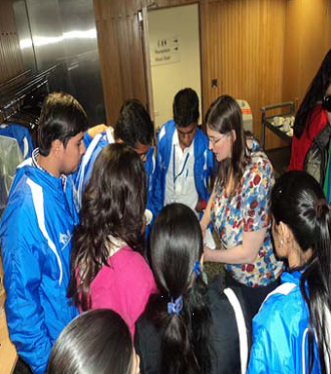

**Online Distance Learners (ODL)**

The Student Disability Service currently (in January 2014) supports **59** (3.4%) ODL students. The number fluctuates and has increased by 34% since the same period last year, but decreased since October 2013 when the SDS was supporting 65 students.

In addition to supporting distance learners via Skype and/or email, work is ongoing to ensure that levels of support are equitable. Discussions have taken place with the Open University regarding their practice, particularly in supporting dyslexic students and the challenges of providing robust evidence of dyslexia, usually done by referral for an Educational Psychology assessment, which can’t currently be carried out remotely. We hope to explore the possibility of reciprocal arrangements in some countries or to devise alternative in-house procedures.

**Current trends and demands**

There is a significant impact on the service of the increasing number of students we support who have mental health problems and those with Asperger Syndrome.

The number of students disclosing mental health problems on entry, year on year, shows:

* an increase of **27.4%** in 2012-13
* an increase of **44.37%** in 2010-11
* an increase of **8%** in 2011-12.

In academic year 2012-13, our four Mental Health Mentors (one permanent and three hours to be notified, now guaranteed hours offered) supported 95 students, an increase of over **10%** on the previous year. **31%** of these students are international students, an increase from **25%** in the previous year. The permanent Mentor also works closely with Vet Med, and we have established a permanent presence at Easter Bush one day per week.

The number of students disclosing Asperger Syndrome has remained static, after 2 years of significant increase in numbers. Supporting these students can be resource-intensive e.g. matching them with a mentor (provided by the Scottish Autistic Society) and a “named contact person” in their School.

In summer 2014, we will pilot a 2 day transition event for new students with Asperger Syndrome, funded by the Student Experience Project.

**What students said:**

“The Mental Health Mentoring service has been extremely helpful, and regular contact to discuss academic problems has proved reassuring.”

“This year has been so much better with the support of my Mentor”.

We are aware that a significant number of students with mental health issues and who are on the autistic spectrum, do not disclose this initially (if at all) on UCAS forms, but may define themselves in the categories of Multiple disabilities (two or more disabling conditions), Unseen or Other.

**Appeals from disabled students**

In 2012-13 students declaring a disability comprised 9.01% of the total student population of the University of Edinburgh. Disabled students comprised **20%** of academic appellants (22 students in a total of 108 who appealed).

**Appeals from disabled students in last 3 years:**

The number of appeals from disabled students is disproportionately higher – **20%** of all appeals - than those from non-disabled students, despite the fact that the total number of appeals decreased by 8% in 2012-13:

* in 2012-13, disabled students made up over **9%** of the student population and **20%** of academic appellants
* in 2011-12 disabled students made up almost **9%** of the student population and **11%** of academic appeals
* In 2010-11 disabled students made up **8.40%** of the student population and **18%** of academic appellants.

It is disappointing that the proportion of disabled students submitting academic appeals has increased. There may be a connection with the decrease in reported implementation (by Schools) of support recommended by the Student Disability Service. The Appeals annual report notes that “Clearly this figure will need to be monitored.”

**What students said:**

“Provided official acknowledgement of my disability in an understanding environment-- I probably wouldn't have brought it up with my director of studies directly.”

“Arranging my learning profile helped immensely during stressful exam periods. Staff took the time to understand what my requirements were even if I wasn't sure at first.”

“They do the best for you, with the constraints put upon them by the uni.”

**Table 3: Number of students disclosing a disability (undergraduate and postgraduate)**

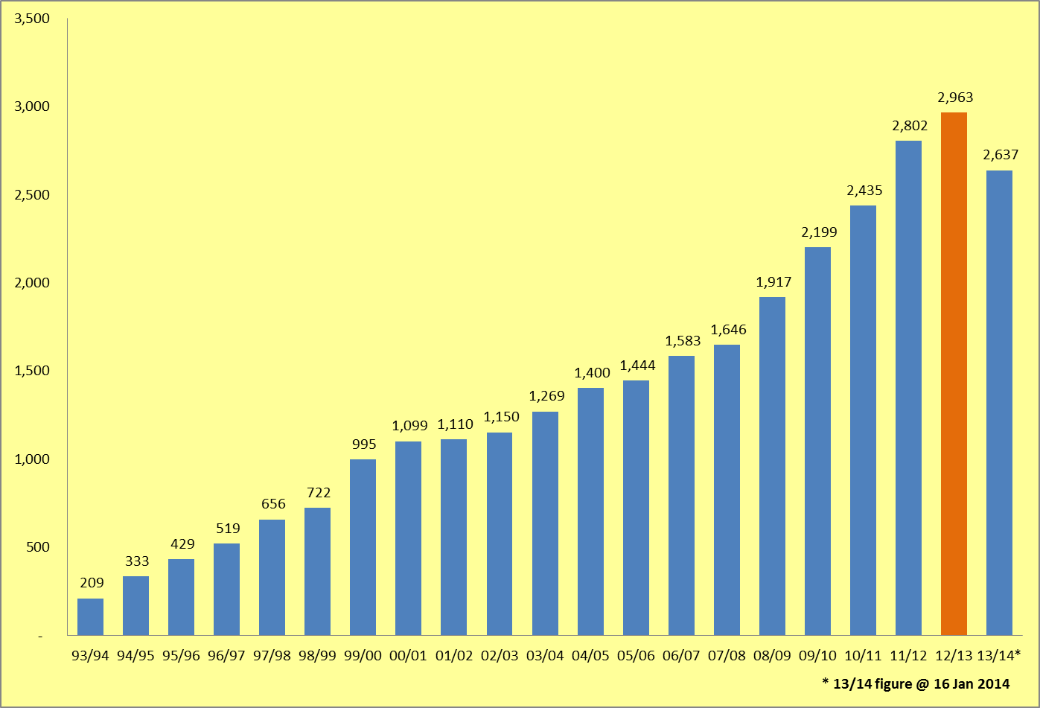

**2013-14 figure is an interim snapshot from January 2014. Final statistics are available in July each year.**

**Table 4: Disabled students - percentage of student population**

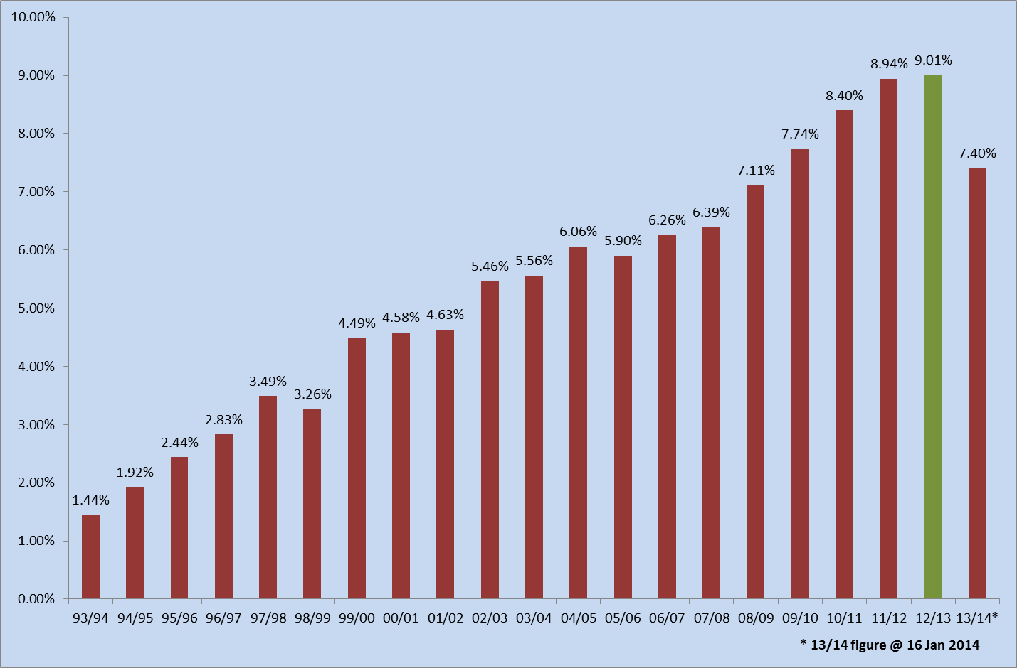

**Table 5: Breakdown of disabled students by College and School**



Case study - supporting a deaf student

Thomas was undertaking a postgraduate course of study which was taught through both lectures and practical interactive classes. The course of study incorporated the communication of a lot of technical and detailed information, particularly during the interactive classes. Thomas had a significant hearing impairment and was extremely concerned about missing key data and facts that his classmates would have no difficulty in picking up.

Thomas studied at the University for several years progressing very successfully from undergraduate to postgraduate study. In the first year his studies at Edinburgh, Thomas was assessed for Disabled Students Allowance (DSA) funding, and received a range of support, including equipment and assistive technology, as well as practical one-to-one support in the form of a notetaker for all classes and tutorials. Over the years Thomas utilised the support, sometimes using an electronic notetaker (notetaking in real time using a laptop), at other times finding that a manual notetaker was more suited to his needs. However, on undertaking his postgraduate studies, with the support of both a manual (for lectures) and electronic notetaker for the interactive sessions, Thomas quickly found that he was missing significant quantities of information delivered in the interactive sessions. The electronic notetaker simply could not capture all of the contributors to the discussions and could not record all of the technical data as accurately as Thomas required.

Thomas discussed his concerns with his Disability Advisor, as the very different nature of his postgraduate course of study made a re-assessment of his support needs essential. A number of new recommendations were made for Thomas's ongoing support, one of which was for the provision of a palantypist* for support in practical classes. As the Student Disability Service does not employ any palantypists, a number of agencies in Scotland were contacted to request the provision of this support for Thomas.

Palantypist availability is extremely limited, and it quickly became apparent that none were available in Scotland, and it seemed likely that the Service would have to arrange for a palantypist to travel from England and stay in Edinburgh for each occasion that Thomas required this support. However, Thomas's Disability Advisor made contact with a London-based service that was able to deliver real-time palantypist support remotely, via an iPad using the lecture room's wi-fi facility.

The Student Disability Service had not provided this support before, therefore, for the first class, we ensured that Thomas also had a notetaker with him, in case there were any problems. Thankfully, the technology and the palantypist in London worked perfectly, and Thomas was delighted, commenting that "The technology is easy and effortless to use. I personally find the system relaxing and an engaging way to understand everything as opposed to tiring when I normally rely on my hearing aids and a notetaker. The palantypist and remote captioning is a real lifesaver for a deaf person."

On the basis of this extremely positive feedback, the remote palantypist has been engaged for the remainder of Thomas's classes. The Student Disability Service will consider recommending this resource to other hearing-impaired students in future.

* Palantypist - A palantypist is a trained and qualified person who uses a Palantype machine and short hand code to note every word a speaker says.

* 1. **Key features of partnerships**

The Student Disability Service values partnership working as a key element of enhancing student support. Please see Appendices B and C for an overview of our main internal and external areas of involvement.

**Internal**

As well as working in partnership with students, we have developed effective relationships with academic colleagues over the years, both formally and informally. Key areas include the establishment of regular meetings with colleagues in Medicine and Veterinary Medicine to clarify and move forward areas of mutual concern regarding specific recommended adjustments. The SDS has had significant input into documentation produced by Vet Med, in addition to working with that School on a pilot project (now permanent) at Easter Bush to provide Mental Health Mentor support.

The Director works closely with academic colleagues, the Institute for Academic Development (IAD) and Edinburgh University Students Association (EUSA) on the implementation of the University’s Accessible and Inclusive Learning Policy and has delivered presentations at several workshops on the mainstreaming of support/adjustments.

The service is represented on several internal University of Edinburgh working groups, including the Enhancing Student Support project, the Equality and Diversity Committee, the Senatus Quality Assurance Committee (SQAC) and the Welfare Consultancy Group. Other recent involvement includes the Resits and Special Circumstances working groups.

We continue to meet twice a year with the Coordinators of Adjustments (key academic and support staff responsible for implementing support recommended by the SDS) in all Schools. The primary focus of these meetings is to streamline systems for implementing student support and to ensure that support recommended by the SDS is put in place.

**Accessible and Inclusive Learning/mainstreaming support**

The University adopted the **Accessible and Inclusive Learning Policy** in June 2013. The policy represents a significant step forward in terms of mainstreaming 7 frequently recommended “adjustments”, including:

* Lecture outlines or PowerPoint presentations slides for lectures/seminars shall be made available to students at least 24 hours in advance of the class – and-
* Students shall be permitted to audio record lectures, tutorials and supervision sessions using their own equipment for their own personal learning.

The aim is to ensure that disabled students are not discriminated against and to minimise the impact on staff of supporting disabled students. The Student Disability Service has continued to include the mainstreamed adjustments in students’ learning profiles until “mainstreaming” is fully embedded in the University.

With funding from the Student Experience Project, the Student Disability Service employed a project worker for 3 months to produce guidance and coordinate communications on the changes, alerting both staff and the student body.

The policy is available at: <http://www.docs.sasg.ed.ac.uk/AcademicServices/Policies/Accessible_and_Inclusive_Learning_Policy.pdf>

Additional guidance for academics is available at:

<http://www.ed.ac.uk/schools-departments/institute-academic-development/learning-teaching/inclusive/accessibility>

The policy has been equality impact assessed and will be reviewed after a year to assess progress towards embedding change.

**Enhancing provision for students with specific learning difficulties (SpLD): removal of coursework stickers for dyslexic students**

The Student Disability Service has now ceased recommending or providing stickers for dyslexic students to attach to their coursework (Exam stickers remain). The driver for change was the fact that that the meaning of the stickers was unclear to both students and to staff and it appeared that some staff were marking more leniently. (The stickers identified students as dyslexic and advised markers not to adjust marking.)

A substantial period of consultation preceded the change, including presenting the case to the Learning and Teaching Committee, focus groups with students and liaison and discussion with the undergraduate Deans, who were all in favour. The Student Disability Service has produced marking guidance, which was circulated to all Schools and which is available in the “Staff” section of the SDS website: <http://www.ed.ac.uk/schools-departments/student-disability-service/staff/supporting-students/coursework-stickers>

An Equality Impact Assessment has also been carried out. SDS staff have dealt with a number of enquiries from academic colleagues regarding the changes and their role. We have clarified the issues and have drawn their attention to the guidance and to the fact that they are able to engage in discussion with SDS Advisors on any aspect of disabled student support.

**Enhancing assessment provision:**

1. **For students with Asperger Syndrome and A(D)HD**

To enable the service to provide a quicker assessment of the above conditions – and thereby enabling us to put appropriate support in place more quickly for relevant students - we have started to work in partnership with two clinical psychologists who are experts in their fields. They are also able to assist with the assessment of dyslexic students, which will enable us to support these students more quickly.

1. **For students whose first language is not English**

After a trial period, we have introduced what we anticipate will be a more effective means of establishing whether some international students, whose first language is not English, can be assessed for indicators of dyslexia. The system will be reviewed after a year and has also been equality impact assessed.

**The work of the Student Disability Committee**

The SDS continues to support and service the University’s Disability Committee and its sub-groups, which cover:

* Access and Facilities
* Mental Health
* Technology, Information and Communication (a merger of the Accessible Information and Technology groups).

Some of the key issues under discussion in the last year include:

* Accessible and Inclusive Learning, the policy, guidance and embedding change
* Revised mental health guidelines for the University (replacing the Code of Practice)
* The new post of Mental Health Co-ordinator
* Input into the accessibility guides to key (ultimately all) buildings in the University estate
* Attempts to ensure that the University incorporates an “accessibility” strapline in all key communications, as evidence of good practice.

Dr Tina Harrison, Assistant Vice Principal for Academic Standards and Quality Assurance, who has been an academic champion of Accessible and Inclusive Learning has taken over the convenorship of the Student Disability Committee.

In addition to representatives from all three Colleges, Edinburgh University Students Association (EUSA) is represented on all disability-related working groups. The Director of the Student Disability Service meets regularly with EUSA staff, sabbaticals and representatives of Disability and Mental Wellbeing Liberation Group.

**Disabled staff support**

Support for disabled staff continues to be an ongoing concern, following the withdrawal of SDS services for staff (due to insufficient resources). Intermittent discussions have taken place with HR and Occupational Health and are ongoing.

**External**

In addition to internal partnership working, the Director continues to be active in working with colleagues in Scotland and throughout the UK on key issues for Disability Services and on equality issues. Disability Heads of Service in Scotland meet quarterly and are represented by the SDS Director on the Scottish Government’s Disabled Student Advisory Group. The Director also represents the University of Edinburgh on the Russell Group Heads of Disability Services and on the Scottish Liaison Group of the Equality Challenge Unit (ECU).

We have also participated in several AMOSSHE (Association of Managers of Student Services in Higher Education) events and hosted national events for ATANET (Association of Technology Advisors) and DSA-NET (Disabled Students Allowance Assessors).

Service Level Agreements and codes of practice are in place with:

* Scotland’s Rural College (previously the Scottish Agricultural College (SAC) to support their disabled students
* the Royal National Institute for Blind People (RNIB) for additional expert support for visually impaired students
* Information Services for support and maintenance of our student support databases
* Iansyst, our technology provider of IT equipment for our students
* The Office of Lifelong Learning
* Autism Scotland, who provide support for students with Asperger Syndrome
* Our professional assessors/psychologists.
  1. **Service Evaluation 2012-13 and issues arising**

The Student Disability Service (SDS) evaluation survey is carried out by the University’s Communications and Marketing (CAM) team. The 2012-13 survey was sent to 2,529 students (116 people more than the previous year). We received 418 responses i.e. a **17%** response rate, a reduction in the numbers of respondents in 2011-12, when we had a 22% response rate. It is possible that the ESES (Edinburgh Student Experience Survey) which was sent out earlier in the year may have impacted on the reduction in numbers of respondents.

Key points:

* **82%** of respondents were very satisfied or satisfied with the service (up from 79%)
* **91%** of respondents were very satisfied or satisfied with the front line service (up from 84%)
* dissatisfied/very dissatisfied ratings decreased to **6%** (12% of users were neutral)
* reported implementation of all course adjustments **decreased** againto **42%** of respondents this year, comparing unfavourably to 49% of students who reported implementation last year and 61% in the year before
* the staff continue to be rated as the best element of the service.

**Table 6: Evaluation responses**

**2012-13**

|  |  |  |
| --- | --- | --- |
| **Three services with most satisfaction** |  | **Three services with least satisfaction** |
| Assessment of Specific Learning Difficulties |  | Asperger Syndrome student mentor service |
| Exam Arrangements |  | Fire evacuation procedures |
| Support to apply for DSA |  | Specific Learning Difficulties tutoring |

**2011-2012**

|  |  |  |
| --- | --- | --- |
| **Three services with most satisfaction** |  | **Three services with least satisfaction** |
| Examination arrangements |  | Asperger Syndrome student mentor service |
| Assessment of Specific Learning Difficulties |  | Specific Learning Difficulties tutoring |
| Support to apply for DSA |  | Fire evacuation procedures |

**2010-2011**

|  |  |  |
| --- | --- | --- |
| **Three most important services** |  | **Three services with least satisfaction** |
| Mental Health Mentor |  | Physical access |
| Examination arrangements |  | Liaison with other staff |
| Finding student support assistants |  | Fire evacuation procedures |

**2009-2010**

|  |  |  |
| --- | --- | --- |
| **Three most important services** |  | **Three services with least satisfaction** |
| Exam arrangements |  | Links with Accommodation Services |
| Assessment of Specific Learning Difficulties |  | Fire evacuation procedures |
| Disabled Student Allowance Application |  | Study skills advice |

**2008-2009**

|  |  |  |
| --- | --- | --- |
| **Three most important services** |  | **Three services with least satisfaction** |
| Exam arrangements |  | Links with Accommodation Services |
| Finding student support assistants |  | Physical access |
| Assessment of Specific Learning Difficulties |  | Links with other staff |

The full evaluation report can be found on the Student Disability Service website at:

[**http://www.ed.ac.uk/schools-departments/student-disability-service/about/feedback-evaluation**](http://www.ed.ac.uk/schools-departments/student-disability-service/about/feedback-evaluation)

As well as the annual evaluation, the Student Disability Service seeks feedback:

* from students to find out if they are satisfied with their Student Support Assistant (e-mail survey)
* from Student Support Assistants to review their match with the students (email survey)
* to find out if students have had their adjustments implemented (e-mail sent out in semester 2 to all students accessing the SDS).

**What students said about their support/adjustments:**

“Not all adjustments are adhered to by courses, the disability service does ask you to inform them but it would be easier if changes were just implemented without the need for the students to chase certain departments.”

Case Study – the dyslexic student in Engineering

Kyle was a final year Engineering student when dyslexia was first recognised. Without support in place he had found the course consistently challenging and had failed examinations every year. He had specific difficulties with memory and speed of processing information.

He found the fast pace of lectures hard to grasp and reported major difficulties maintaining concentration. His slow speed of handwriting and difficulty writing legibly impeded his ability to take effective notes in lectures. Consequently he was left with poor recall of lectures and notes of limited use.

As Engineering lectures often include references to visual information such as graphs it was arranged for Kyle to have access to both an audio and visual recording of the lecture. By replaying the lecture in his own time this enabled him to process the content by stopping and starting the recording as required.

As the locations of the lectures for Kyle’s course did not allow the school to create podcasts, the school agreed to allow him to video lectures using a handheld recording device. Kyle was provided with a camcorder on loan through the Student Disability Service. However, as handheld camcorders are not designed for recording all day, he found that there was insufficient battery power to last for a full day of lectures. Discussions between the Student Disability Service and the Learning Teaching Spaces Technology Section then resulted in Kyle being loaned a digital camcorder with sufficient battery power.

Kyle was also provided with PowerPoint presentations in advance of lectures and a contribution towards printing costs as this enabled him to have a print-out of the slides during the lecture. This reduced the amount of information he had to write as he could annotate the slides, including visual images such as graphs and diagrams.

As he had significant difficulty with spelling and proofreading he was also given access to a proofreader for his dissertation. In his final exams he was not penalised for poor spelling, grammar, punctuation or structure in exam scripts and he received 25% extra time.

* 1. **How the Student Disability Service supports our staff to enhance effectiveness in supporting students**

At the time of writing the Student Disability Service employs 64 staff, 17 (14.9 full time equivalent) core staff and 47 Student Support Assistants and psychologists, who work on a “guaranteed hours offered” basis (see organisational chart, Appendix D). These roles encompass a wide range of skills and experience, which is reflected in our staff development.

Staff are encouraged to undertake relevant professional development and are currently engaged in training on Asperger Syndrome, A(D)HD and on assistive technology, software and website development. Managers are also encouraged to undertake leadership and relevant skills-based training and development e.g. absence management.

Training is key to ensuring that SDS staff are up to date with areas such as employment legislation and data protection, Freedom of Information legislation and the Equality Act, including the introduction of Equality Impact Assessments.



**Providing an Integrated and Effective Service – service restructure**

The Service currently operates via two teams of Advisors who see students with specific impairments. We are aiming for a provision which does not separate students by impairment but puts the student at the heart of the process. The service is currently undergoing restructure, taking forward a project “Providing an Integrated and Effective Service” which aims to provide more effective support to disabled students by utilising and developing the skills of our Advisory staff, enabling more Advisors to see **all** students, not just students with specific impairments. This will enable us to maximise resources and support students even more effectively. Specialisms will continue to be maintained and shared throughout the team.

**Staff Training**

The Student Disability Service continues to provide a range of training throughout the University, which can be tailored on request for any School or support service, including:

* training for Personal Tutors and Student Support Officers
* Disability Equality Training for IS and Estates and Buildings staff
* training on mental health issues (with Student Counselling)
* Supporting students with Asperger Syndrome
* training on the Equality Act 2010
* “Living with Dyslexia” (delivered with Student Counselling)
* sessions on dyslexia and Asperger Syndrome
* Post Graduate Certificate in University Teaching (Diversity model)
* Presentations in support of international students.

Students are involved in delivering many of our training sessions.

In June 2013, we were involved, with the International Office, in the programme for visiting disabled students from the University of Delhi, outlined earlier in the report. The service also hosted a staff member from the Central European University, Budapest for a 3 day Erasmus staff exchange in March 2013.

The Director has presented on the issue of mainstreaming adjustments and the Equality Act at Accessible and Inclusive Learning implementation workshops. The Director also presented on this issue to the University Senate, with academic and student colleagues, in February 2013.

The SDS also has regular input into:

* Open Days
* International Day
* New staff induction events.

**What University staff said about SDS training:**

**“**An excellent session giving an insight into the problems facing students at the University and the obligations under the Equality Act”.

“I really appreciated the opportunity for round-table discussion with colleagues on different approaches, plus support and advice from the trainers concerning what we’re already doing well and how we could improve”.

“Very well-rounded approach to all topics – different aspects reviewed and quite thought provoking”.

1. Quality and standards

**2.1.** **Approach to setting and maintaining standards**

The Student Disability Service is committed to providing a high quality service and works to continuously enhance provision in a range of ways, including seeking regular feedback from students and by increased liaison and dialogue with University staff.

The service provided by SDS to disabled students to produce Needs Assessments for Disabled Students Allowance (DSA) is validated annually by the Scottish Government. Our revalidation submissions are well received and in June 2013 it was noted that “the Panel felt that this was a good standard of application.”

In the context of performance management, the Student Disability Service achieved a 100% rate for annual appraisal of eligible staff. All staff have regular supervision meetings with their line managers.

The service works to Key Performance Indicators (KPIs). New KPIS have been developed for the service in line with the University new strategic plan. See table 7 for current and previous years’ KPIs and statistical data.

There are no formal benchmarking systems for the service, but we participate in regular informal benchmarking with colleagues in other Scottish institutions and the Russell Group. It can be a challenge to compare Disability Services as they are delivered in different ways, depending on size of institution, specialisms in Advisory teams and IT focus. The most recent informal Russell Group benchmarking exercise showed the SDS slightly above the mid-point of the ratio of Advisory staff to number of students.

The **International Student Barometer** (ISB) provides an element of international benchmarking.

In the most recent (autumn 2012) ISB the Student Disability Service achieved a satisfaction rating of **95.2%.** This is an increase from the earlier 84% rating.

We are rated:

* 2nd in Scotland (3rd in previous rankings)
* 5th in the Russell Group (previously 4th)
* 8th in UK (previously 9th)
* 12th in the full ISB rankings (previously 10th).

**An international student said: - “**(I was) able to borrow equipment that made a big difference to my ability to meet essay deadlines.”

**Table 7: Student Disability Service Key Performance Indicators (KPIs)**

|  |  |  |  |  |  |  |  |
| --- | --- | --- | --- | --- | --- | --- | --- |
| **Student Disability Service KPIs** | **2006-07** | **2007-08** | **2008-09** | **2009-10** | **2010-11** | **2011-12** | **2012-13** |
| Number of enquiries from students | 4,558 | 5,761 | 6,910 | 9,194 | 13,478 | 17,026 | 18,491 |
| Number of enquiries from staff and others | 4,857 | 4,724 | 6,291 | 7,825 | 9,869 | 13,543 | 14,217 |
| Unique visitors to SDS website | 71,200 | 73,745 | 59,682 | 66,811 | 34,150 | 22,508 | 24,349 |
| Number of **new** needs assessments for Disabled Students Allowance (DSA) | 177 | 195 | 222 | 264 | 250 | 223 | 293 |
| Number of students supported via DSA | 562 | 512 | 585 | 574 | 707 | 561 | 570 |
| Number of students supported by the University’s Disabled Student Support Fund (mostly international students) | 176 | 131 | 193 | 212 | 220 | 279 | 259 |
| Number of students using student support assistants (note takers, tutors etc) | 176 | 221 | 217 | 266 | 291 | 381 | 448 |
| Number of Learning Profiles produced (new/total) – * 2011-12 totals reflect impact of eca merger | 364/697 | 366/681 | 469/855 | 615/870 | 459/915 | 814/1220* | 784/427 |
| Items of equipment loaned (digital recorders, laptops etc) | 116 | 138 | 129 | 124 | 127 | 186 | 163 |
| Number of visitors to the Student Disability Service (reception area shared with the Student Counselling Service) | - | - | - | - | - | 12,252  Jan – Jul | 24,435 |

**2.****2** **Approach to monitoring and quality assurance**

Validation submission and approval for accreditation to carry out Needs Assessments for Disabled Students Allowance (DSA) is carried out annually. This validation will include site visits from the Scottish Government Lifelong Learning Department.

Quality assurance is largely managed in the context of continuous enhancement and improvement, in line with our key performance indicators (KPIs) and strategic plan. Due regard is given to the results and feedback from our annual student evaluation; it is our aim to make positive changes in line with the issues highlighted by the students. For example, students identified problems with our frontline service in the 2010-11 evaluation. These issues were taken on board and the 2012-13 evaluation gave a **91%** satisfaction rating for our frontline staff, compared to 84% for the previous year. This represents a leap from a 64% rating in 2010-11.

The service vision, mission and internal and external values, in addition to the legislative guidance of the Equality Act, continues to give us a clear purpose and focus within the framework of the University’s strategic plan.

Developments are monitored and progressed via SDS strategic and operational plans, reflecting the University’s strategic plans and themes. In addition, the service has several in-house, short-life working groups, all intended to enhance service delivery and the quality of the student support which we provide. These groups, as well as existing workgroups, take forward key pieces of work and ensure that we continue to enhance provision.

These include or have included over the year:

* Use of technology (e.g. Skype) to support students at a distance (done and implemented)
* Good office practice group (standing) – to enhance communications and best practice in customer service
* Kelso and Radium group (standing) – to enhance our student support databases
* Website group (standing) – to review and develop website content and usability
* Mental Health group (standing)– to enhance the work of our Mental Health Mentors and Advisors
* Assessing students whose main language is not English (done and recommendations implemented)
* Management team meetings, full office team meetings and regular one to one meetings for all staff
* Annual appraisals for all eligible staff.

At the time of writing we are recruiting for a new post of Assistant Director (Development) whose role will be to take forward strategic initiatives, working with the Director and in partnership with key stakeholders throughout the University.

1. Enhancement and sharing of good practice

**3.1****Extent to which the service takes steps to manage quality enhancement**

Please also see section 2.2.

The key initiatives, as described and highlighted in the report, during the last year are:

* Accessible and Inclusive Learning – working to have the University’s policy adopted, securing project funding to communicate the policy and the related practical guidance and moving to further embed the policy and practice. The introduction of the policy has attracted positive comment and attention from Heads of Disability Services in the Russell Group and amongst colleagues in Scottish institutions.
* Removal of coursework stickers for dyslexic students, following consultation with the Learning and teaching committee, senior academics and affected students.
* Service enhancement via our project to provide an integrated and effective service, by developing training provision, skills, and maximising resources.
* Development of the SDS wiki enables easy access to the full range of SDS operational guidance and policies.
* Advisory staff are producing an in-house reference guide for their (complex) role, which will also serve as an essential induction and signposting tool.

In addition, the following steps are taken to enhance the quality of the service:

* All staff work together to define service and personal objectives alongside carrying out operational planning
* Management team and core staff group team events are held annually.
* The SDS has a 100% annual appraisal rate of eligible staff, in addition to regular one to one meetings for staff and team meetings.
* Liaison with Schools – we are in contact with all 22 Schools and SDS continues to push forward on more effective liaison and joint working with the Student Disability Service. Each of our Advisors has a responsibility to liaise with and develop in-depth working knowledge of specific Schools, to enhance our scope for supporting students. Meetings are held with a range of School staff on a variety of issues e.g. adjustments, mental health, fitness to study.
* SDS Advisory staff are all members of professional organisations such as the National Association of Disability Practitioners (NADP), the Association of Dyslexia Specialists in Higher Education (ADSHE), the Assistive Technology Advisors network (ATANET) and the Association of Managers of Student Services in Higher Education (AMOSSHE).
* Staff development - all staff are encouraged to further their professional skills and are engaged in a range of continuing professional development.

**3.2.** **Overview of good practice for dissemination**

Issues highlighted in the annual evaluation and elsewhere are incorporated into SDS team and staff operational plans and addressed via revision of service policy and procedures which then define operational delivery.

For example, in response to comments from students in the annual service evaluation, we have made efforts to raise the profile of the service throughout the University.

We have used the Student Information Points (SIPs) Twitter and Facebook pages to let students know about exam deadline dates.

The 13 student factsheets produced in 2012 were positively received by students in the 2012-13 evaluation. We have and are reorganising the structure and content of our website to make it more user friendly.

We are about to add video clips to the website, highlighting positive student experience of our Mental Health Mentor service (funded by a grant from 12S). We intend to extend this to include many other aspects of the work of the service.

IT provision for the service was re-tendered in the summer of 2012. This is a contract worth approximately £230,000 to the provider. Since the new provider was appointed, student satisfaction levels have risen and SDS staff are generally satisfied with the service provided. The service level agreement is revisited annually and has been amended in light of the first full year of partnership.

In May 2013, the Director undertook a study trip to the University of Wisconsin, Madison (and Milwaukee) an institution of similar dimensions to the University of Edinburgh. This was particularly useful in understanding the context of disabled US students and their expectations of support when they study here.

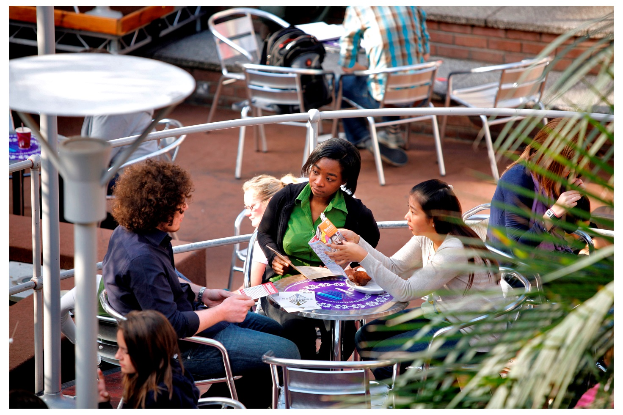

1. **Projects and drivers**

There are a number of factors which will influence the future of the Student Disability Service and disabled student support in the wider sense. Some of the known areas are outlined below. Other factors remain unknown, such as predicted intake numbers of students in future years and the progress and impact of the Accessible and Inclusive Learning Policy and how effectively it becomes embedded as mainstream provision.

**The main external factors** which may impact on the Student Disability Service include:

* The outcome of the Scottish Government’s review of Disabled Students Allowance (DSA): at the time of writing the review process is ongoing, following a consultation which ended in September 2013. Responses from Further Education and Higher Education (including the University of Edinburgh) highlighted a clear difference of views in the two sectors in relation to the devolution of DSA funds to individual institutions. We currently await the government’s response on next steps. Currently the service generates around
* Revision of the Quality Assurance Agency (QAA) guidance covering disabled students has resulted in a generic guidance document, which has led to less specific guidance in relation to disabled students.
* The Equality Act Public Sector Duty and the requirement to carry out Equality Impact Assessments on changes of policy, procedure and practice. This has been carried out by SDS on 4 areas of working practice.
* Lack of experienced Advisory staff throughout the UK. SDS is addressing this by recruitment of a trainee Advisors, who will be trained “on the job”.

**Internal University of Edinburgh initiatives and issues** which impact on the service, include:

* The challenge of embedding Accessible and Inclusive Learning. Whilst the University has adopted a clear policy and produced specific guidance, a number of ongoing issues continue to arise. The SDS Director and Assistant VP will continue to progress issues via the University’s Learning and Teaching Committee. It is hoped that a project to further the embedding of good practice may be taken forward with the School of History, Classics and Archaeology in 2014 and used as a template for work with other Schools.
* The increasing number of disabled students using the service and their expectations
* Increasing complexities of support pertaining to the increasing number of international students, as well as of students with mental health issues and those on the autistic spectrum. At the time of writing there are a series of developments and discussions in the University which should positively impact on the way in which we support students with mental health problems. (The Student Disability Service will be running a transition event over 2 days for students with Asperger Syndrome in July 2014, designed to prepare and enable these students to feel more comfortable in the University environment.)

**Implementation of Recommended Course Adjustments**

Non-implementation of adjustments recommended by the Student Disability Service continues to pose a significant challenge.

The impact of this lack of support can cause students significant stress and may impact negatively on their progress. The University has an “anticipatory duty” under the terms of the Equality Act in relation to disabled students. Education providers should not wait until a disabled person approaches them before they give consideration to their duty to make reasonable adjustments. The University “should anticipate the requirements of disabled students and the adjustments that may have to be made for them.” (Equality Act 2010 Technical Guidance on Further and Higher Education.)

In the 2013-13 SDS annual evaluation only 42% respondents reported that their course adjustments, as recommended in their Learning Profiles, were fully implemented. This is a worrying development in light of 49% and 61% of students reporting full implementation in the previous two year.

Whilst many academic and support services staff make strenuous efforts to support disabled students, especially the nominated Coordinators of Adjustments in each School, there remain instances where this does not happen. This continues to put the University at risk of legal action.

It is anticipated the implementation and embedding of mainstreamed support – as defined by the Accessible and Inclusive Learning policy will reduce risk and enhance good practice, in the long term. The SDS welcomes the support and commitment of key academic colleagues and EUSA working in partnership in moving this forward.

**What students said:**

**“**Not all adjustments are adhered to by courses, the disability service does ask you to inform them but it would be easier if changes were just implemented without the need for the student to chase certain departments.”



5. Forward look

The Student Disability Service welcomes the continuing increase in numbers of students using the service and those disclosing an impairment. This is a positive development for the University, which highlights the lessening stigma of having a disability. In part this is due to the UK education system where there is a “presumption to mainstream” and a move away from a segregated education system. There is a greater awareness of the right not to be discriminated against, as enshrined in the Equality Act 2010 and its predecessor, the Disability Discrimination Act.

The service has a knowledgeable and experienced staff group, working in a complex area. However, one of our major challenges going forward is the restricted pool of advisory staff with relevant experience in this specialised area of work. We will therefore be recruiting trainee Advisors, so that someone with no previous experience can be trained “on the job” and inducted gradually into an Advisory role.

The impact of the introduction of the Personal Tutor system continues to be largely positive, in that students often mention that they have been referred to the service by their Personal Tutor. The service has, in partnership with the Student Counselling Service and others, carried out training for PTs and Student Support Officers. At the time of writing, the training programme on supporting distressed students is being revisited and updated.

The impact of online distance learners is gradual, although current numbers of students (January 2014) being supported has increased by **34%** in the past year to **59** online distance learners. Although the Distance Learning Initiative may attract a disproportionately high number of disabled students, it appears that they may have fewer support requirements if working online. We are continuing to explore the most effective means of supporting this students cohort e.g. provision of Educational Psychology assessments and acceptable evidence of impairment.

The physical accessibility of the University’s estate continues to present major challenges for some students, particularly those who use wheelchairs, as does the issue of ensuring that equipment such as lifts are maintained in working order. However, Estates and Buildings are producing a series of access guides to University buildings.

We continue to promote the embedding of good practice and Accessible and Inclusive Learning and welcome the support of Vice Principals, EUSA and senior academic colleagues in this area.



**Specific priorities identified in last year’s annual report have been achieved or are on-going, as follows:**

* Review of coursework stickers for dyslexic students: **achieved**, coursework stickers now removed for dyslexic students following consultation with students and academic colleagues. (To be reviewed in July as part of the equality impact assessment process)
* Review SDS structure with a view to enhancing effectiveness of service delivery to disabled students: **underway**, being taken forward by the “Providing and Effective and Integrated Service” group. Skills audit being carried out to identify areas where training required. Restructure of Technology posts carried out, IT and Administration now closely aligned and database enhancements completed
* Review operations e.g. IT, to interact with students: **done**, Skype appointments being offered
* Review training for Student Support Assistant notetakers: part-achieved and **ongoing**
* Promote and embed Accessible and Inclusive Learning throughout the University: **ongoing**
* Review and increase our service locations: Mental Health Mentor support now being provided at the Vet School, Easter Bush. Ongoing as new staff are taken on. (**Progress limited** due to space issues throughout the University).

**Additional work areas achieved/ongoing:**

* Process for assessing non-English speaking students for dyslexia carried out and now implemented
* Process for applying for support for disabled international students reviewed and made more robust (equality impact assessed)
* Review of acceptable evidence completed, but further work to be carried out in the current academic year
* Funding received from the Student Experience (SEP) to run a pilot Transition project for students with Asperger Syndrome in July 2014, to facilitate the move from school to university.

**The following remain to be progressed:**

* IT enhancements (IS projects), including waiting lists, financial enhancements and changes to EUCLID which will enable Personal Tutors to access Learning Profiles
* Working in partnership to enhance provision for students with mental health issues and distressed students.

**What students said about the Student Disability Service:**

**“…**I am glad it exists**…!”**

APPENDIX A: Top 10 adjustments recommended for disabled students, January 2014

|  |  |  |
| --- | --- | --- |
| **Recommended adjustment** | **No of students with adjustment** | **% total adjustments (13,198)** |
| Lecture outlines or PowerPoint presentation slides for lectures/seminars shall be made available to students at least 24 hours in advance of the class Now mainstreamed (wording amended) | **1,235** | **9.4%** |
| 25% additional time in examinations. Student may use this extra time for writing or to take rest breaks throughout the exam. | **1,119** | **8.5%** |
| Students shall be permitted to audio record lectures, tutorials and supervision sessions using their own equipment for their own personal learning Now mainstreamed (wording amended) | **1,043** | **7.9%** |
| This student has specific learning difficulties. He/she should incur no penalties for poor spelling, grammar, punctuation and structure in examination scripts, unless these are being directly assessed and are core to an understanding of the course. | **886** | **6.7%** |
| Provide double loan time on reserve/short loan books. | **880** | **6.7%** |
| Reading lists shall indicate priority and/or relevance Now mainstreamed (wording amended) | **698** | **5.3%** |
| Student requires prior sight (15 minutes) of the paper for the purposes of reading and highlighting. | **655** | **5%** |
| Student not to sit two three-hour exams in one day (where possible Registry will schedule examinations to avoid this; however where not possible additional adjustments may be required) | **578** | **4.4%** |
| All students are expected to submit work to specified deadlines. However, on occasions some students may not be able to meet submission deadlines as a direct consequence of their disability or health condition. Requests for late submission should be made by the student following the School’s guidance procedures. It may not always be possible to accommodate extensions. The recommended extension time is 3-5 days however, any late submission approved by the School may vary depending on individual circumstances. This recommendation does not apply to weekly hand-ins for formative or summative continual assessment. | **445** | **3.4%** |
| Provide student with a standard PC in exams and in-course assessment | **396** | **3%** |

APPENDIX B: Internal relationships and key involvement

|  |  |
| --- | --- |
| Area | Relationship and Example Activities |
| Student Counselling Service | Jointly managing frontline services. Preparing and running several mental health awareness workshops for staff and contributing to the Disability Committee |
| Edinburgh University Students Association (EUSA) | Active contributor to Disability Committee and its sub-groups. Liaison with sabbaticals and EUSA staff. |
| Accommodation Services | Arranging suitable accommodation for disabled students, and contributing to the Disability Committee |
| Academic Registry | Advising on policy, discussing, resolving exam adjustments and inputting to student appeals. Putting in place examination arrangements for students and contributing to the Disability Committee |
| Student Recruitment and Admissions/International Office | Working together on Widening Participation, establishing procedures for international/visiting students, and contributing to the Disability Committee |
| Health Service | Liaising with GPs for advice, and contributing to the Disability Committee |
| Careers Service | Contributes data on the first destinations for graduating disabled students, and contributing to the Disability Committee |
| Chaplaincy | Students are referred both from and to the Chaplaincy; the Chaplain sits on the Disability Committee |
| Information Services | Contributing to the IS Disability Computing Support Group, advising on best practice and actions required to improve accessibility. IS represented on the Disability Committee.  SDS Assistant Director sits on Information Services Disability Advisory Group (ISDAG). |
| College, Schools, academic colleagues | Streamlining the adjustment process through consultation with Colleges and Schools |
| Coordinators of Adjustments | Discussing suitability of adjustments with each School's context, and working on establishing monitoring systems to ensure students have the opportunity to give feedback. |
| Institute for Academic Development (IAD) | Contributing to Postgraduate Certificate in University Teaching, and guidance documents. Liaison on study skills support to disabled students. |
| Resits working group | SDS represented |
| Enhancing Student Support project | SDS are/were represented on 3 of the working groups (the Applicant Experience, online support and Student Information Points) |
| Special Circumstances Task Group | SDS represented (2012-13) |

APPENDIX C: Internal and external relationships and key involvement

|  |  |
| --- | --- |
| Area | Relationship and Example Activities |
| Equality and Diversity Committee and Russell Group Equality Forum | Director, Student Disability Services is involved in this committee and in producing relevant equality plans. Also a member of Russell Group forum sharing information and good practice. |
| Russell Group Heads of Disability Services | Director represents the University of Edinburgh |
| Accessible and Inclusive Learning initiatives | Director involved in taking forward the University’s accessible and inclusive learning implementation and providing training. |
| Welfare Consultancy Group | SDS, Careers, Student Counselling, Accommodation, Health Services, EUSA and International Office |
| Library MOBUG (Multiple Occupancy Building User Group) | SDS Office Manager sits on this group |
| Disability Heads of Service, Scotland | Director represents University of Edinburgh |
| Equality Challenge Unit (ECU) | Director represents the University with a representative from HR on the Scottish Liaison Group |
| National Association of Disability Practitioners (NADP) | All SDS Advisory staff are members and contribute to online discussion on a UK-wide basis |
| Association of Dyslexia Specialists in Higher Education (ADSHE) | All SDS SpLD staff are members |
| Association of Managers of Student Services in Higher Education (AMOSSHE ) | Director is a contributing member of AMOSSHE – a forum for sharing information, experience and good practice. |
| Disabled Students Advisory Group (DSAG) | Director represents Scottish Disability Heads of Service (higher education) on this Scottish Government advisory group |
| Student Experience Project | SDS representation on 3 groups |
| Student Disability Committee and 3 working sub-groups | SDS services these committee/groups and has representation on all four. |
| Student Recruitment and Admissions EQIA | SDS sits on this group, looking at equality impact assessment of SRA processes |
| PTAS (Principal’s Teaching Award Scheme) panel | SDS Assistant Director sits on PTAS |

APPENDIX D: Student Disability Service organisational chart

|  |  |
| --- | --- |
| Student Disability Service  Annual Report 2012-13 | LogoUniEdinburgh |



Challenging attitudes. Mainstreaming equality.

|  |
| --- |
| **Our Vision:** Challenging attitudes. Mainstreaming equality.  **Our Mission:** Supporting students with impairments to fulfil their academic potential. Working with academics and other University colleagues to support them to create an accessible learning and teaching environment.  www.ed.ac.uk/student-disability-service |