

**The University of Edinburgh** OM-RPAS-Appendix 7 – Signs and Labels -Rev. 1-1

School of GeoSciences

**RPAS Operations Manual**

**APPENDIX 7**

**Signs and Labels for RPAS Operations**

**The University Of Edinburgh (School of Geosciences)**

|  |  |  |  |
| --- | --- | --- | --- |
| **Template Version Info.** | | | |
| **Version** | **Date** | **Author (Institution)** | **Note** |
| R1-1 | 2016-04-12 | TW | New document |
|  |  |  |  |
|  |  |  |  |
|  |  |  |  |
|  |  |  |  |
|  |  |  |  |
|  |  |  |  |

**LANDING AREA**

**For Your Safety Please**

**DO NOT APPROACH**

**While RED FLAG Displayed**



**Remotely Piloted Aircraft**

**CAUTION**

**Unmanned Aircraft Operations**



**CAUTION**



**Indoor Unmanned Aircraft Training**

**Please Knock and Await Positive Response Before Entry**

LiPo BATTERY

STORAGE



LiPo BATTERY

STORAGE



LiPo BATTERY

STORAGE



LIPO FIRE

SAND

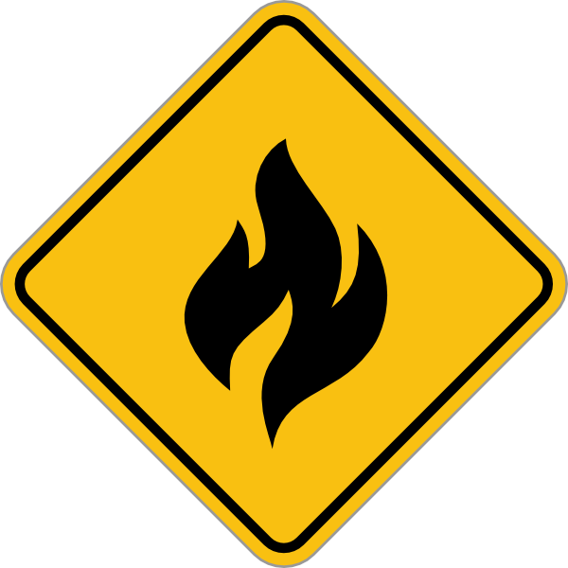

LIPO FIRE

SAND



LIPO FIRE

SAND





**DANGER: PROPS**

**DO NOT place body parts within propeller arc**

**LiPo Batteries**

Risk of Fire or

Explosion if Damaged



**LiPo Batteries**

Risk of Fire or

Explosion if Damaged



**DANGER: PROPS**

**DO NOT place body parts within propeller arc**



**LiPo Batteries**

Risk of Fire or

Explosion if Damaged



**DANGER: PROPS**

**DO NOT place body parts within propeller arc**

**LiPo Batteries**

Risk of Fire or

Explosion if Damaged



**DANGER: PROPS**

**DO NOT place body parts within propeller arc**



**LiPo Batteries**

Risk of Fire or

Explosion if Damaged



**DANGER: PROPS**

**DO NOT place body parts within propeller arc**

**LiPo Batteries**

Risk of Fire or

Explosion if Damaged





**DANGER: PROPS**

**DO NOT place body parts within propeller arc**

**LiPo Batteries**

Risk of Fire or

Explosion if Damaged



**DANGER: PROPS**

**DO NOT place body parts within propeller arc**

**LiPo Batteries**

Risk of Fire or

Explosion if Damaged





**DANGER: PROPS**

**DO NOT place body parts within propeller arc**

**LiPo Batteries**

Risk of Fire or

Explosion if Damaged



**LiPo Batteries**

Risk of Fire or

Explosion if Damaged



**LiPo Batteries**

Risk of Fire or

Explosion if Damaged



**DANGER: PROPS**

**DO NOT place body parts within propeller arc**

*Airborne GeoSciences*



**DANGER: PROPS**

**DO NOT place body parts within propeller arc**

**LiPo Batteries**

Risk of Fire or

Explosion if Damaged



**DANGER: PROPS**

**DO NOT place body parts within propeller arc**

**DANGER: PROP**

**DANGER: PROP**

**DANGER: PROP**

**DANGER: PROP**





Airborne GeoSciences Facility



Airborne GeoSciences Facility







Airborne GeoSciences Facility









Airborne GeoSciences Facility



Airborne GeoSciences Facility



Airborne GeoSciences Facility



Airborne GeoSciences Facility



Airborne GeoSciences Facility



Airborne GeoSciences Facility



Airborne GeoSciences Facility



Airborne GeoSciences Facility

