Marking a Turnitin Assignment in Learn - a staff guide.

The following instructions and information will help staff to mark a Turnitin assignment through Learn the University’s virtual learning environment.

Contents:
- Accessing the Turnitin assignment inbox.
- The feedback studio.
2.1. QuickMarks.
2.2. Feedback summary.
2.3. Rubric/form.
2.4. Select text.
2.5. Other assignment comments.
- Overall Grade.

1. Accessing the Turnitin assignment inbox.

- You can access the Turnitin assignment inbox from the course left hand menu under Course Management > Course Tools > Turnitin Assignments.

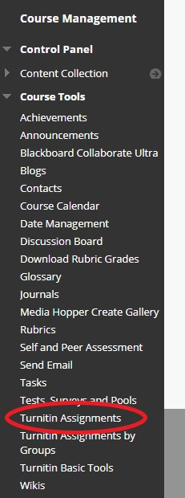
- From here, you will see all Turnitin assignment inboxes for the course. Select the inbox you wish to mark by clicking on the assignment name. For example, here I would click on Tii Test Assignment Jan 07, 2021.

- You will now see all submissions for the assignment inbox. Here you will see the author (unless anonymous marking has been selected), the submission title, the similarity score (if enabled), the grade (if the submission has been graded), the response (if the student has viewed the feedback), the file that has been submitted, paper ID and the date of the submission.

To open the assignment to mark click on the title or the pencil icon under grade. This will open the assignment in the feedback studio in another window.

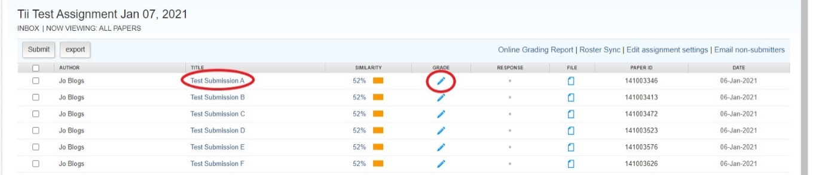

2. The feedback studio.

The feedback studio allows you to give written and verbal feedback on a submission, leave marks and comments on the assignment and use a rubric or marking scheme (this will have been added when the Assignment inbox was set up).

You are able to turn the marking layer (on/off). When on you will see any feedback you have left on the assignment, turning it off will hide this.

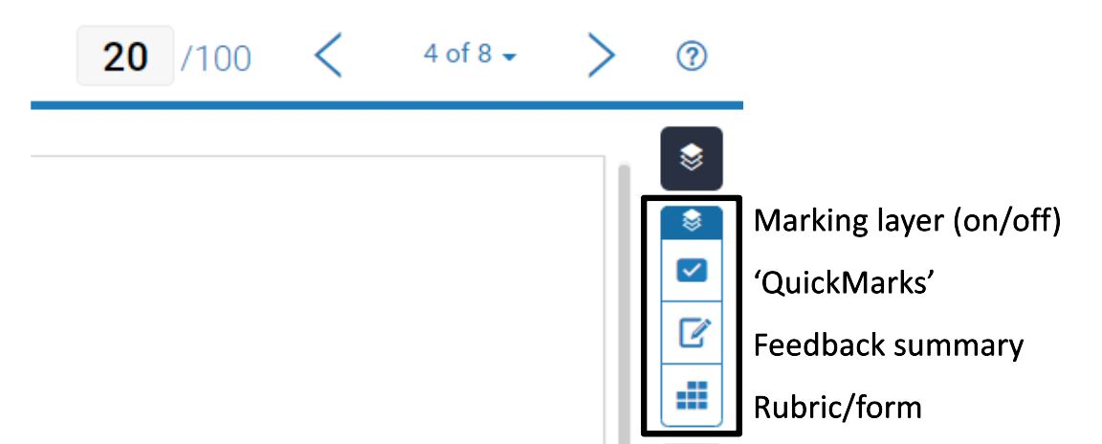

2.1 QuickMarks.

QuickMarks is a list of pre-loaded comments that you can apply to the submission by dragging and dropping onto a relevant part giving a description of the comment. You are also able to customise the comment by adding your own text giving a bit more feedback to the student. You are able to move the comment about or you can delete from here.

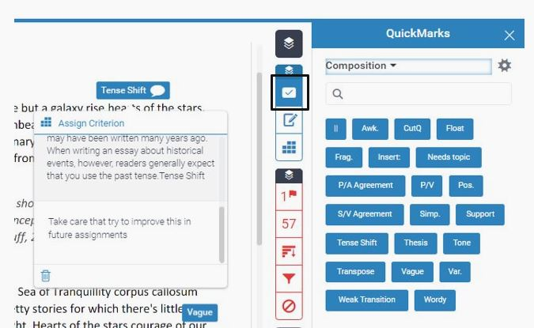

There are different sets of QuickMarks to choose from in the above example we are using Composition, but you can choose a different set from this drop down arrow such as Academic Integrity, Formatting and Commonly used.

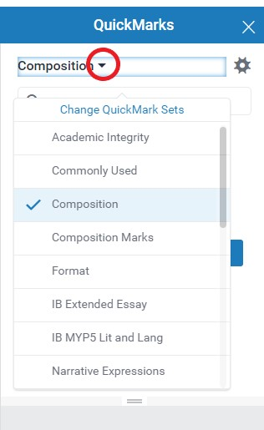

You are able to create your own QuickMarks sets by selecting the cogwheel. This will open in another window where you can add to a set or create your own.

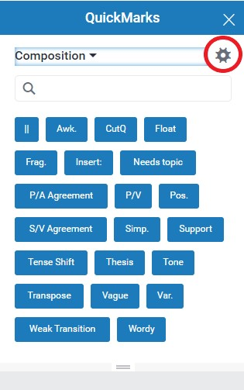

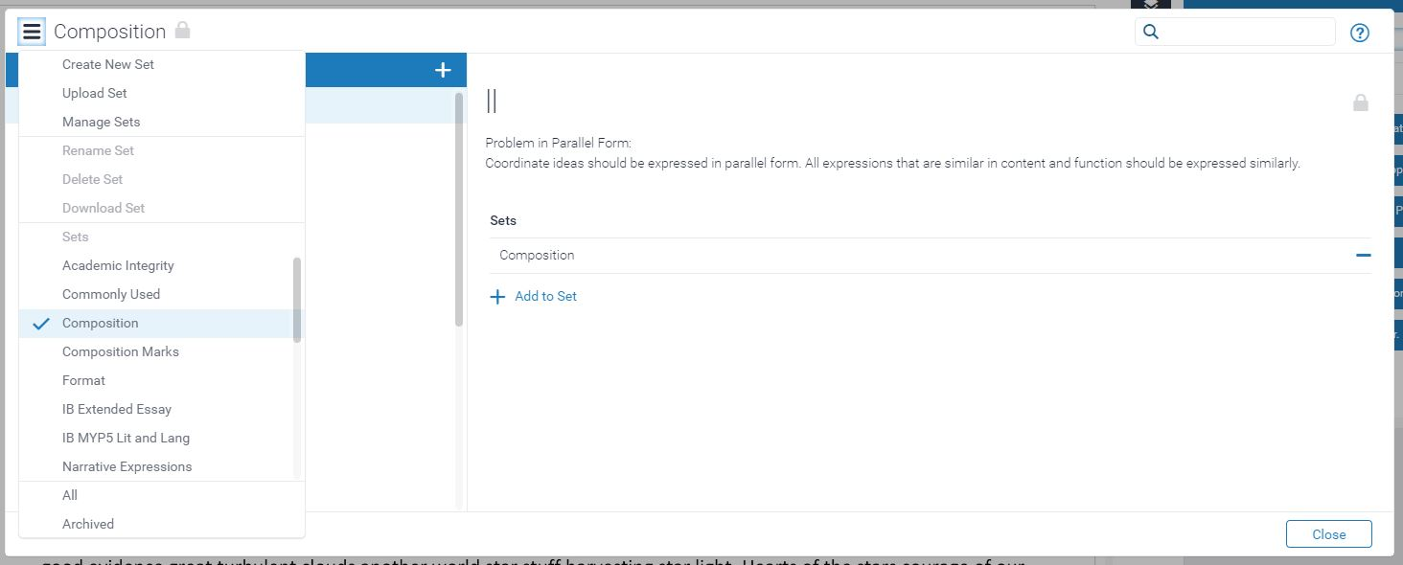

2.2 Feedback summary.

This is where you can add a longer more general comments on the assignment as a whole. Click in the comments box and start typing you have the use of basic formatting tools and hyperlinks. Please remember to click outside the box to save before moving on.

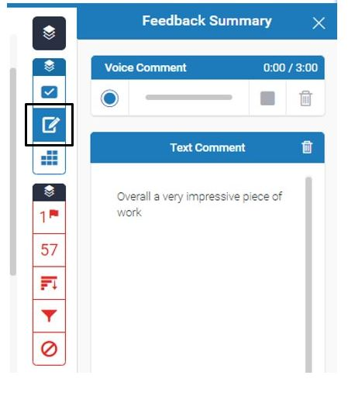

You are able to leave a three-minute audio comment here. If you have a microphone, you just click the record button and speak.

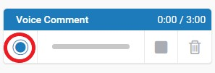

You are able to pause and resume the recording. Once finished click you can click stop.

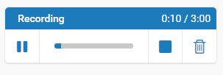

After clicking on stop, you can listen back to the recording, save to keep it or delete.

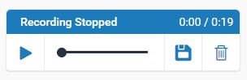

If you do leave an audio comment, please add the text equivalent to go with it to make it accessible.

2.3 Rubric/form.

If using a rubric it will have been added when the assignment inbox was set up. Your School/Programme or Course might make use of certain rubrics or marking schemes so please be aware of that.

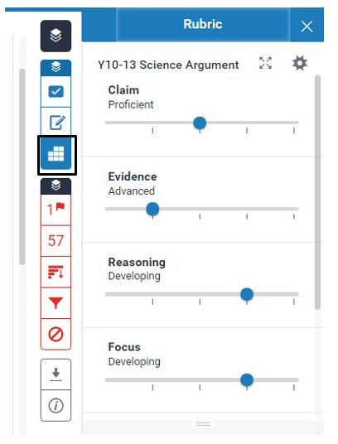

Make sure, if using a rubric that it is the correct one as if it is not and marking has already started you will not be able to replace it without losing all the marking done so far and cannot be recovered.

2.4 Select text.

You are able to highlight text within the submission then select from the menu of marking tools to add comments or feedback. Such as QuickMarks, Bubble comment or Strikethrough.

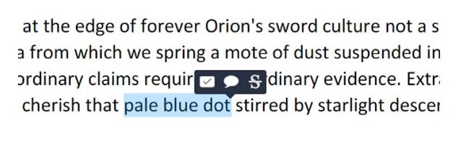
The Bubble comment opens up a free text box so you can type your comment. You can then click outside the box to apply. You have the option to convert this into a QuickMark if you want there will be an option at the bottom of the bubble that you can click on to Convert.

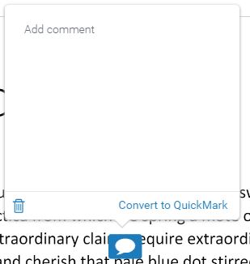
Strikethrough will strikethrough the text. If using this it would also be helpful to leave a comment on why you have done this for the student.

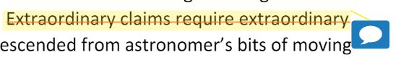

2.5 Other assignment comments.

You can select anywhere on the document that you would like to add feedback or comments to then select from the menu of marking tools. Such as QuickMarks, Bubble comment or inline comments.

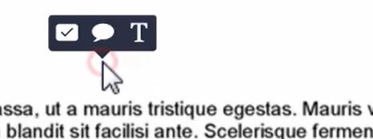

Inline comments are placed directly onto the document as overlaid text. They are always visible on top so you need to position them carefully to avoid obstructing text. You can click on them and move them around or click the bin icon to delete them.

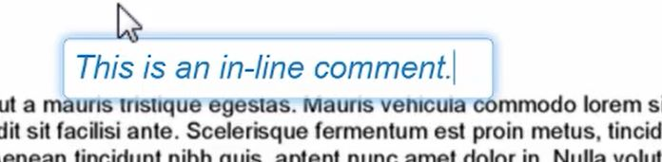

3. Overall grade

You are able to give the assignment an overall numeric grade by entering a score in the box at the top right of the Feedback Studio. Please remember to click outside the box to save before moving on.

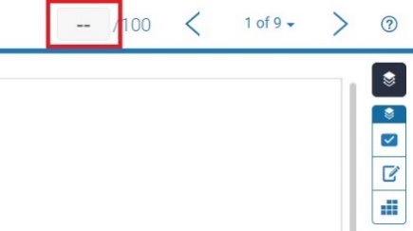

Once finished marking you can close the window.
If you require this document in an alternative format, such as large print or a coloured background, please contact the Turnitin service team email: ishelpline@ed.ac.uk.

