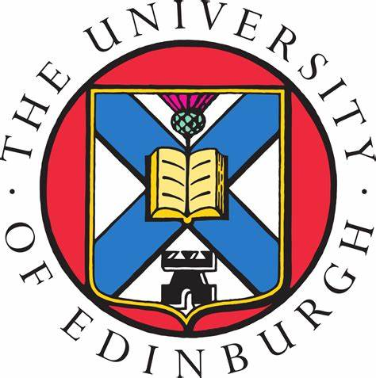 | The University of Edinburgh  College of Medicine and Veterinary Medicine

PReDICTED GRADES REQUEST FORM
INTERNATIONAL BACCALAUREATE (IB Diploma)

Please complete this form electronically where possible

Name of Applicant:
UCAS Personal ID Number:
School Name & Address:

OVERALL PREDICTED TOTAL SCORE (out of 45) TO INCLUDE TOK/EE

Subjects  (Please specify which subjects are taken at HL or SL) |  | Predicted Grades
Subject
Subject
Subject
Subject
Subject
Subject
Subject
Subject
Subject
Subject

Teacher’s Name: | Teacher’s Signature: | Date:

