LGBT HISTORY MONTH – FILM SCREENING
Ghost Empire § Singapore/Cyprus
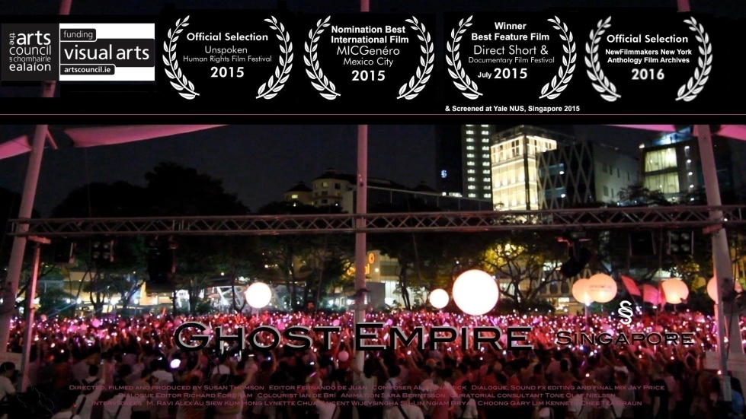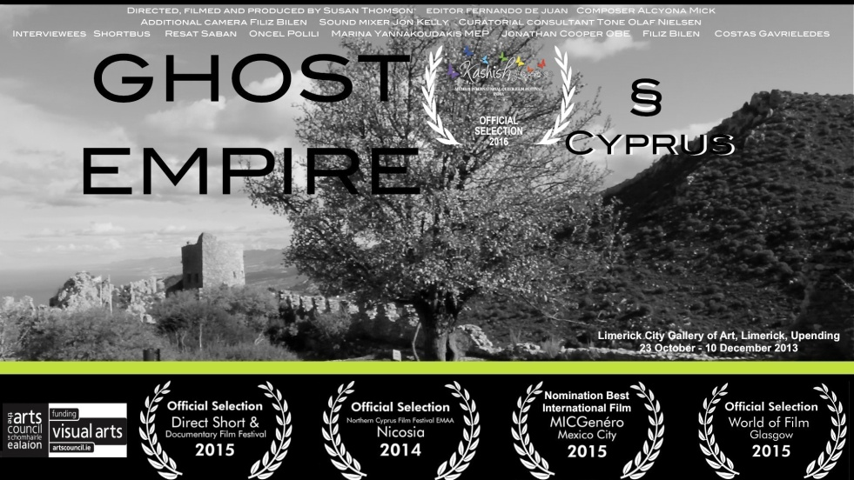
(dir. Susan Thomson, 2014)
Ghost Empire is a film project series, funded by the Arts Council of Ireland, exploring the legacy of British colonialism on LGBTI rights around the world. Currently around half of the countries which criminalize homosexuality (37 out of 76 countries) use British colonial laws from the 19th and early 20th centuries or revised versions of these laws. The trilogy of films follows legal challenges to these laws happening in three different continents, in Northern Cyprus, Singapore and Belize, and are the only films made about these court cases.
Director Susan Thomson will introduce the films – screening followed by Q&A

Thursday 23rd February, 6 – 9 pm SCREENING ROOM, G.04 – 50 GEORGE SQUARE
EVERYONE WELCOME For more information please contact Carole Jones: carole.jones@ed.ac.

