PERICORONARY ADIPOSE TISSUE ATTENUATION, LOW ATTENUATION PLAQUE BURDEN AND 5-YEAR RISK OF MYOCARDIAL INFARCTION

Introduction
Pericoronary adipose tissue (PCAT) attenuation has emerged as a surrogate marker of pericoronary inflammation. To date, no studies have compared the impact of pericoronary adipose tissue (PCAT) attenuation and quantitative plaque burden on cardiac outcomes. We aimed to establish the relative merits of these approaches to risk prediction and hypothesised that the combination of PCAT attenuation and quantitative plaque burden measures could provide additive and improved prediction of myocardial infarction in patients with stable chest pain.

METHODS
In a post-hoc analysis of a randomized controlled trial, we investigated the association between the future risk of fatal or non-fatal myocardial infarction and PCAT attenuation measured from CT coronary angiography using multivariable Cox regression models including plaque burden, obstructive coronary disease and cardiac risk score (incorporating age, sex, diabetes, smoking, hypertension, hyperlipidaemia and family history of cardiovascular disease).

Results
In 1697 evaluable participants (mean age 58±10 years), there were 37 myocardial infarctions after a median follow-up of 4.7 [interquartile interval, 4.0-5.7] years. Median low-attenuation plaque burden was 4.20[0-6.86] % and mean PCAT -76±8 Hounsfield units (HU). PCAT-RCA attenuation was higher in patients who suffered a myocardial infarction (-72.5±8.3 HU versus -76.5± 7.8 HU, p=0.0063), but there was no difference in PCAT-LAD (-76.3±8.6 HU vs -77.0±7.8 HU, p=0.54) or PCAT-LCx(-71.6±7.3 HU vs -73.3±7.7 HU, p=0.33). Patients sustaining a myocardial infarction also had higher total, non-calcified, low-attenuation and calcified plaque burden, higher Agatston calcium score, higher cardiovascular risk score and increased presence of obstructive disease on CCTA (Table 1).

On univariable analysis, PCAT-RCA attenuation was a predictor of myocardial infarction (HR 1.55, 95% CI 1.08 to 2.22, p=0.017), but PCAT-LAD or PCAT-LCx were not. Univariable analysis also identified the burden of non-calcified, low-attenuation and calcified plaque as well as Agatston coronary calcium score, presence of obstructive coronary artery disease and cardiovascular risk score were predictors of myocardial infarction (Table 2). Male sex, age and body-mass index were not predictors of future myocardial infarction (p=0.06, p=0.86 and 0.26 respectively). In multivariable analysis, only the low-attenuation plaque burden (HR 1.80, 95% CI 1.16 to 2.81, p=0.011, per doubling) and PCAT-RCA (HR 1.47 95%1.02 to 2.13, p=0.040, per standard deviation increment) remained predictors of myocardial infarction (Table 2).

Based on the Youden’s index of the ROC curves, the optimal cut-off of the right coronary artery PCAT attenuation was –70.5 HU for the primary endpoint of fatal or non-fatal myocardial infarction. Patients with PCAT-RCA above ≥–70.5 HU were nearly 2.5 times more likely to suffer a myocardial infarction (HR 2.45, 95% CI 1.23 to 4.80; p=0.001). Patients with low-attenuation plaque burden (greater than 4%) were nearly 5 times more likely to suffer a myocardial infarction (HR 4.87, 95% CI 2.03 to 11.78, p<0.0001). When the two metrics were combined, patients with both low-attenuation plaque burden >4% and PCAT-RCA ≥-70.5 HU were at the greatest risk of myocardial infarction (HR 11.7, 95% CI 3.3 to 40.9, p<0.0001), followed by those with low-attenuation plaque burden >4% and PCAT-RCA <-70.5 (HR 5.1, 95% CI 1.5 to 17.7, p<0.0001; Figure 1). In ROC analysis, low attenuation plaque burden was a stronger predictor of future fatal or non-fatal myocardial infarction than PCAT-RCA (area-under-the-curve, 0.71 (95% CI 0.62-0.81) to 0.75 (95% CI 0.65–0.8) (ΔAUC=0.04; p=0.01); Figure 2.

Conclusion
CT coronary angiography defined PCAT attenuation and low-attenuation plaque have marked and additive predictive value for the risk of fatal or non-fatal myocardial infarction.

Tables and Figures
Table 1. PCAT attenuation and quantitative plaque burden in patients with and without subsequent myocardial infarction.

 | No event | Event |  | p value
Plaque burden (%) | 38.9 [0 to 49.2] | 50.1 [43.0 to 53.8] | <0.001
Noncalcified plaque burden (%) | 35.4 [0 to 45.3] | 42 [37.39 to 48.95] | <0.001
Low-attenuation plaque burden (%) | 4.1 [0 to 6.7] | 7.4 [4.8 to 9.1] | <0.001
Calcified plaque burden (%) | 0.39 [0 to 2.69] | 3.18 [0.9 to 7.97] | <0.001
PCAT-RCA (HU) | -76.0 ± 7.8 | -72.5 ± 8.3 | 0.009
PCAT-LAD (HU) | -77.0 ± 7.8 | -76.2 ± 8.6 | 0.5432
PCAT-LCx (HU) | -73.3 ± 7.7 | -71.6 ± 7.3 | 0.3345
Agatston CACS (Agatston Units) | 19 [0 to 218] | 283 [59 to 1041] | <0.001
Obstructive disease | 416 (25%) | 19 (51%) | <0.001
Cardiovascular risk score (%) | 18 ± 11 | 22 ± 12 | 0.039

Median [interquartile interval], mean ± standard deviation or number (%).
CACS, coronary artery calcium score; HU, Hounsfield units; PCAT, Pericoronary adipose tissue attenuation.

Table 2: Univariable and multivariable analysis for the prediction of myocardial infarction
 | Univariable |  | Multivariable #
 | HR (95% CI) | P value | HR (95% CI) | P value
Total plaque burden* | 1.44 (1.15-1.18) | <0.0001 | 1.33 (0.97-1.82) | 0.0720
NCP burden* | 1.41 (1.14-1.75) | <0.0001 | 1.30 (0.96-1.75) | 0.0883
LAP burden* | 1.87 (1.36-2.57) | <0.0001 | 1.80 (1.16-2.80) | 0.009
CP burden* | 1.70 (1.26-2.12) | <0.0001 | 1.55 (0.92-2.63) | 0.1021
PCAT-RCA§ | 1.55 (1.08-2.22) | 0.0171 | 1.47 (1.02 – 2.12) | 0.0382
Cardiovascular risk score | 1.03 (1-1.05) | 0.0463 | - | -
Agatston calcium score* | 1.2 (1.1-1.3) | <0.0001 | - | -
Obstructive disease | 3.02 (1.6-5.8) | <0.0001 | - | -

# Multivariable analysis includes the individual quantitative plaque measure, Agatston calcium score, obstructive disease and cardiovascular risk score. Full model results are presented in Table i in the Data Supplement.
* Per doubling.
§ Per 1 standard deviation increment in PCAT attenuation.
CI, confidence interval; CP, calcified plaque; LAP, low attenuation plaque; HR, hazard ratio; PCAT-RCA, pericoronary adipose tissue attenuation around the right coronary artery.

Figure 1. Cumulative incidence of fatal or nonfatal myocardial infarction in patients with and without PCAT-RCA ≥ -70.5 HU and with and without low-attenuation (LAP) non-calcified plaque burden above 4%. Patients with LA plaque burden>4 % and PCAT-RCA≥-70.5 HU (purple line) were at the greatest risk of myocardial infarction (HR 11.7, 95% CI 3.3 to 40.9, p<0.0001), followed by people with LA plaque burden>4 % and PCAT-RCA<-70.5 HU (green line); HR= 5.1 (1.5 -17.7), p<0.0001.

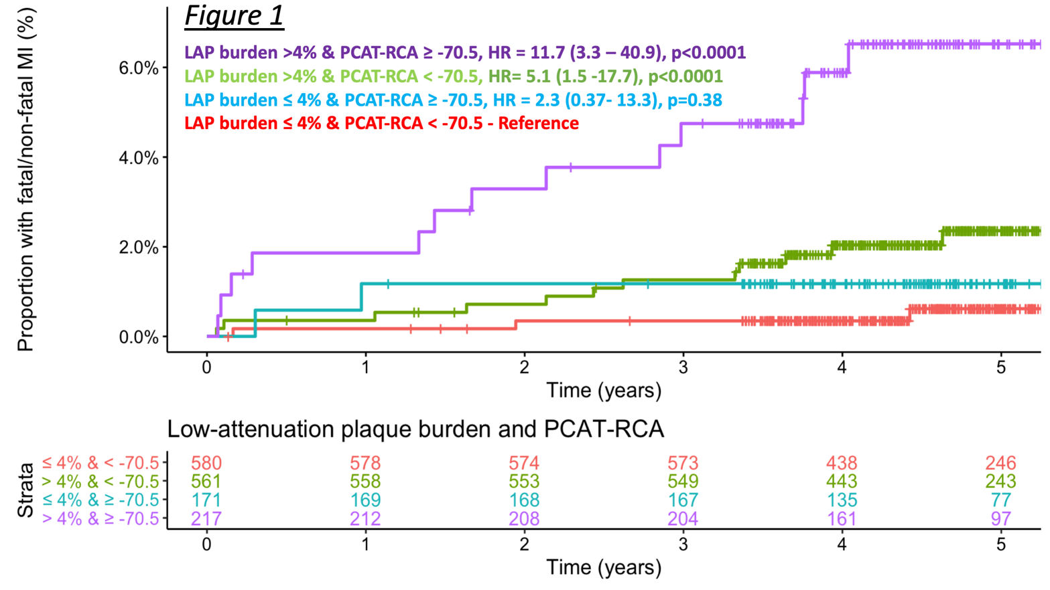

Figure 2: Comparison ROC curves (at 5 years) and respective area under the curve (AUC). LAP plaque burden is a stronger predictor comparted to PCAT-RCA. The combination of the two metrics increase the AUC to 0.75 (Δ_{AUC}= 0.04, p=0.01).

