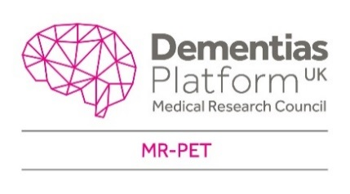

NRES: IRAS ID:

Title of Study
  - Participant consent form
Read each of the statements below. If you agree with the statement, please initial the box.

I have read and understood the participant information sheet (version .... dated .......) for this study. I have had enough time to think about taking part, and my questions have been answered. | Initial
I understand that taking part in this research study is my choice. I understand that I can stop taking part at any time, without giving any reason, and without my medical care or legal rights being affected. | Initial
I agree to undergo medical tests as part of this study. I understand what is involved in the tests. | Initial
I agree to have a PET-MRI scan. | Initial
I agree to members of the study team using my details to contact me, when it is needed for the study. | Initial
I agree to members of the research team seeing my medical files, when it is needed for the study. | Initial
I agree to my images and test data being shared in the Dementias Platform UK network. I understand that the images and data will not identify me. | Initial
I agree to my anonymised images and test data being used in other research and used by other researchers in the future. I agree to the Dementias Platform UK, and those who use its resources, using my anonymised data for future research. | Initial
OPTIONAL: If my dementia gets worse and I am no longer able to make decisions, I wish to carry on being part of this study | Initial
I agree to take part in this study. | Initial

____________________________________ ____________ ________________________
Name of participant Date Signature

____________________________________ ____________ ________________________
Name of consenting person Date Signature

