––––––––––––––––––––––––––––––––––––––––––––––––––
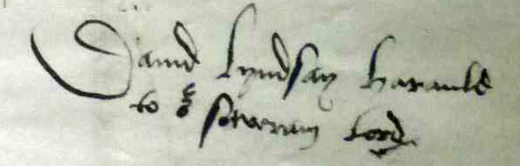
Sir David Lyndsay
Society
© British Library Board, MS. Cotton Caligula B. I. f. 313
––––––––––––––––––––––––––––––––––––––––––––––––––

The ‘Current Lyndsay’ Project

The aim: a Register of current Lyndsay research and related activities for Lyndsay Society members. It is hoped that such an overview will help members to exchange information and ideas; increase the potential for cross-disciplinary and multi-campus projects, or courses in which Lyndsay is taught; and highlight areas where research or teaching courses might usefully be initiated.

To achieve this: we’d be most grateful if you, as a member of the Sir David Lyndsay Society, would accept the invitation to complete the short questionnaire, as briefly or fully as you wish, and return it to the Secretary, at sarah.carpenter@ed.ac.uk. The Register will be based on the responses to the questionnaire. You will always be consulted before the information is shared.

Current Lyndsay: Research

1. Are you personally currently undertaking research on Lyndsay? Yes / No
Would you share your particular interests and topic/s?
(Please add your comments here)

2. Are you planning to undertake Lyndsay research in the future? Yes / No
Would you share your particular interests and topic/s?
(Please add your comments here)

3. Have you undertaken Lyndsay research in the past? Yes / No
Would you share your particular interests and topic/s?
(Please add your comments here)

4. Do you know of colleagues or postgraduates currently untertaking research
on Lyndsay? Yes / No
If possible, please pass on a copy of this questionnaire to these colleagues,
with a warm invitation to join the Society, so that they might also contribute,
and have access to news of other Lyndsay work, both in progress and planned.
Current Lyndsay: Teaching

1. Does Lyndsay appear on courses you are teaching, or which you know are taught in your institution? Yes / No

2. If so, which courses / departments / degree curricula include Lyndsay?

3. At what level is / are these courses taught (e.g. postgraduate; undergraduate; extramural / continuing education)?

4. Approximately how many students take these course/s?

5. How much time is devoted to Lyndsay?

6. Which Lyndsay texts are taught?

7. What editions of Lyndsay texts or materials are used?

8. Is the availability of student texts a consideration in whether / how much Lyndsay is taught?

In principle, would you be happy for the information you have provided in this questionnaire to be included in a ‘Current Lyndsay’ Register, to be made available to you and other members of the Sir David Lyndsay Society? Yes / No

Please add any comments you have on this survey, or the proposed Register.

