Creating a Turnitin Assignment inbox in Learn – a staff guide

The following instructions and information will help staff to create a Turnitin assignment inbox in Learn the University’s virtual learning environment.

Creating an Assignment inbox

1. Go to the assignment submission folder where the assignment is to be created.

2. Select the ‘Assessment menu’, from the dropdown toolbar.

3. Select ‘Turnitin Assignment’.

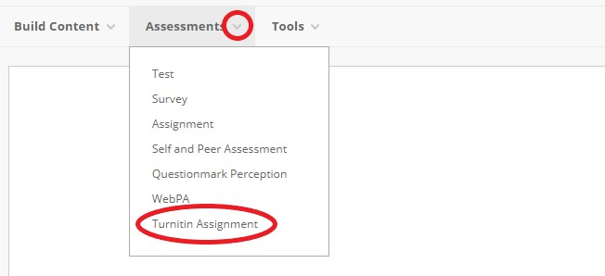

4. The Turnitin assignment creation page will open within the Learn interface. Select ‘Paper Assignment’ and click on ‘Next Step’.

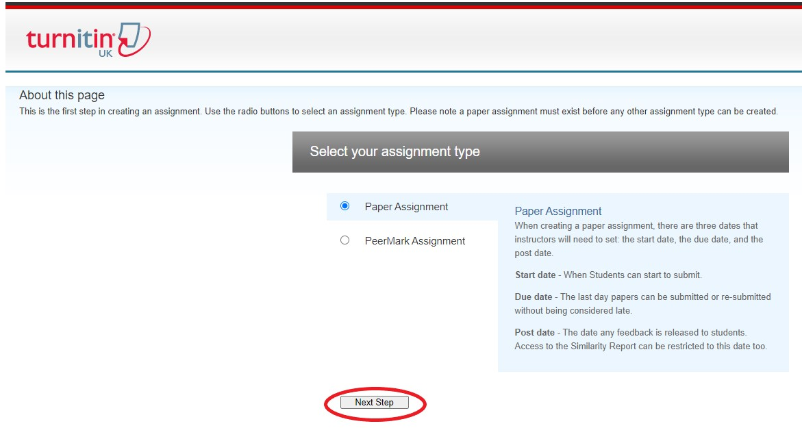

Basic Settings

To create the assignment, enter an assignment title, decide on the points value (optional), chose a start, due and post date and time.

Assignment title:

- Make sure this uses the same wording that you have used elsewhere in the course and is easily distinguished from all other assignments.

Points Value:

- This allows the setting of a point value for the assignment.
- Setting a point value allows the grade to be set by rubrics (if used) and be sent to the gradebook.

Start date:

- The date and time students can start submitting the assignment.

Due date:

- This is the date and time that the students’ papers are due for the assignment.
- Students cannot submit after this date and time unless late submissions are enabled (see Optional Settings).

Post date:

- The date and time students can start viewing instructor feedback.

Allow only file types that Turnitin can check for similarity / Allow any file type:

- Only certain file types will generate a similarity report (see the TurnitinUK website for full list, opens in a new window)
- Non-supported file types may still allow for the use of grading tools
- All files will be available for download

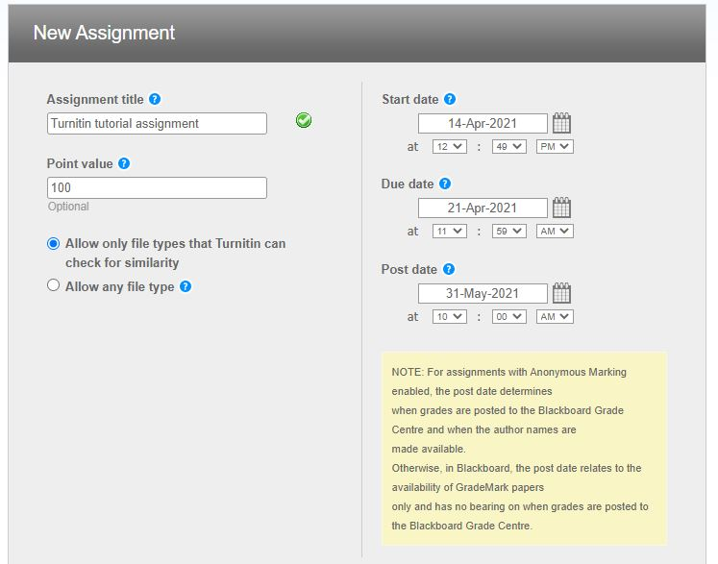

Optional settings

To view the advanced assignment options, click on the Optional settings link at the bottom of the assignment creation or the assignment update page.

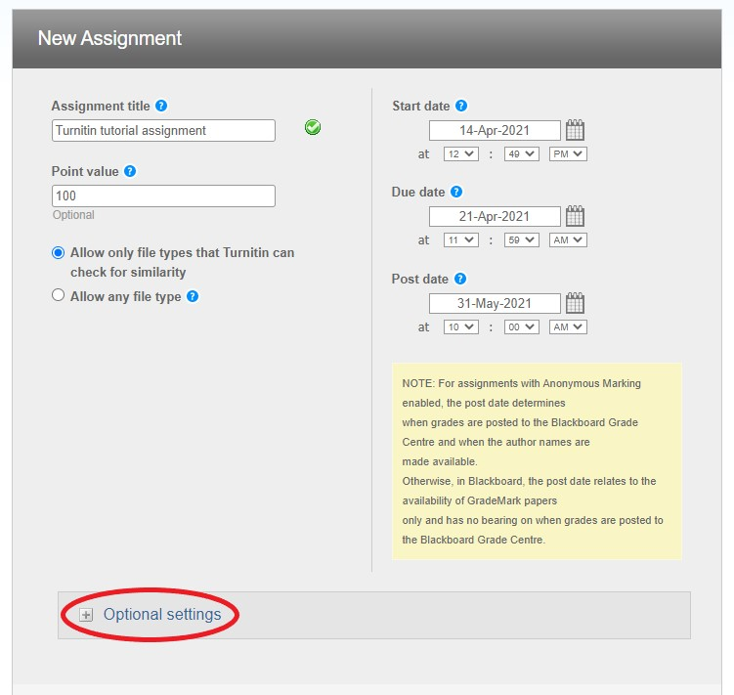
Optional settings is where you can set specific settings for the Turnitin inbox. You are able to leave special instructions, adjust similarity report settings and add a rubric or grading form.

Enter special instructions:

- Any specific instructions to the student regarding the assignment.

Allow submissions after the due date?:

- If set to ‘no’ then students will be prevented from submitting after the due date, so no late submissions will be accepted.
- If set to ‘yes’ this will accommodate both students submitting late, and students who have been given an extension. Students who have already submitted will not be able to resubmit after the due date.

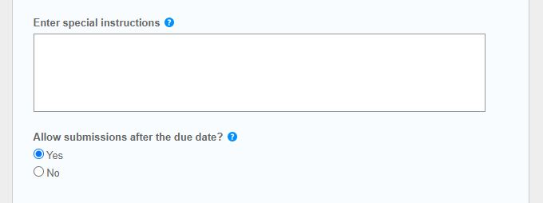

SIMILARITY REPORT

Generate Similarity Reports for submissions?:

- Set to ‘no’ if you do not want to generate Similarity Reports.

Generate Similarity Reports for student submissions…:

- ‘Immediately first report is final’ - Students can submit once to the assignment and a Similarity Report will be produced immediately.
- ‘Immediately (can overwrite reports until due date)’ - Students can submit multiple times (until the due date) and receive a new Similarity Report. After three resubmissions, students will need to wait 24 hours to see a new report.
- ‘On due date’ - A Similarity Report will be generated after the due date of the assignment has passed. This allows submissions to the same assignment to be checked against each other.

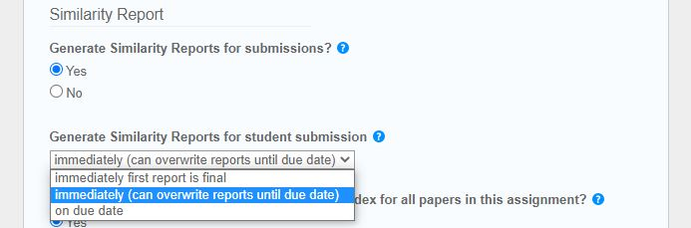

Exclude bibliographic materials from Similarity Index for all papers in this assignment?:

- Excludes text in bibliography, works cited or references sections of the submission.
- This can be overridden by staff when viewing the individual Similarity Report.

Exclude quoted materials from Similarity Index for all papers in this assignment?:

- Excludes text in quotation marks.
- This can be overridden by staff when viewing the individual Similarity Report.

Exclude small sources?:

- Length can be set in terms of word count or percentage.
- This can be overridden by staff when viewing the individual Similarity Report.

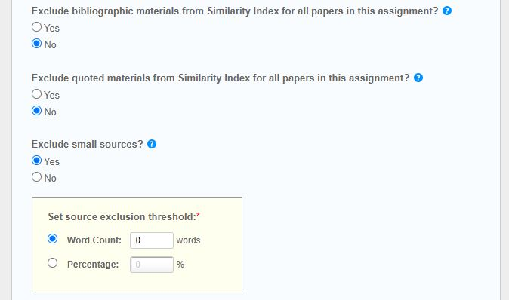

Allow students to see Similarity Reports?:

- This allows students to be able to see their own Similarity Report.

Reveal grades to students only on post date?:

- This means that students will all receive their grades and feedback at the same time.

Enable anonymous marking?:

- Applies a mask to student’s personal information until the post date.

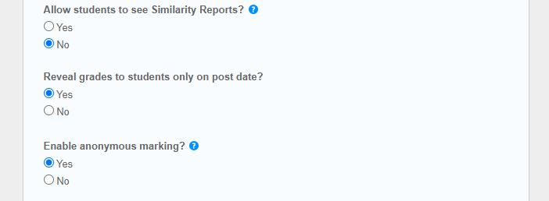

Submit papers to:

- Standard paper repository - Turnitin will add a copy of the submitted document to its standard repository (so other submissions can be checked against it).
- No repository.

Search options:

- Student paper repository
- Current and archived internet
- Periodicals, journals, & publications

ONLINE GRADING

Attach a rubric/form to this assignment:

- Select from previously created or imported rubrics when marking submissions to this drop box
- Once marking has started, the rubric cannot be removed or changed without all the previous marking of submissions to this drop box being lost.

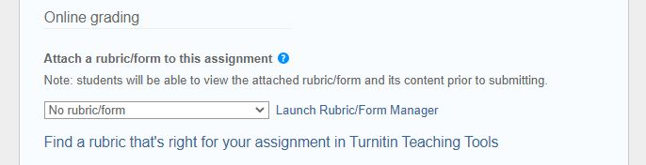

Before submitting and creating your inbox, you have an opportunity to save your defaults for future assignments. To do so tick the box.

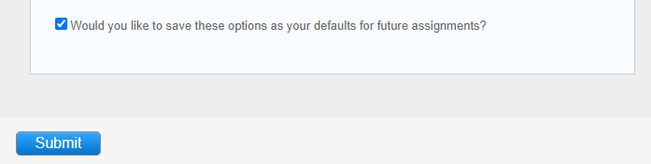

To complete the assessment inbox, select ‘Submit’

Prevent false notifications of late submission being sent to students

This will prevent Learn issuing overdue notifications for that specific assessment (which it can do for student who should not receive them, which causes confusion).

Remove the due date from the Learn Grade:

- Navigate to the Grade Centre in the left hand menu

- Select ‘Full Grade Centre’

- Select column dropdown for the assignment inbox > Edit column information

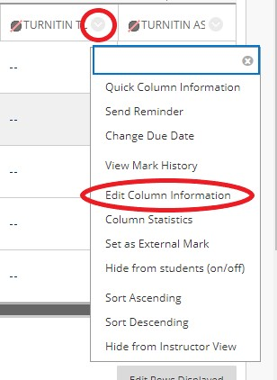

- Dates > Untick Due date

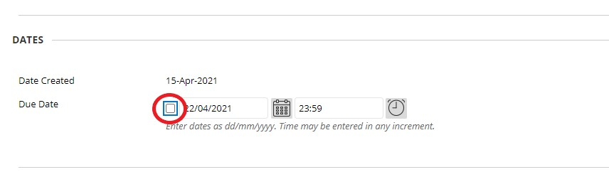

- Click ‘Submit’

If you require this document in an alternative format, such as large print or a coloured background, please contact the Turnitin service team email: ishelpline@ed.ac.uk.

