Edinburgh Clinical Neurology Course 2019 CPC

A 74-year-old previously well retired manager attended the Emergency Department on 12.11.18 with a one month history of progressive bilateral leg weakness and two weeks of vertigo with nausea and vomiting. She had lost 2 kg over this time with reduced appetite. She described prior coryzal symptoms, followed by progressive left ear deafness, neck pain worse on flexion and intermittent frontal headache. She reported a possible tick bite in early October. Her only medication was vitamin D, she was an ex-smoker, drank alcohol in moderation and had not travelled outside Scotland for several years. On examination, she had bilateral arm intention tremor, 4+/5 power on left hip flexion and extension with left leg ataxia and positive Romberg’s. Investigations were unremarkable and she was discharged with a walking stick. She was readmitted on 15.11.18 with urinary retention, worsening gait, leg cramps, bilateral hand tremor and constipation. The examination was unchanged. On 19.11.18, she required urinary catheterisation and was noted to have worsening left leg weakness 3-4/5, flexors preferentially affected. By 22.11.18 she was unable to move either leg and had periods of hypotension, constipation and confusion. She was reviewed by a consultant neurologist on 23.11.18. She was afebrile, rambling and unable to draw a clock face or spell WORLD backwards, although naming and orientation to day and month were intact. Cranial nerve examination was normal. There was left upper limb intention tremor, the rest of her upper limb examination was normal. Tone in her legs was normal, movement was limited to minimal knee extension and wiggling toes. Deep tendon reflexes were normal. Left plantar response was extensor, right mute.

She received Pabrinex and after CSF results, IV ceftriaxone, amoxicillin and aciclovir (see antimicrobial history below). She developed a swinging pyrexia from 25.11.18 with tachycardia and hypotension. She was noted on 27.11.18 to have a sensory level to T6. Blood stained dark urine was noted and bloods confirmed acute kidney injury on 29.11.18. She was reviewed by infectious diseases on 30.11.18. She developed diarrhoea and treated for confirmed enterococcus urinary tract infection. On 6.12.18, she became acutely unwell with hypoxia, pyrexia and hypotension, but no new neurological symptoms. Chest XR showed left basal effusion, she was treated for hospital acquired pneumonia. Over the subsequent 2 weeks, she had fluctuating cognition, pyrexia, tachycardia and hypotension. She was able to draw a clock face accurately on 11.12.18.

She was transferred to a neurology centre on 19.12.18. She was neurologically unchanged, continued to have fluctuating pyrexia, tachycardia, hypotension and hypoxia with increasing oxygen requirements. LP was performed on 21.12.18 (see below). Following systemic and haemodynamic deterioration, she was transferred to Intensive Care on 23.12.18. She had had intermittent requirements for noradrenaline and adrenaline. She was stepped down to Neuro HDU on 24.12.18 and received 5 days of 1g methylprednisolone. She was noted to have a sacral sore with necrotic skin and surrounding erythema extending to buttock but no active signs of infection or pus. On 27.12.18, she was noted to have a PaO2 of 9.8 on 2L Oxygen and Lactate of 4.7 (arterial blood gas). She had transient episodes of central chest pain, breathlessness and severe hypertension, but required noradrenaline to maintain her MAP above 60. She had transient narrow complex tachyarrhythmia.

- 29.12.18: developed acute thrombocytopenia. Neurologically unchanged. Enoxaparin switched to treatment dose fondaparinux.
- 30.12.18: worsening type 1 respiratory failure. Developed new petechial, non-blanching rash on trunk. All antibiotics stopped. NG inserted. Fondaparinux dose reduced to prophylactic dose.
- 31.12.18: NG feed started including thiamine and forceval.
- 2.1.19: became confused and flushed. Blood tests revealed rising white cell count, inflammatory markers and lactate. Urine output dropped. Overnight became less responsive, clammy and unwell.
- 3.1.19: died, attributed to overwhelming sepsis with an underlying central nervous system disorder of unknown aetiology. An autopsy took place.

Antimicrobial courses November 2018 - January 2019
Ceftriaxone 23.11.18 – 30.11.18
Aciclovir 23.11.18 – 30.11.18
Amoxicillin 2g 4 hourly 23.11.18 – 30.11.18
Amoxicillin 1g TDS 30.11.18 – 4.12.18
Amoxicillin 6.12.18 – 9.12.18
Gentamicin 6.12.18 – 9.12.18
Tazocin 9.12.18 – 12.12.18
Ceftriaxone 12.12.18 – 21.12.18
Metronidazole 13.12.18 –21.12.18
Meropenem 21.12.18 – 30.12.18
Gentamicin 21.12.18 – 21.12.18
Doxycycline 22.12.18 – 30.12.18
Tazocin 2.1.19 –
Vancomycin 2.1.19 –

Investigations
Blood tests:
See table for FBC, U&E, CRP and lactate

- 16.11.18 Haematocrit 0.403, MCV 90 fL
- 19.11.18 Normal calcium. Albumin 31, CK 11 U/L (30-135)
- 17.12.18 Coag screen: PT 15, INR 1.2, Fib 4.3 (1.5-4), APTT normal
- 27.12.18 LFTs: Bil 8, ALT 7, ALP 89, GGT 37 (5-35 U/L), Albumin 18 g/L
- 29.12.18 LDH 1143 U/L. Coagulation screen normal.
- 30.12.18 corrected calcium 2.33, albumin 17. Ferritin 1166 microgram/l. Iron 9.3 umol/l, Transferrin 1.16 g/l, Transferrin sats 31% Folate 2.1 (2.8-20)
- Urine Bence Jones protein type kappa light chains present in urine <0.03 g/L
- ANA 1/80 Speckled

Normal or negative tests:
- Phosphate, early morning cortisol, immunoglobulins and serum free light chains, protein electrophoresis, thyroid function test, serum urate, amylase, Vitamin B12, serum ACE, MPO-ANCA,PR3-ANCA, C3, C4 levels, ENA, Fixed NMDAR ab, VGKC antibodies, HIT screen
- HIV/Borrelia/antitreponema serology, EBV/CMV/HSV1/HSV2/VZV PCR

Admission 12 lead ECG: Sinus rhythm

Imaging
- CT head 12.11.18: Early small vessel change only
- XR Chest 15.11.18: Bilateral hilar elevation due to post inflammatory scarring and volume loss in each lung apex. Lungs emphysematous.
- MRI head with gadolinium 19.11.18: Areas of increased signal intensity on T2-weighted imaging bilaterally in the cerebral white matter in the centrum semiovale, most prominent in the right parietal lobe and left frontal lobe, in keeping with areas of small vessel ischaemic change. Normal vascular flow voids demonstrated in the circle of Willis and dural venous sinuses.
- MR whole spine 21.11.18: Normal cord signal with no evidence of focal inflammatory lesion.
- CT chest/abdo/pelvis with contrast 23.11.18: Unremarkable.
- US kidneys 30.11.18: Normal
- Transthoracic echocardiogram 4.12.18: Normal
- MR brain and spine with gadolinium 5.12.18:
  - Brain: Multiple white matter hyperintensities, more acute looking in the left parietal lobe. Faint enhancement of this lesion centrally, further loci in right frontal subcortical and deep white matter.
  - Spine: Questionable cervical white matter change, small T5 intrinsic cord lesion with likely enhancement.
Radiologists concluded appearances suggested active inflammatory change rather than small vessel change.
- CT Chest/abdo/pelvis with contrast 23.12.18: Moderate to large bilateral pleural effusion, small volume of ascites and widespread subcutaneous oedema in keeping with a positive fluid balance.
- XR calcaneum and sacrum 24.12.18: normal.
- XR Chest 2.1.19: Progressive bilateral lower zone consolidation, worse on the right. Moderate right-sided pleural effusion, increased from previous.
CSF
- CSF 23.11.18: Opening pressure 11 cm H20. WCC 10 RCC 311. Protein 1.41 (small pellet of red blood cells visible after centrifugation). Glucose 3.1 (Plasma 5). No oligoclonal bands. No organisms seen. Viral PCR negative (Enterovirus, HSV1/2, Parechovirus, VZV PCR)
- CSF 21.12.18: Unable to lie flat due to breathlessness, no opening pressure recorded. WCC3 RCC 0. Protein 0.86, Glucose 2.9 (plasma 5.4) multiple matched oligoclonal bands. No growth. Mycobacteria, Viral PCR, mycology and cryptococcal antigen negative. Cytology: no evidence of malignancy or inflammation.

Microbiology:
- Serial Blood cultures: Negative
- C&S Urine 17.11.18 Mixed organisms.
- Urine 23.11.18: Enterococccus species >100,000 cfu/ml. Sensitive to Amoxicillin and Nitrofurantoin.
- Urine 30.11.18: Yeasts greater than 100,000 cfu/ml.
- Urine 8.12.18: Mixed organisms >100,000 cfu/ml.
- Faeces M,C&S negative, norovirus, C diff, adenovirus, enterovirus, parechovirus negative.
- Throat swab C&S and MRSA: negative

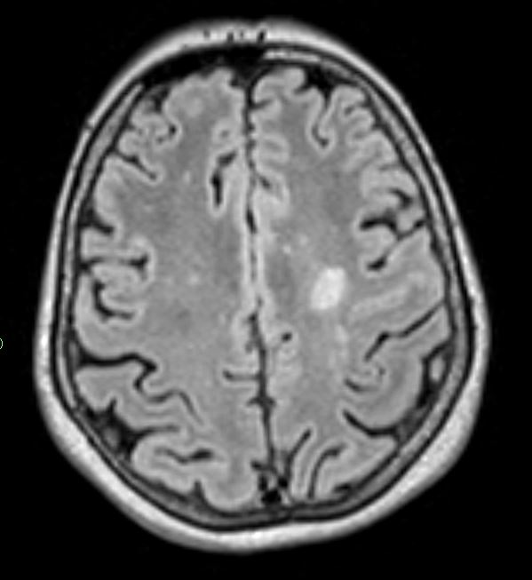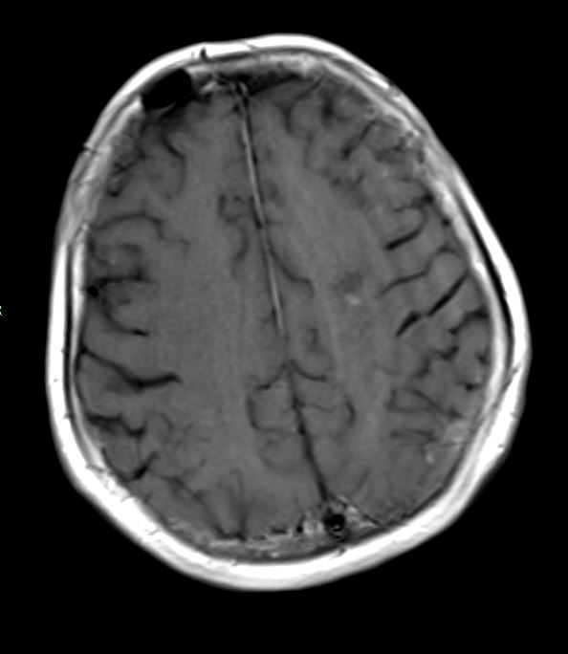
MR brain 5.12.18: (left) Axial FLAIR, (right) T1 axial with gadolinium.

 | 16.11.18 | 23.11.18 | 30.11.18 | 6.12.18 | 16.12.18 | 25.12.18 | 26.12.18 | 28.12.18 | 1.1.19 | 2.1.19
Haemoglobin (g/L) | 137 | 165 | 106 | 103 | 113 | 114 | 152 | 100 | 97 | 103
WCC (x10⁹/L) | 8.6 | 16.2 | 9.5 | 8.3 | 8.3 | 16.8 | 22.1 | 16.4 | 10.5 | 19.8
Neutrophils (x10⁹/L) | 5.87 | 10.51 | 6.50 | 5.35 | 5.18 | 11.77 | 16.42 | 13.46 | 7.78 | N/A
Lymphocytes (x10⁹/L) | 1.42 | 4.21 | 0.67 | 0.88 | 1.07 | 1.77 | 1.59 | 0.95 | 0.94 | N/A
Monocytes (x10⁹/L) | 1.26 | 1.28 | 1.41 | 1.98 | 1.91 | 3.28 | 4.06 | 1.96 | 1.61 | N/A
Eosinophils (x10⁹/L) | 0.03 | 0.15 | 0.12 | 0.06 | 0.05 | 0 | 0 | 0 | 0.03 | N/A
Basophils (x10⁹/L) | 0.01 | 0.05 | 0.01 | 0.01 | 0.04 | 0.01 | 0.03 | 0.04 | 0.17 | N/A
Platelets (x10⁹/L) | 200 | 381 | 216 | 227 | 172 | 185 | 152 | 62 | 39 | 57
Urea (mmol/l) | 8.7 | 7.4 | 9 | 6.7 | 6 | 7.8 | 8 | 10.8 | 15.7 | 17.5
Sodium (mmol/l) | 137 | 134 | 136 | 138 | 135 | 131 | 135 | 132 | 133 | 135
Potassium (mmol/l) | 4.2 | 4.3 | 4.1 | 4.3 | 4.5 | 4.2 | 3.9 | 3.7 | 4.3 | 5
Creatinine (umol/l) | 66 | 57 | 211 | 65 | 59 | 47 | 46 | 46 | 42 | 62
eGFR (/1.73m²) | >60 | >60 | 20 | >60 | >60 | >60 | >60 | >60 | >60 | >60
CRP (mg/l) | N/A | 22 | 112 | 56 | 132 | 85 | 54 | 52 | 149 | 205

 | 22.12.18 | 23.12.18 | 24.12.18 | 27.12.18 | 28.12.18 | 29.12.18 | 30.12.18 | 31.12.18 | 2.1.19
Lactate (mmol/L) | 2 | 3.3 | 1.5 | 3.9 | 4.3 | 5.6 | 5.4 | 7 | 15

