Accounting for multiple clause negators in Construction Grammar

In Construction Grammar, reference to a negation construction usually more accurately describes a negative verbal clause construction (Croft, 2001: 25-7; Ross, 2008). For example, Croft (2001: 25-7) discusses the [Sbj Aux-n't Verb] construction for negative intransitive clauses like I didn’t sleep, which, according to Croft, is formed by means of multiple inheritance from the negation construction [Sbj Aux-n't Verb] and the intransitive construction [Sbj IntrV]. Similarly, Croft and Cruse (2004: 320-2) posit that affirmative imperatives have a negative counterpart under the same schema:

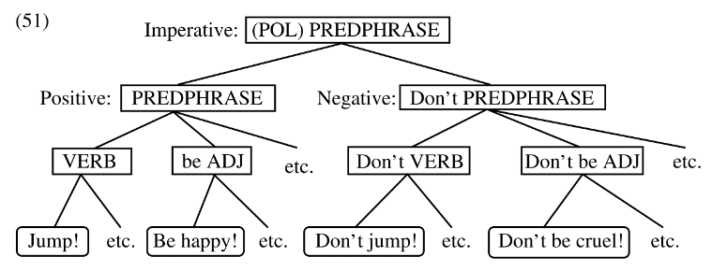
Croft and Cruse, 2004: 321

However, models of schemas like that above do not capture the paradigmatic relations between different negators that co-exist in languages as a result of changes to the expression of clause negation. For example, Zwicky and Pullum (1983) show that there are syntactic, semantic and pragmatic differences between the English canonical basic clause negator not and affixal (as they argue) n’t. This suggests that there are at least two clause negator micro-constructions in English, and it is not clear how they may interact with schemas like that above.

In this talk, then, I explore the factors that may play a role in the use of one negator over another in a language that has multiple clause negator micro-constructions. Data show that late nineteenth-century Milanese has three clause negator micro-constructions: preverbal non (i), and postverbal minga (ii) and no (iii).

- Tàs che non la senta.
quiet.imp that neg she hear
‘Quiet so she doesn’t hear.’
- L'=è minga lú!
it =cop neg him
‘It’s not him!’
- Te vedet no che fann aposta?
you see neg that do right
‘Don’t you see that they are doing the right thing?

A qualitative analysis demonstrates that use of these negators is determined by syntagmatic relations with specific sets of verbs and clause constructions, as well as by discourse pragmatic functions. I suggest that each clause negator micro-construction is associated with different constructional schemas in the language network through these relations (cf. the four types of associative links in Schmid, 2016), adding another layer of complexity to models like that above. I also argue that these relations lead to the constructionalization (Traugott & Trousdale, 2013) of the discourse marker-like mi soo no ‘I don’t know’ construction. Finally, time permitting, I will consider the possibility of an abstract negation schema to which clause negator micro-constructions may belong.
References

Croft, W. (2001). Radical Construction Grammar: Syntactic Theory in Typological Perspective. Oxford University Press.
Croft, William, & Cruse, A. (2004). Cognitive Linguistics. Cambridge University Press.
Ross, M. (2008). Negative verbal clause constructions in Puyuma: Exploring constructional disharmony. In A. Bergs & G. Diewald (Eds.), Constructions and Language Change (pp. 171–193). de Gruyter. https://doi.org/10.1515/9783110211757.171
Schmid, H. J. (2016). A framework for understanding linguistic entrenchment and its psychological foundations. Entrenchment and the Psychology of Language Learning: How We Reorganize and Adapt Linguistic Knowledge, 9–35. https://doi.org/10.1515/9783110341423-002
Traugott, E. C., & Trousdale, G. (2013). Constructionalization and Constructional Changes. In Constructionalization and Constructional Changes. Oxford University Press. https://doi.org/10.1093/acprof:oso/9780199679898.001.0001
Zwicky M, A., & Pullum K, G. (1983). Cliticalization vs inflection, English n’t. In Language (Vol. 59, Issue 3, pp. 502–513).

