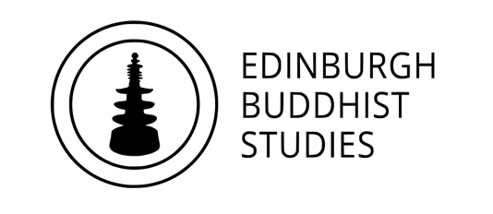
The Khyentse Foundation Buddhist Studies PhD scholarship 2020
University of Edinburgh

Before submitting this form, please read the full information about this scholarship on the website: www.ed.ac.uk/buddhist-studies/study/khyentse-foundation-phd-scholarship

Complete all fields below and email as a word or pdf attachment to Buddhist.studies@ed.ac.uk by 14th June 2020, 22:00GMT. You must also have submitted an application for PhD study at the University of Edinburgh by the end of May 2020, and meet the entry requirements for PhD laid out on the relevant University webpages (www.ed.ac.uk/studying/postgraduate). This includes a high quality relevant Masters programme, and proof of English language competence. You do not need to wait for official acceptance of your PhD application before submitting the scholarship form.

If shortlisted for the scholarship, we will also review your full research proposal, writing sample and references from your PhD application. We may also invite shortlisted candidates to a brief online interview.

We will aim to notify the successful candidate by the end of June 2020.

Personal statement (maximum 500 words)
This should include why you are interested in this scholarship, why you feel you are well qualified, and how you think it might affect your career prospects.

Relevant qualifications and skills (maximum 500 words)
Please list your most recent and relevant academic qualifications and grades, and any other stills or training relevant to your field of proposed research (such as language skills, research methods, specialist software, etc). If you have not yet completed your Masters degree please tell us about what you are studying currently and what outcome you anticipate.

Research topic (maximum 750 words)
Give a brief overview of your proposed research. Note that, if shortlisted, we will also review your full research proposal via your PhD application.

Why Edinburgh? (maximum 250 words)
Tell us which supervisor(s) you wish to work with and why, and how being part of Edinburgh Buddhist Studies might benefit your project and career. You may wish to review the EBS website when writing this section: www.ed.ac.uk/buddhist-studies

Any other relevant considerations (maximum 500 words)
Use this space to tell us anything else relevant to your application, including if your application or current studies have been affected by the COVID-19 pandemic, or if you have experienced other circumstances that may need to be taken into account.

