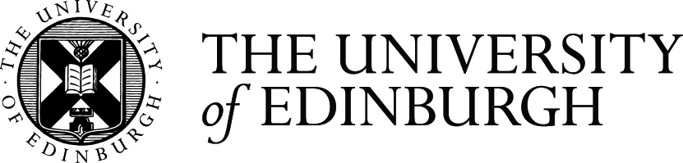

Brand Case Study

The Careers Service: Staying on brand yet creating your own personality

What was the challenge?
The Careers Team wanted to see the wood from the trees! There was a mish mash of messaging, images, identities, copy structure, and communication channels. It was affecting their communication, visibility and understanding of what they offered –key stakeholders were both confused and overwhelmed. The ‘brand’ did not look professional and certainly not suggestive of a high performing, top class service.

What were the objectives?
Create clear, consistent, targeted messaging
Identify and manage effective communication channels
Bring the Careers team on board
Stay on University brand and identity

What was the solution?
A clearly articulated brand architecture
A realistic & robust communications strategy
A well thought out and consistently implemented visual brand language
An appropriate marketing strategy to support and deliver against the communications strategy - initiated by the communications consultant, and continued in-house

What did you do?
The Careers Team had attempted a similar exercise previously so they knew they needed external help. They brought in a communications consultant who planned, facilitated and helped them through their journey. It was key that the whole service was involved and contributed to team building and shared understanding.

How did you do it?
The Careers Team held leadership workshops, researched their audiences, re-imagined their vision and mission, crafted their personality, values and proposition.
This then helped them to create clear, consistent, targeted and ‘owned’ messaging. They ‘owned’ it by creating a visual look and feel that was unique to them, distinctive to their audience and yet reflected the world-class university that they represent.

What was the impact?
The Careers Team now has a clear understanding of their united mission and vision. They have created Communications and Marketing group with cross-team representation, to ensure consistency and conformity with the brand and provide ongoing support and momentum. The group conducted a small staff survey 6 months after launch, which showed staff were very positive and could see real change. Anecdotal feedback has been similarly positive and there has been good student engagement.

Who was involved?
Careers Team, Student stakeholders, Service stakeholders & Communications & Marketing.

For more information on the University brand see: www.ed.ac.uk/communications-marketing/resources/university-brand or contact deepthi.dsw@ed.ac.uk

