Accessing your similarity report on a Turnitin assignment in Learn - a student’s guide

The following instruction and information will help students access their similarity report on a Turnitin assignment in Learn the University’s virtual learning environment.

1. Accessing the Turnitin assignment
After the assignment post-date your grade and feedback can be accessed through the Turnitin assignment. You can access Turnitin assignments from course content pages in Learn. Turnitin assignments can be identified by the Turnitin logo to the left of the assignment.

To open the Assignment, click on ‘View/Complete’

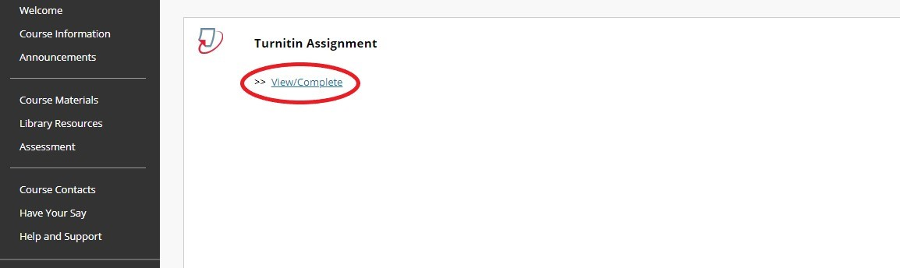

2. Turnitin assignment inbox
From the assignment inbox you will see the paper title, any information about the assignment, relevant dates and the similarity score (if the instructor has enabled this). To view your similarity report click on ‘View’. This will open the assignment feedback studio in a new window.

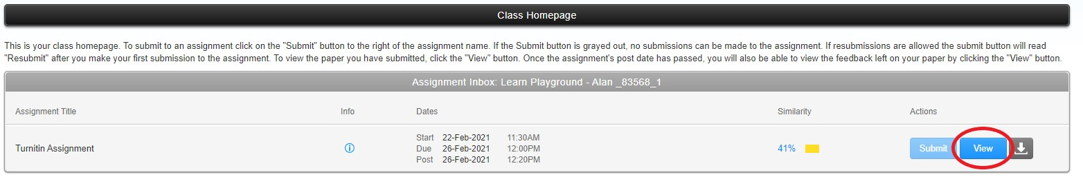

3. Similarity Report Toolbar
When a Similarity Report has been generated for a submission the overall similarity percentage can be found in the side panel toolbar for quick reference. For instance, this example shows 44% Similarity match against the database.

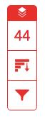
To view the similarity Match Overview, click on the red similarity score. The Match Overview will be displayed in the side panel.

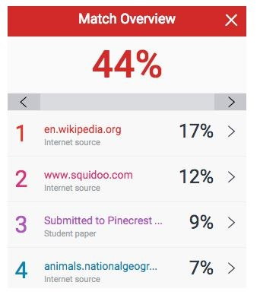

The Match Overview gives you a breakdown of all the matches that have been found in the paper and allows you to clearly view the similarity score. Matches are ordered by highest instance of similarity down to the lowest. Each match has a colour and a number attached to it. These colour tags will help you to find the match on the paper itself.

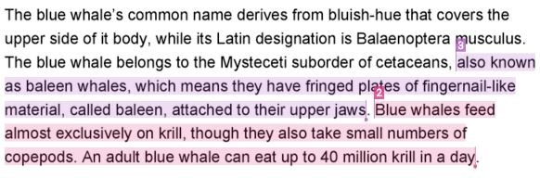

To view All Sources associated with your paper, select the red graph icon from the similarity toolbar.

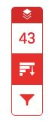

In the All Sources side panel, all of the sources that have been found are displayed and sorted by highest percentage to lowest percentage match. Clicking on any source will change the navigation bar at the top of the page, displaying how many times that this source has matched in the paper. Clicking the arrows will allow you to see where these have matched on the page. You can further refine this navigation by clicking on an individual page within a source; this will simply show you matches from that specific sub-source. You can now see a large list of all the sources for this paper. Select any of these matches to be directed to it on your paper.

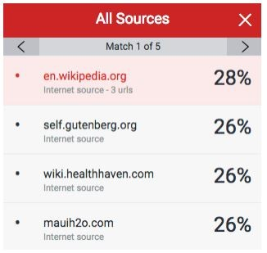

To exclude small matched, quotes and bibliography from your similarity report select the filter icon on the similarity toolbar.

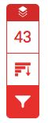
From the Filters and Settings side panel, use the check boxes to make bibliography and quote exclusions from the similarity report. You may also exclude sources that are less than a certain number of words or a certain percentage of words by selecting and entering a number in the text box.

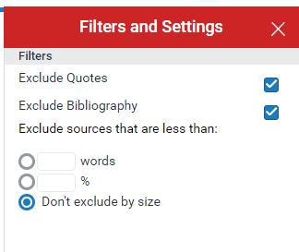

Click ‘Apply Changes’ to confirm your selected filters. This will regenerate the similarity report to include your exclusions.

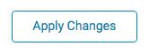

Note: Any exclusions you make to your Similarity Report will not reflect your official similarity score. Student changes are only temporary.

If you require this document in an alternative format, such as large print or a coloured background, please contact the Turnitin service team email: ishelpline@ed.ac.uk.

