Accessing your grade and feedback on a Turnitin assignment in Learn - a student's guide

The following instruction and information will help students access their grade and feedback on a Turnitin assignment in Learn the University’s virtual learning environment.

Contents:
- Accessing the Turnitin assignment.
- Turnitin assignment inbox.
- Assignment feedback studio.
3.1. Overall grade.
3.2. Grading Form and Rubric.
3.3. Instructor Feedback.
- Text Comment.
- Voice Comment.
- Comments on the paper.
3.4. How to download a copy of your feedback.

1. Accessing the Turnitin assignment
After the assignment post-date your grade and feedback can be accessed through the Turnitin assignment. You can access Turnitin assignments from course content pages in Learn. Turnitin assignments can be identified by the Turnitin logo to the left of the assignment.

To open the Assignment, click on ‘View/Complete’

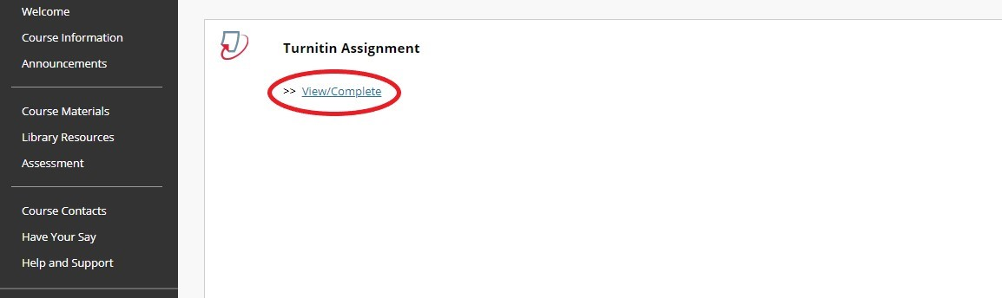

2. Turnitin assignment inbox
From the assignment inbox you will see the paper title, any information about the assignment, relevant dates and the similarity score (if the instructor has enabled this). To view the grade and feedback click on ‘View’. This will open the assignment feedback studio in a new window.

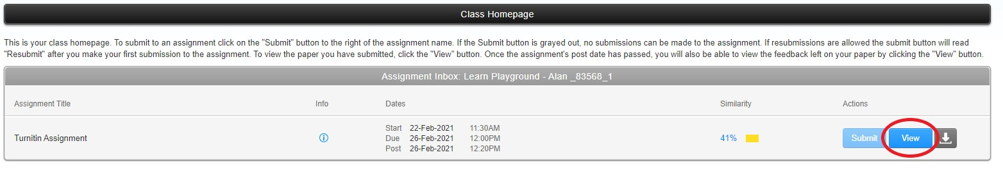

3. Assignment feedback studio
From the Feedback Studio you will be able to view your Overall Grade, view the Grading Form or Rubric (if used), view all Instructors Feedback, listen to any Voice Comments and Download a copy of the feedback on your paper.

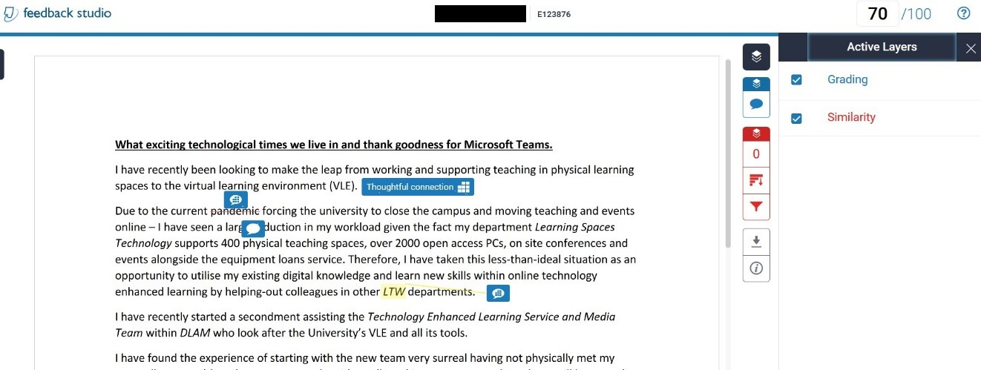

You are also able to click on the grading layers to show or hide feedback on the assignment.

3.1 Overall grade
Your overall grade can be found at the top right-hand corner of the Turnitin Feedback Studio. You can also see the maximum marks available for the assignment.

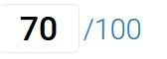

3.2 Grading Form and Rubric
Grading Form - Grading forms can be used to provide free form feedback and scores to evaluate student work based on defined criteria. If the instructor has used a grading form to grade the paper, you can view the score and comments that have given for each criterion in the grading form.

1. To access the grading for or Rubric click on the grade icon from the toolbar

2. Select the View Rubric button from the Instructor Feedback side panel to open the scorecard in a new window.

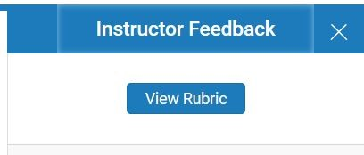

3. From this new window, you can view the grading form that was used to grade the paper. Each criterion will be followed with a score and an optional comment; this information displays the extent to what has been achieved in each criterion. The total score can be found at the bottom of the grading form.

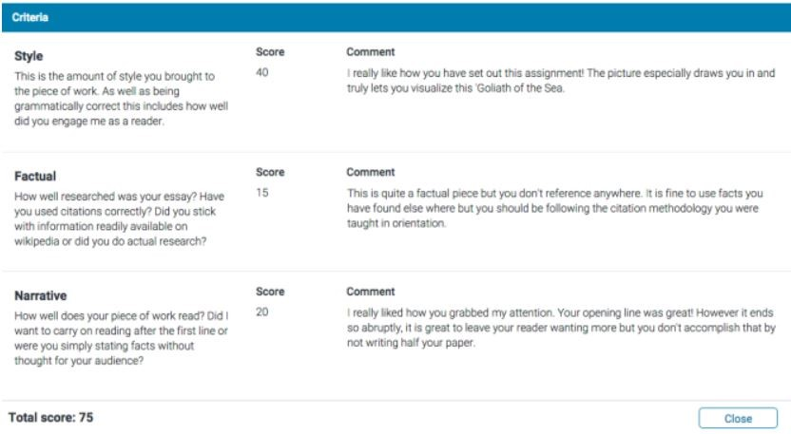

Rubric - Rubric scorecards can be used to evaluate students work based on defined criteria and scales. If the instructor has used a rubric scorecard to grade the paper, you can view the criteria and scale that has been used to grade.
Follow steps 1 and 2 as before for the grading form:

3. A new window will appear where you can view the rubric scorecard that was used to grade the paper. Each blue highlighted box shows where you have been graded in each of the criteria of the assignment.

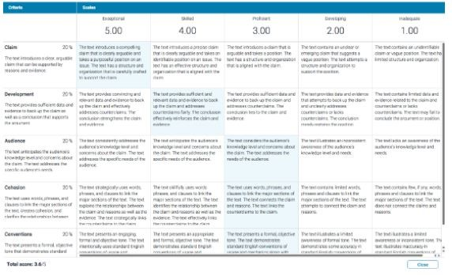

3.3 Instructor Feedback
Instructor Feedback can be given as Text Comments, Voice Comments or Comments on the paper.

Text Comment
A text comment is an overall comment given by the instructor regarding the whole paper. This may include comments on positive aspects of the paper, how to improve in future, or any issues with the paper.

1. To view the instructor's text comment, click the grade icon from the toolbar.

2. The instructor's text comment is now visible from the Instructor Feedback side panel.

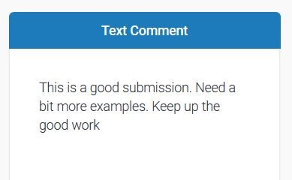

Voice Comment
The instructor may leave a voice comment. You can listen to this when in the Instructor Feedback side panel.

To play the recording select the triangular play icon to the left of the voice comment.

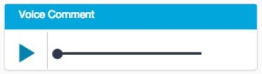

To pause the recording select the pause icon to the left of the voice comment.

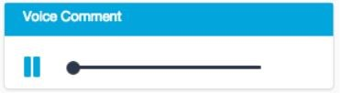

Comments on the paper
The instructor my leave comments on your paper. Some appear in line with the text.

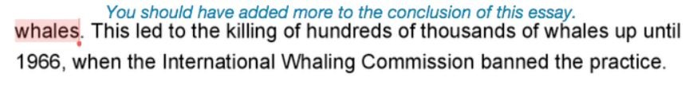

Speech bubble comments need to be clicked on to open and view.

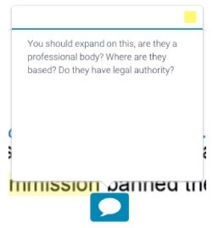

A QuickMark comment may be a word, phrase or an abbreviation that may have a description attached. This may be a highlighted and labelled to refer to a specific piece of text.

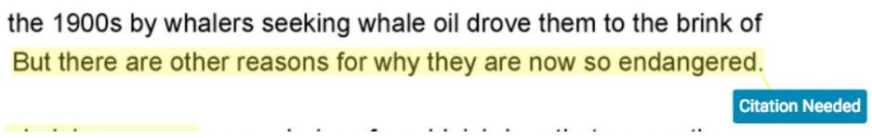

Alternatively, a QuickMark may be placed alongside a line or paragraph. This is usually the case if your instructor is making a more general comment about your paper. Select the QuickMark to view the definition of the mark. Scroll through the information, then click anywhere outside of the expanded to close the QuickMark.

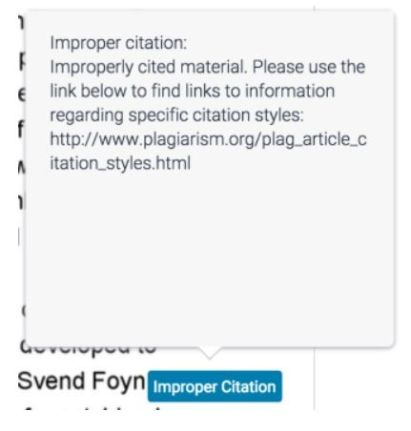

3.4 How to download a copy of your feedback
To download the current view of the Feedback Studio, digital receipt of your submission, or the originally submitted file click on the download button.

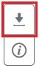

Select Current View.

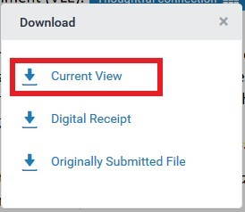

From here, you can choose to ‘Open with your browser’, ‘Open as a PDF’ or ‘Save File’.
If you require this document in an alternative format, such as large print or a coloured background, please contact the Turnitin service team email: ishelpline@ed.ac.uk.

