PARTICIPANT EXTRA INFORMATION: AAMOS-00 Phase 1
“Mobile device monitoring to inform prediction of
asthma attacks: an observational study (AAMOS-00)”
This is a reference sheet designed to assist you with various areas you might be having trouble with. We do not expect you to read from start to finish, but to pick and choose the areas that might be of help.

Contents
Get Started with Mobistudy 2
Step 1: Downloading the app on your smartphone 2
Step 2: Registration 2
Step 3: Joining This Study 4
Step 4: Completing a questionnaire or task 6
More information about Mobistudy 7
Navigation Around Mobistudy 7
General Mobistudy Use 9
Forgot Password 10

Get Started with Mobistudy

Step 1: Downloading the app on your smartphone
Mobistudy is a mobile app available on the Apple App Store and the Google Play Store. There are 2 methods of downloading Mobistudy.
Method 1: Search “Mobistudy” inside the app store or play store and look for the logo

After you have found the Mobistudy app, press “install” to download and install the app onto your phone. Please go to step 2.

Method 2: Follow the direct link below, depending on whether you have an iPhone or Android phone (such as Samsung, Google, LG, Huawei) respectively. Please click the link on your phone.
Apple https://apps.apple.com/us/app/id1462273500
Android https://play.google.com/store/apps/details?id=org.mobistudy.app

After you have found the Mobistudy app, press “install” to download and install the app onto your phone. Please go to step 2.

Step 2: Registration
After installing the Mobistudy app onto your phone, you will need to register an account with Mobistudy. The first time you enter Mobistudy, you will be greeted with the “Login” page. Please press the blue button with “REGISTER” at the bottom of the page to begin the registration process. If you do not see the button, please scroll down.
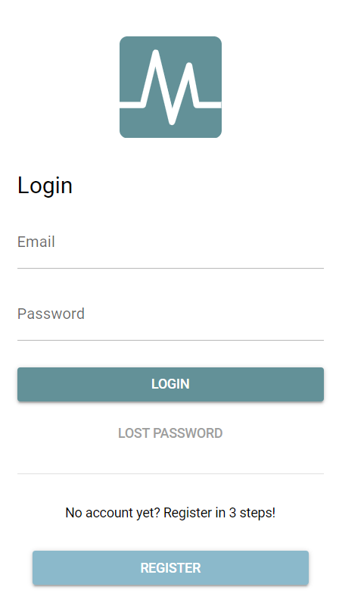

Please make sure you read and understand the terms and conditions and privacy policy of Mobistudy before pressing the “accept” button.
To create an account, you will need to provide an email address and make a password. We recommend you use one email address for all correspondence with this study. The password must have the following properties:
- A minimum of 8 characters
- At least 1 lowercase character
- At least 1 uppercase character
- At least 1 number
- At least 1 special character (e.g. !$%^&*)
- No obvious patterns like “abc” and “123456”
Then fill in the information for your profile:
- First name
- Surname
- Language selection, press the arrow on the right (▼) for a drop-down selection, English would be preferable
- Country, press the arrow on the right (▼) for a drop-down selection
- Sex, press the arrow on the right (▼) for a drop-down selection
- Date of Birth, press the calendar icon for a date selection, or you could type your date of birth in the format YYYY/MM/DD, the forward slashes will appear automatically
- Weight (kg)
- Height (cm
- Long term conditions, type “asthma” and select from the drop-down. Feel free to put any other conditions you may have. After selecting all your conditions, please touch anywhere outside the box on your screen to confirm your selection.
- Long term medication, type the name of the medications and select from the drop-down. After selecting all your conditions, please touch anywhere outside the box on your screen to confirm your selection.
After filling in all the information, please press “NEXT”
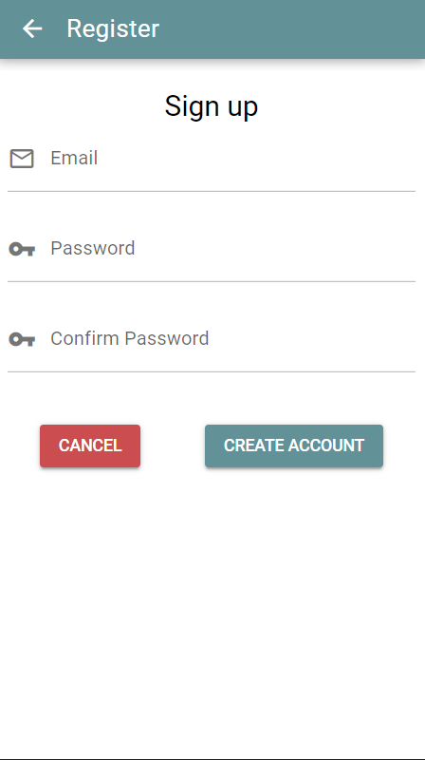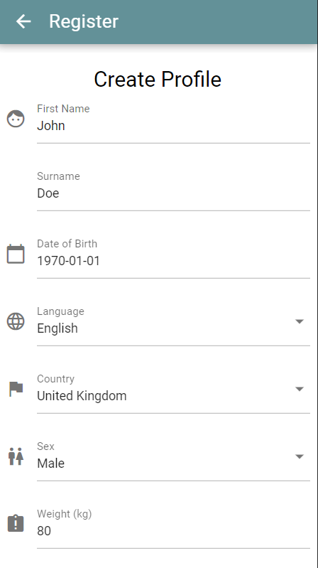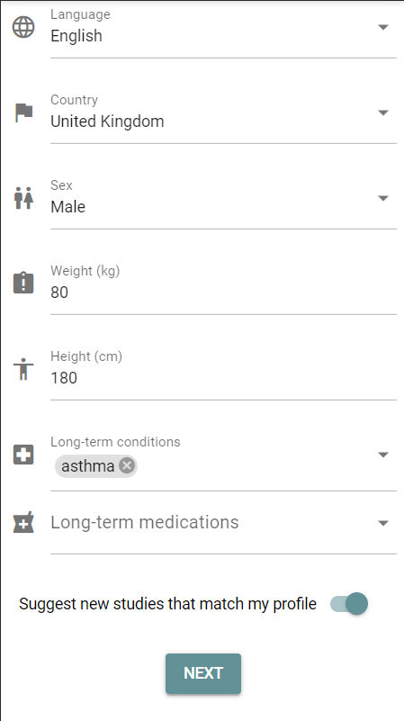

Please go to step 3.

Step 3: Joining This Study
After completing your profile, please use the navigation bar at the bottom of the screen and press the word “STUDIES” to see a plus button (+) in the bottom right. Press on the plus button and type the study invitation code in the pop-up prompt, the code will be provided by the research team. Pressing “OK” would bring up the study invitation with “You are invited to a new study”.
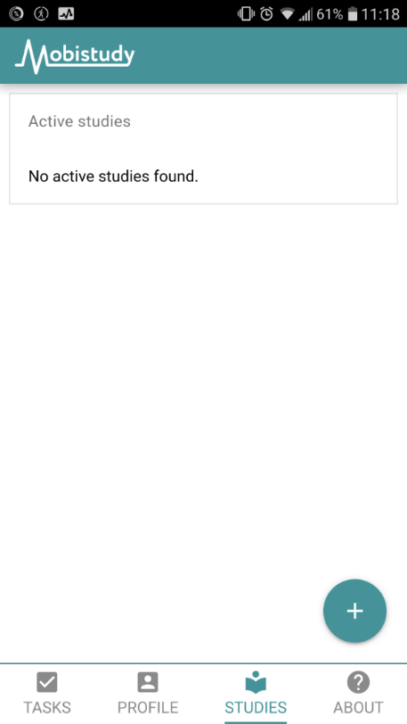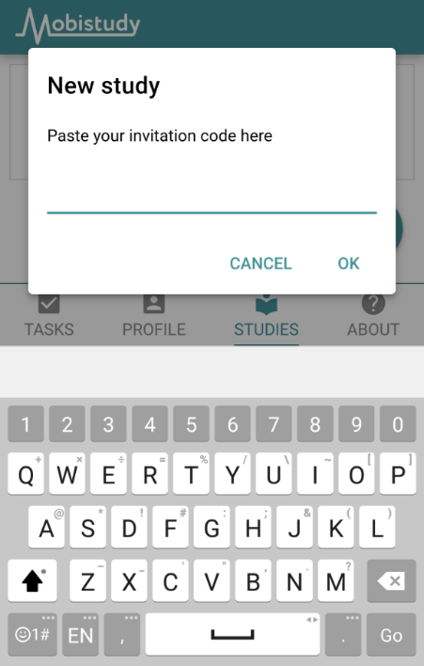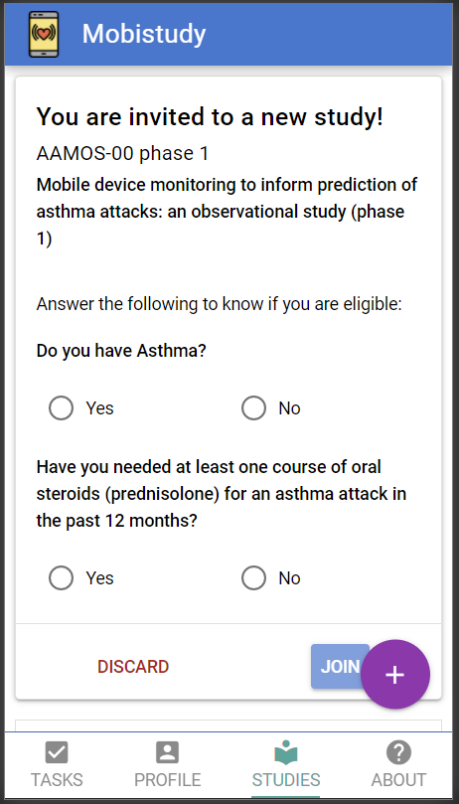
Once you can see the invitation, please press the “JOIN” button. This will take you through some information about the study. After reading through all the information and pressing “JOIN STUDY”, you will have joined this study within the Mobistudy app. Please go to step 4.

Step 4: Completing a questionnaire or task
After joining the study, the tasks for today are listed in “Task” page.
In phase 1, you should expect to see the daily questionnaire task every day, this will be 6 questions and take around 2 minutes to answer. The weekly questionnaire task should be completed every 7 days, a reminder inside the app will give the prompt when it has been 7 days.
In phase 2, there are 4 daily tasks: daily questionnaire, take peak flow measurements, send inhaler usage, and send smartwatch data. The weekly questionnaire will appear in the same way as in phase 1.
Click on any of the listed tasks to begin that task and follow the instructions within. For example, “Daily Questionnaire”
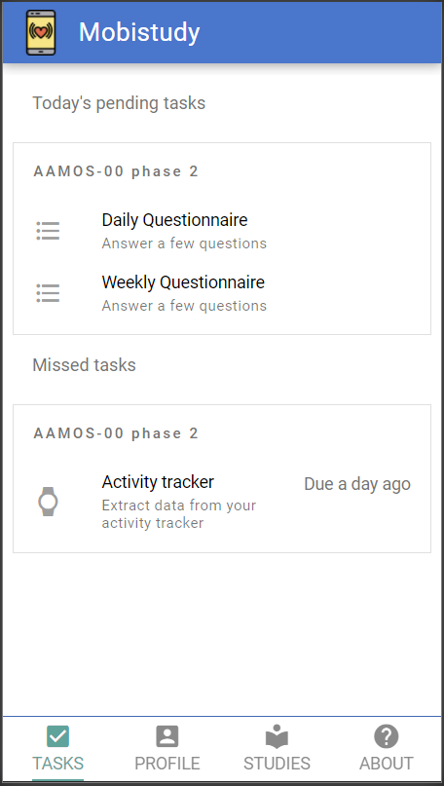

Once all the tasks are completed, the “TASKS” page will have no more pending tasks and should look like this.
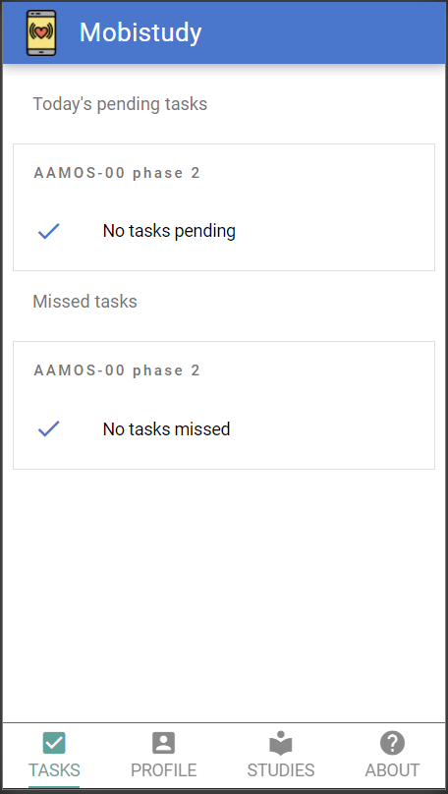

There is no need to logout after each session. Thank you for following the steps to get started with Mobistudy. Please open Mobistudy again tomorrow to answer the daily questionnaire, you should see the task mentioned in step 4 every day throughout the study period.

More information about Mobistudy

Navigation Around Mobistudy
There are 4 pages in Mobistudy:
- TASKS
- PROFILE
- STUDIES
- ABOUT
To navigate between any of these pages, use the icons at the bottom of the screen which list the pages. If the page is underlined, it means you are already on the page.
If at any time the bottom navigation bar disappears and you are looking for it, you may be in a task. To leave the task press the cross at the top right of the page to quit the task, but you will lose the progress up to that stage in the task.
TASKS
Under “TASKS” you will find all the tasks for the day. Click on any of the listed tasks to begin that task.

PROFILE
In the “PROFILE” page, you will find all the profile information you entered when you used Mobistudy for the first time, this information can be changed at any time by editing the information and pressing the green “UPDATE” button.
On this page, you will also find functions that are not generally needed, such as the reset password function, logout of Mobistudy function, and delete account function.
If you wish to delete your account, we would like you to contact the research team before using the function so that we can advise you on the appropriate method to leave this study.

STUDIES
The “STUDIES” page lists the studies you are currently involved and were involved. Also, this is where you would find the study invitations. You are under no obligation to join any other studies.

ABOUT
The “ABOUT” page contains information relating to Mobistudy.

General Mobistudy Use
Once registered and logged in, there is no need to logout of Mobistudy if you are completing the tasks on a personal smartphone. This will reduce the time required to complete a daily task.
Mobistudy Login
If you have logged out of Mobistudy or using Mobistudy on another phone, you will see the “Login” page when you open the app. You can enter your email address and password. It should take to the main page “Today’s tasks” and you should see the tasks for today. If you have forgotten your email or password, please follow the instructions below in “Forgot Password”.

Mobistudy Logout
If for any reason you wish to logout of Mobistudy, press “PROFILE” at the navigation bar at the bottom of the screen. Scroll to the bottom and press the yellow “Logout” button to logout.

Forgot Password
If you have forgotten your password for Mobistudy, your account can be recovered with the following steps. Firstly, press the “LOST PASSWORD” in the login page, this will direct you to enter your email which you have used to sign up to Mobistudy. Secondly, press the “RESET PASSWORD” to send an email with a token used to set the new password.
If you have forgotten what email address you have used to sign up to Mobistudy, please try all your email addresses, it will not save and send to any email addresses that are not registered with Mobistudy. If all the options are exhausted, please get in touch with the research team.
