

**ARCHIBUS Mobile App**

*The Craftsperson Screens v23*

Syncing the Archibus mobile app with and creating a new request.

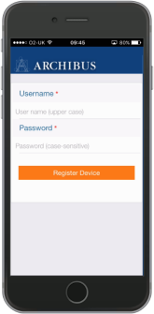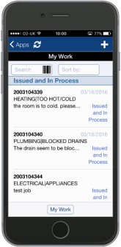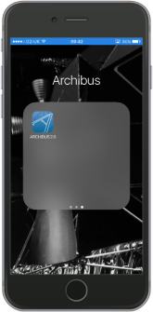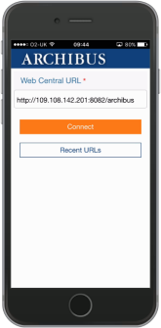

Start the ARCHIBUS App Work by Tapping on the application Icon.

Enter the Web Central URL to connect the Mobile App to Archibus now enter your Archibus User name and Password.

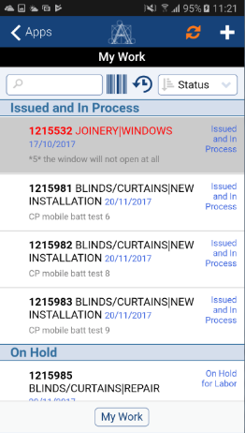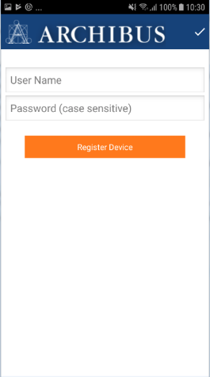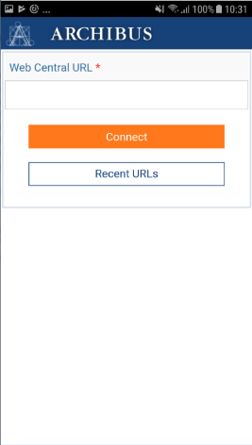

Back to main apps screen

Type in the Web Central URL here

Create a new request **(see step 6)**

Recently entered WC URL’s can be viewed here



Enter your Archibus User Name & Password (case Sensitive)

The application Icon

Sync requests

**The Buttons along the bottom of the screen allow update craftsperson’s time and view attached documents**.

|  |  |
| --- | --- |
| (G) | The craftsperson’s button allows you to update time & date started for each visit. You can also add another member of the team by selecting the + symbol and then adding their name. |
| (F) | You should also leave any comments about the job in this section. |

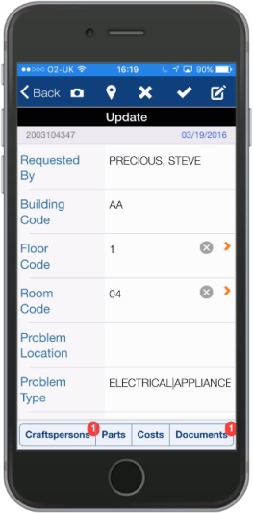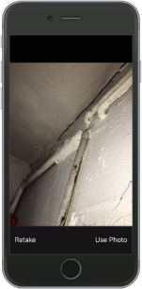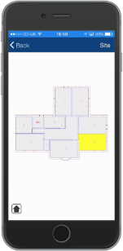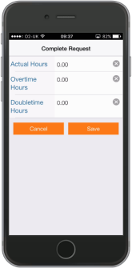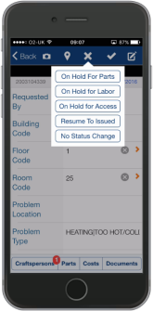

Once you have sync’d and received your work requests, the sort icon enables to change how these are ordered and displayed. **Location** is a useful option.

Search for requests by work request code

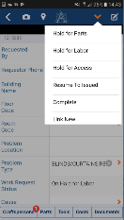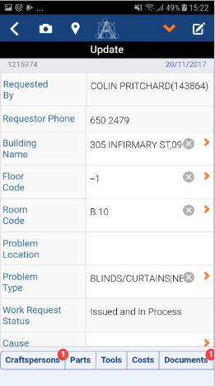

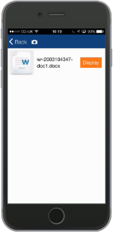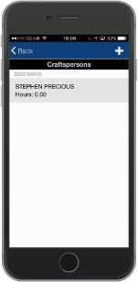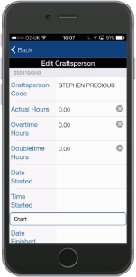

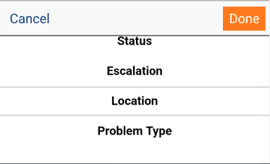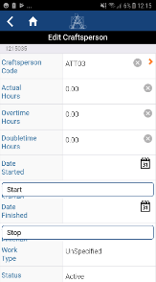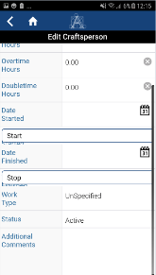

**Screens for updating an existing request. The icons along the top of the screen allow you do the following.**

|  |  |  |  |  |  |  |
| --- | --- | --- | --- | --- | --- | --- |
| (A) | Use the camera to add images | | (C) | | Set the request On Hold, Complete, or raise a linked request. | |
| (B) | Use the pin to view the location on the drawing | | **(D)** | | You will be prompted to add time after Completing the job, if not already done so | |
|  | |  | |  | |

Change between My Work & My Requests – **see step 6.**

**By clicking on the + sign in the front screen you can add a new request through the mobile app that will be uploaded to the Archibus system when it next syncs**. **Before you start make the following selection -**

**1. My Work – add to my queue 2. My Requests – direct to Helpdesk**

|  |  |
| --- | --- |
| (A) | Select the first & second problem type by selecting the arrows at the edge of the field |
| (B) | Enter a problem description. |

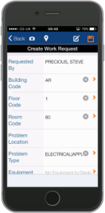

**Sync App to Receive Work Requests**

**Triage & Approve**

**Report a Problem**

**Location**r

**Problem Type**r

Back to request list

Outline of a Work Request workflow. Showing the various stages of an on demand request.

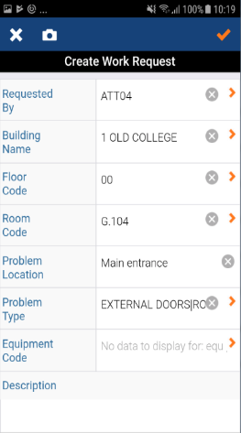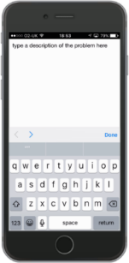

**Requester**r

Use the camera to add a photo

**Cause Code & Repair Type**

**Issue to Work Team**

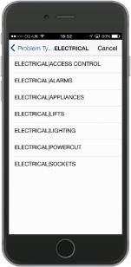

**Work Request Complete**

**Time, Date & Comments**

**Assign to Craftsperson**

Version 22.1 Archibus Mobile App

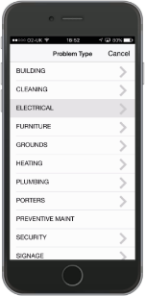

**Helpdesk**

**Customer**

**ATL**

**Craftsperson**

**System**

**Request Closed**

**Sync App**

**Complete**

**Issue Request**

**Description**

**Submit**

Save the new request

