Estates Helpdesk

Customer – v23 Changes



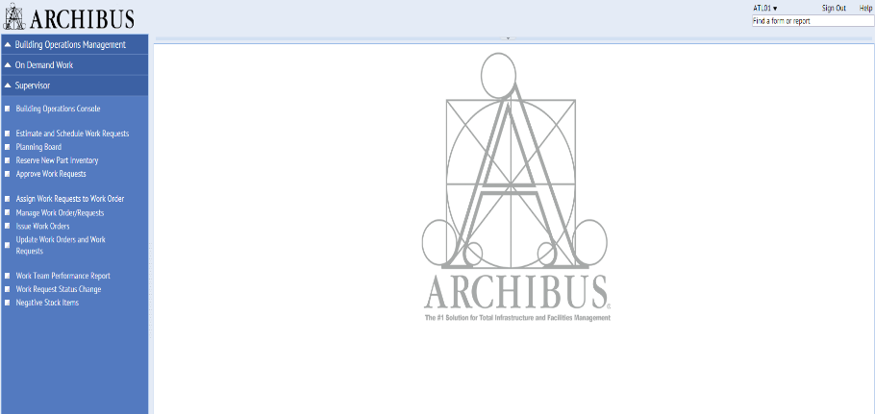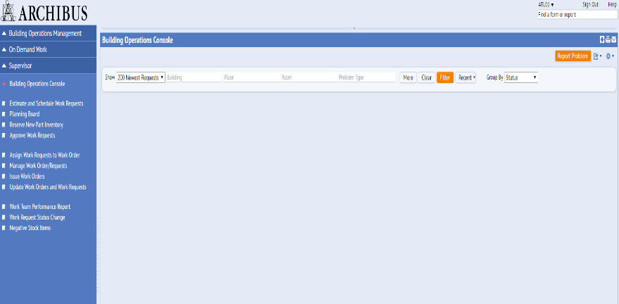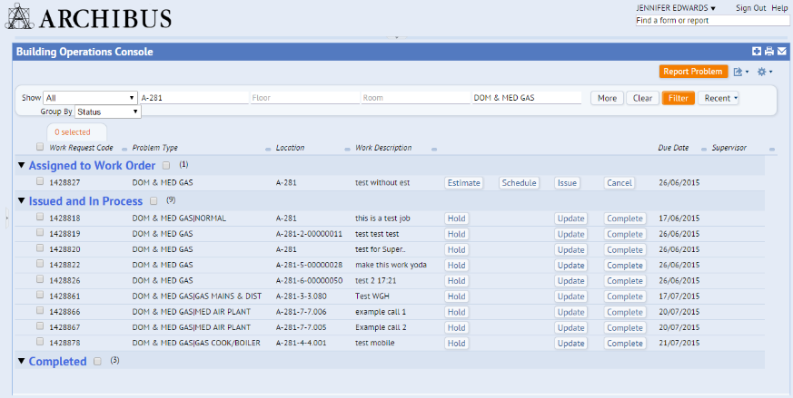

Login using EASE and Select the Building Operations Console

Select the Work Request Code to access more information about a Work Request

**ACCESSING INFORMATION ABOUT A WORK REQUEST**

Collapse the Navigator by clicking on the dotted area

Click the **Filter** button to see all the requests

Login to ARCHIBUS Web Central via EASE. The link is available on the [Estates Helpdesk homepage](http://www.ed.ac.uk/estates/estates-helpdesk). Try adding this to your browser favourites. Once logged in select the **Building Operations Console.**

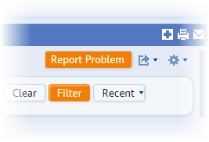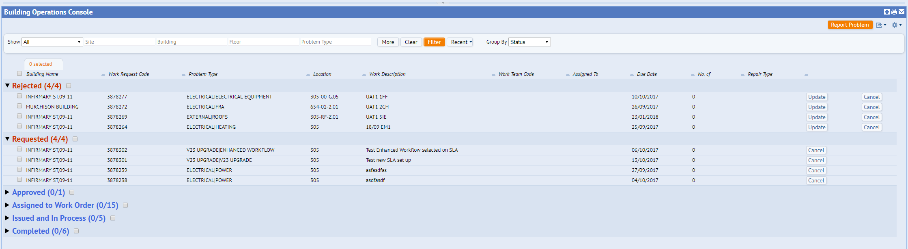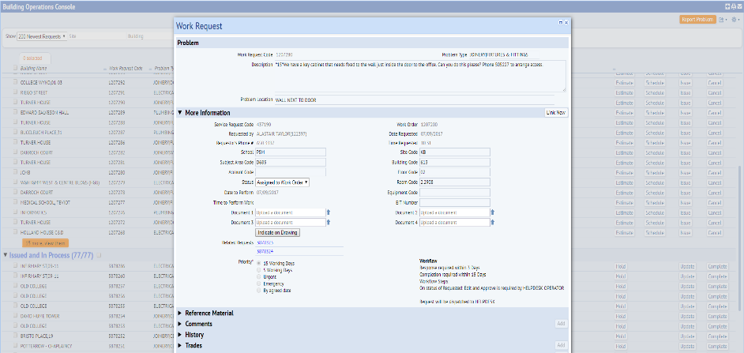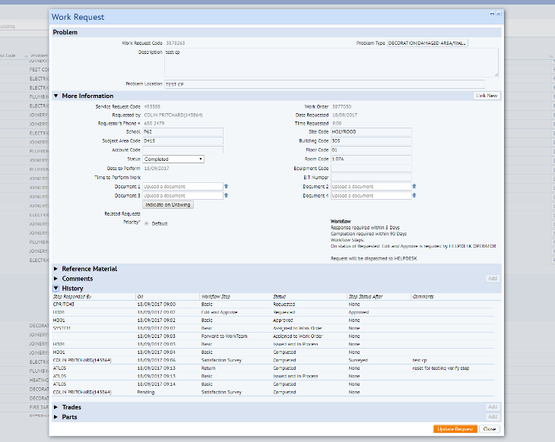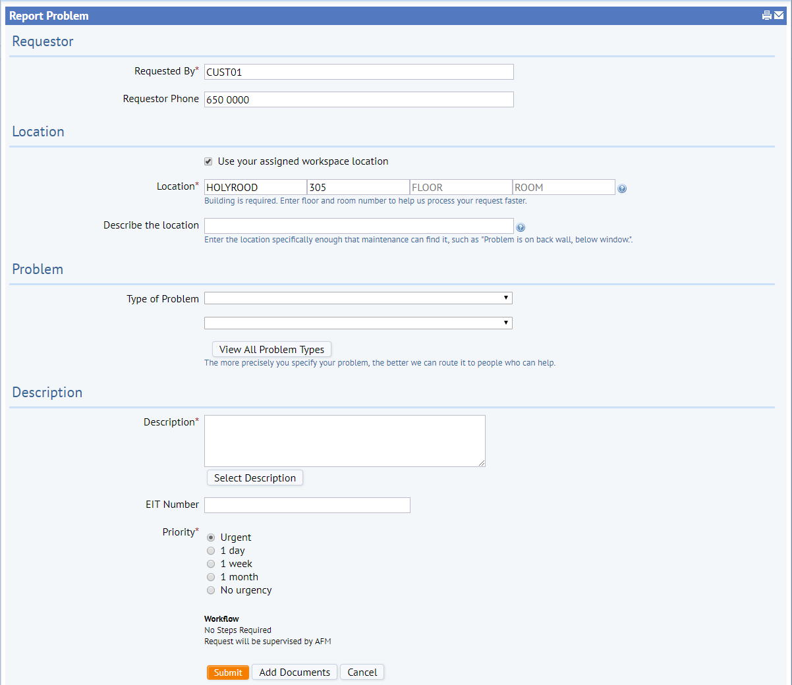

Within the settings cog;

Highlight escalated requests/ or select work request fields to amend console headings

Returning to the main **Building Ops Console**, you can now view jobs rejected by the Estates Helpdesk. You also now have ability to provide more information in the description field about the job and resubmit the request. Please see user guide for more information on how to do this.

EBIS Office – ebisusers@ed.ac.uk | 650 9683

Estates Helpdesk – estates.helpdesk@ed.ac.uk | 0131 650 2494

Under the Rejected status jobs can be updated and re-submitted.

**REJECTED WORK REQUEST**

You can now add a document from the Report Problem screen

**ADDING A DOCUMENT TO A WORK REQUEST**

Related Work Requests hyperlink

Use the **Filter** button to view requests that you have raised. Additional criteria can be entered into the filter options to reduce the number of requests shown.

Check for comments left by Estates staff in the **Comments,** **History** or **Craftspersons** sections

You can also view linked work requests by selecting the related requests hyperlink. Estates staff will create a new request, linked to the original request when a job needs to move work team i.e. Mainteance Servcies to Contract Services.

Within the work request pop up screen there is useful information regarding the progress of the job. You can view all the available sections by scrolling up and down in this screen.

You can check or add documents against the Work Request.

Enter a description of the issues. Enter the name /phone number of the requestor if they are not in the requested by menu

The problem type sets the SLA for the request

The location of the issue must be entered

Enter your name and contact number.

Once you have selected an appropriate filter and returned a list of work requests, you can select the **Work Request Code** to view the work request pop up screen. This displays more information about the job.

**Report Problem**

Requestor

Location

Problem Type

Description

Submit