

Estates Helpdesk

Customer – How to Guide

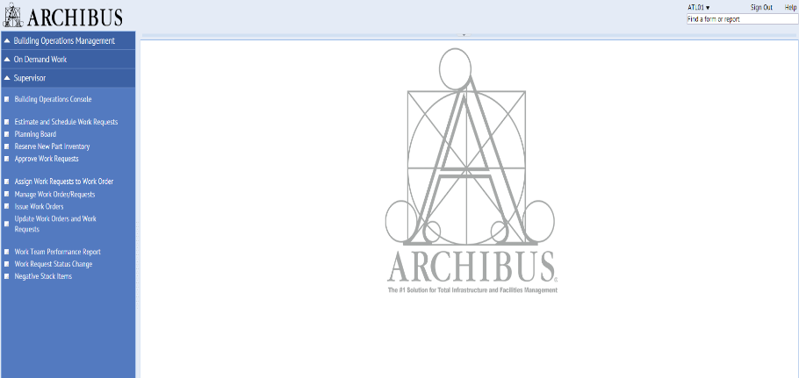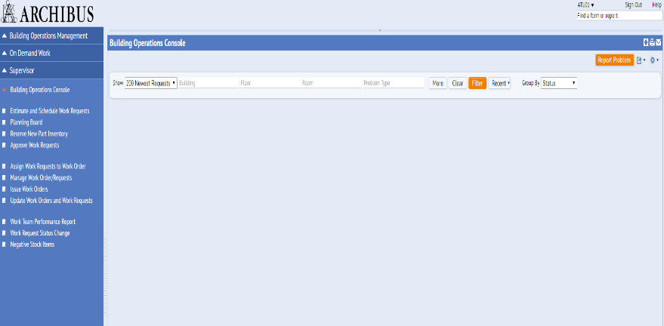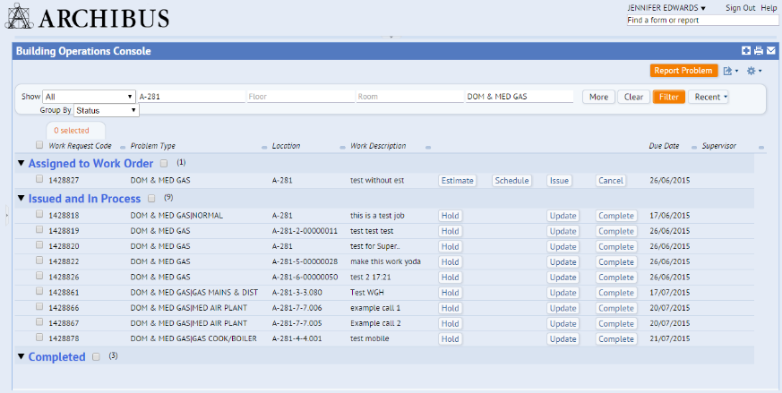



Click the **Filter** button once you have selected the options you want, or the **Recent** button to apply previously used filters.

Collapse the Navigator by clicking on the dotted area

Click the **Filter** button to see all the requests

Login using EASE and Select the Building Operations Console

Add in extra filter parameters to narrow your search.

Login to ARCHIBUS Web Central via EASE. The link is available on the [Estates Helpdesk homepage](http://www.ed.ac.uk/estates/estates-helpdesk). Try adding this to your browser favourites. Once logged in select the **Building Operations Console.**

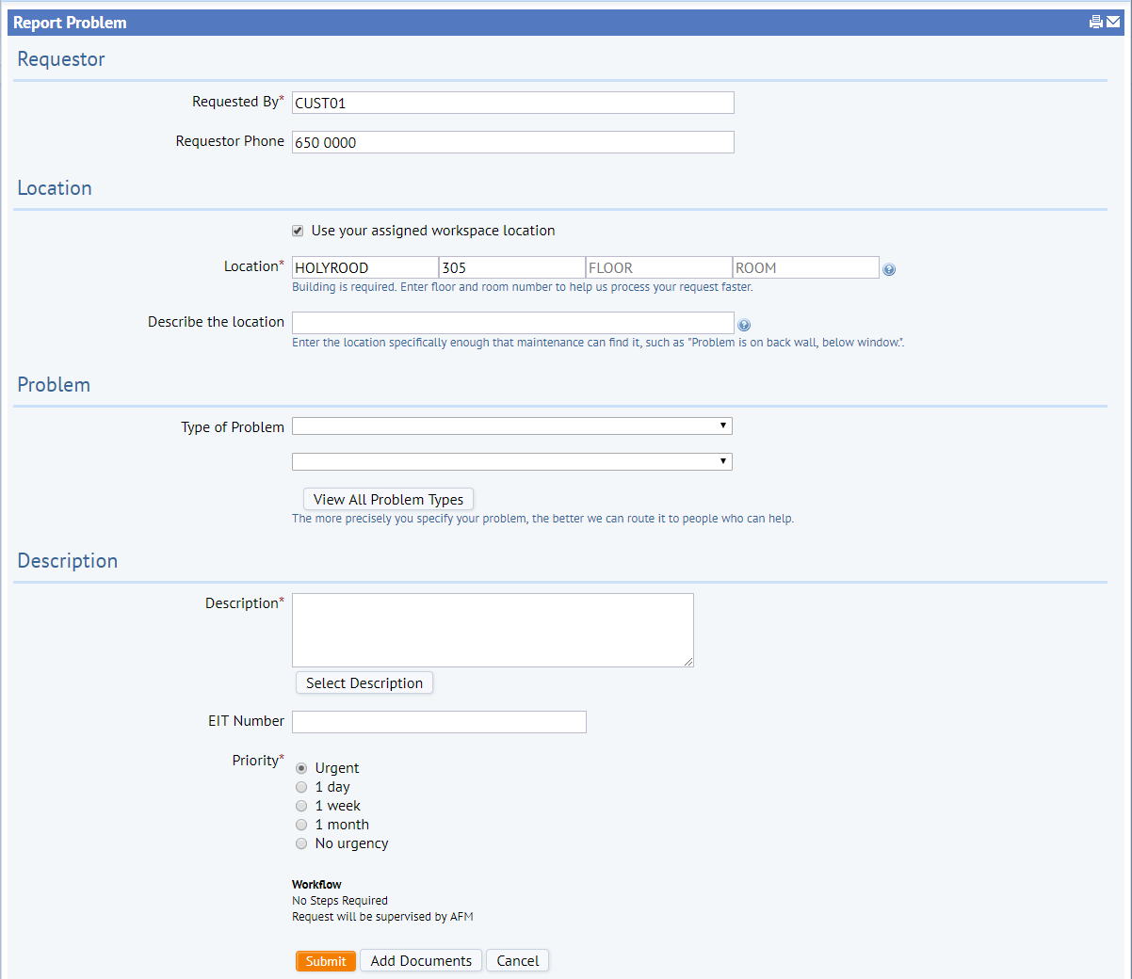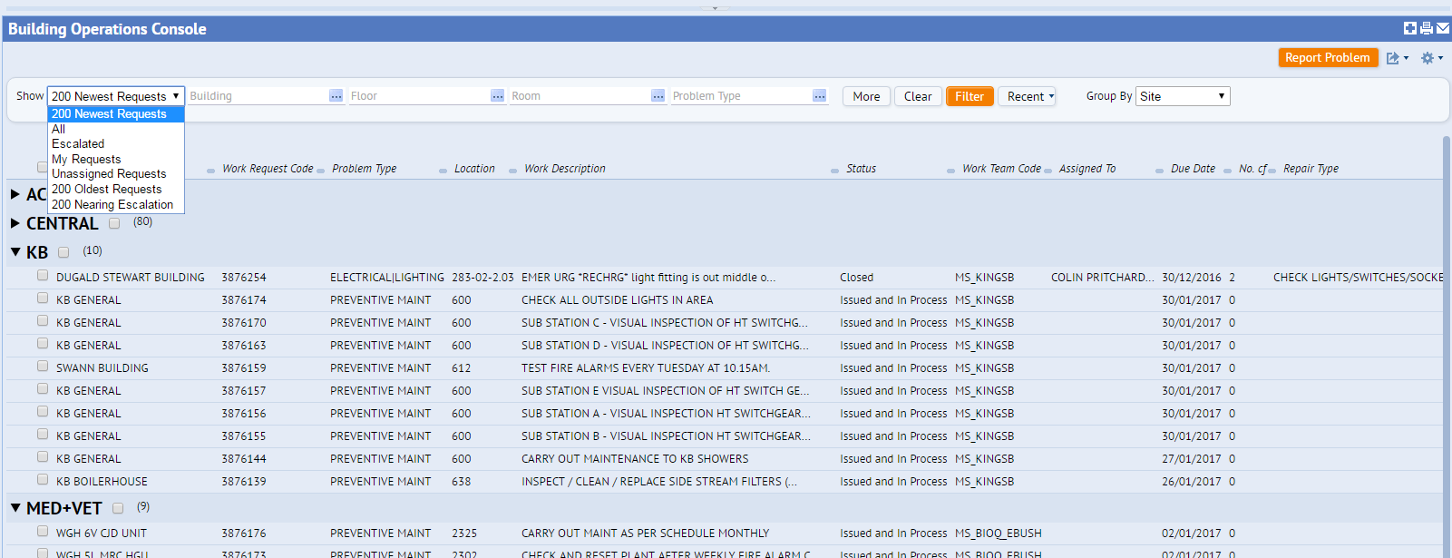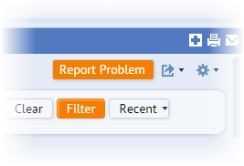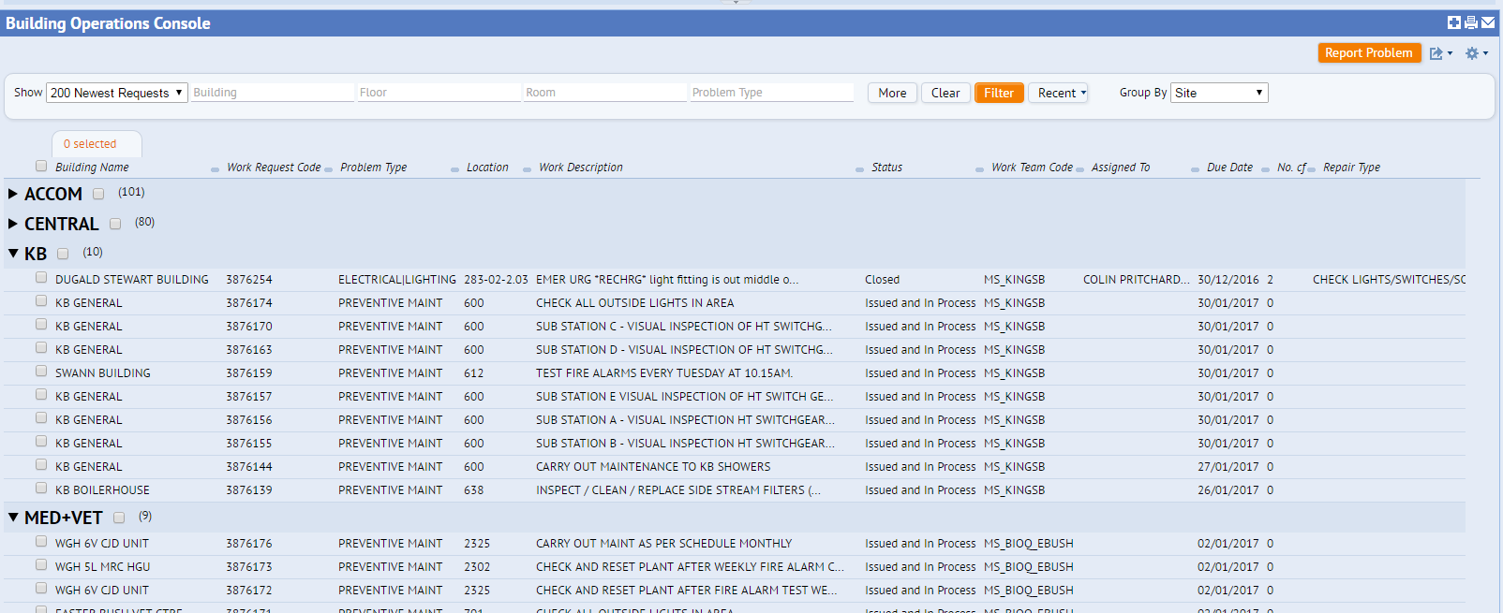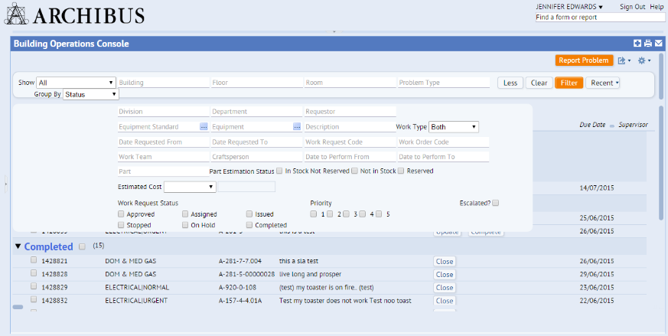

EBIS Office – ebisusers@ed.ac.uk | 650 9683

Estates Helpdesk – estates.helpdesk@ed.ac.uk | 0131 650 2494

By selecting the Work Request code, you can view all the information regarding each request like who is assigned to the job, any comments left, and a history log of the request to date.

Click on the Work Request code to view more information about a Work Request.

You can now add a document from the Report Problem screen

Enter a description of the issues. Enter the name /phone number of the requestor if they are not in the requested by menu

The problem type sets the SLA for the request

The location of the issue must be entered

Enter your name and contact number.

Select the **More/Less** button to display more filter options. Such as *Date Requested /Work Team / Craftsperson /Requestor / WR Code.* You can also search for key words in the *Description* field. The fewer Work Requests you have displayed on your console, the faster the system will perform - filters are a useful tool. You can also click anywhere on screen to activate scrolling using your arrow keys.

Further filter options on the **More/Less** button

Short cut to group the filtered requests by different headings

Use the top Building/ Floor/ Room / Problem fields to filter the request list. Use the **Recent** button to select previously used filters.

Select the **Group by** option to sort the filtered request by the selected headings in the drop down box. *Building / Problem Type*

Highlight escalated requests/ or select work request fields to amend console headings

**Report Problem**

Requestor

Location

Problem Type

Description

Submit

Use the **Filter** button to view requests that you have raised.