How to Download and Upload DNA data files

Ancestry DNA
Download Instructions
In order to transfer your autosomal DNA file to Coronagenes, you’ll first need to download the file from Ancestry.
Download Step 1
Sign in to your account at Ancestry and click on the DNA Results Summary link.
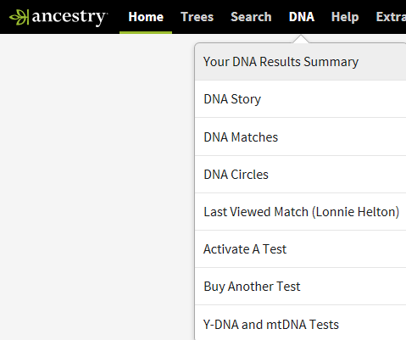

Download Step 2
Click on the Settings gear. It’s at the far upper right hand corner of the summary page, just beneath your Ancestry user ID.
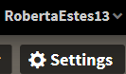

Download Step 3
Click on the link for “Download Raw DNA Data.”
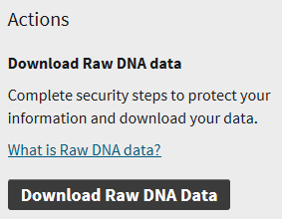

Download Step 4
Enter your password and click on “I Understand,” after reading the information.
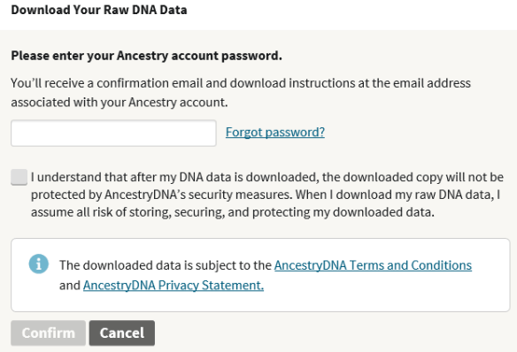

At this point, the confirm button will turn orange – click there.
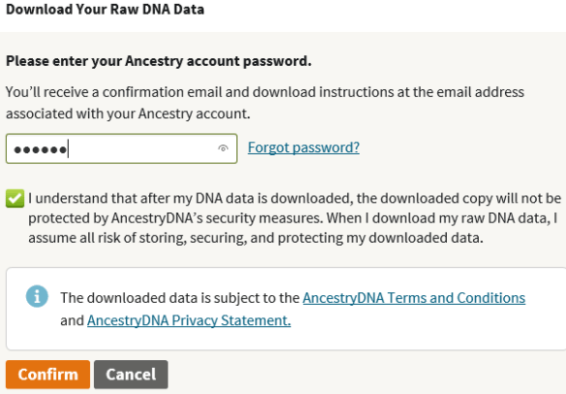

Download Step 5
Ancestry will send an e-mail to the e-mail address where you are registered with Ancestry. Check your inbox for that e-mail.
If the e-mail doesn’t arrive shortly, check your spam folder. If you’ve changed e-mail addresses, check to be sure your new one is registered with Ancestry. That’s on the same Settings page. If all else fails, request the e-mail again.
Download Step 6

When you receive the email, click on the green “Confirm Data Download” button. Do not close the window.
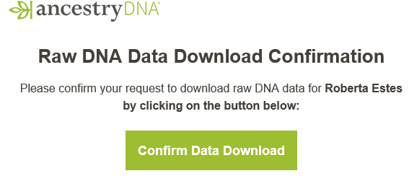
Download Step 7
Next, click on the green “Download DNA Raw Data.”
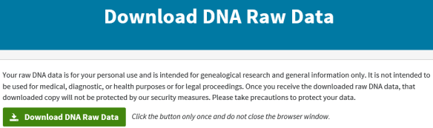

You’ll see the following confirmation screen.
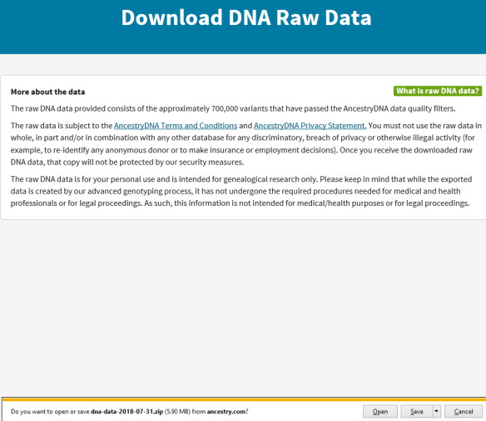

Download Step 8
At the bottom of the page, if you’re on a PC, you’ll see the typical file download box that asks you if you want to open or save. Save the file as a name you can find later.
The file name will be “dna-data-2018-07-31”. The date is when you downloaded the file. We suggest adding the word Ancestry to the front when you save the file on your system.
Upload Instructions

Upload Step 1
In the volunteer dashboard select Upload File to start.

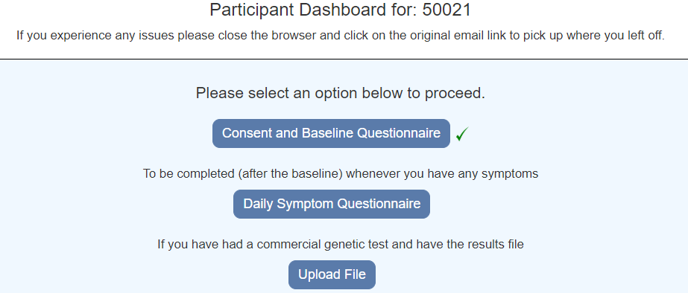

Upload Step 2

Choose a file and select Upload

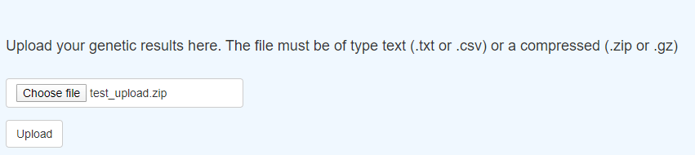

Upload Step 3

The message “File successfully uploaded” will be displayed

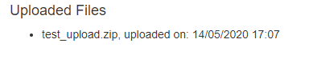
If there was an error, a message will be displayed. IF you have problems please contact the Coronagenes team. Please send us details of any errors you receive.

Upload Step 4

Select Back to Dashboard

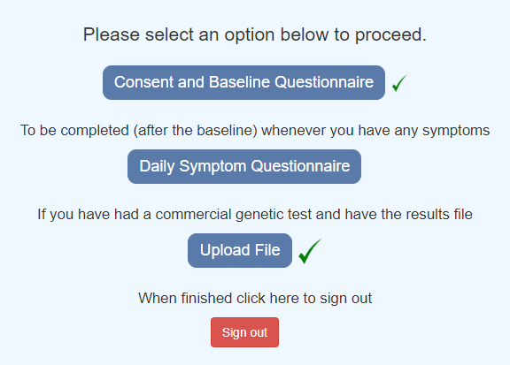

The Upload file will have a green tick.

Upload Step 6

Select Sign Out to complete the process.

