**Number of students with a disability attending the University of Edinburgh**

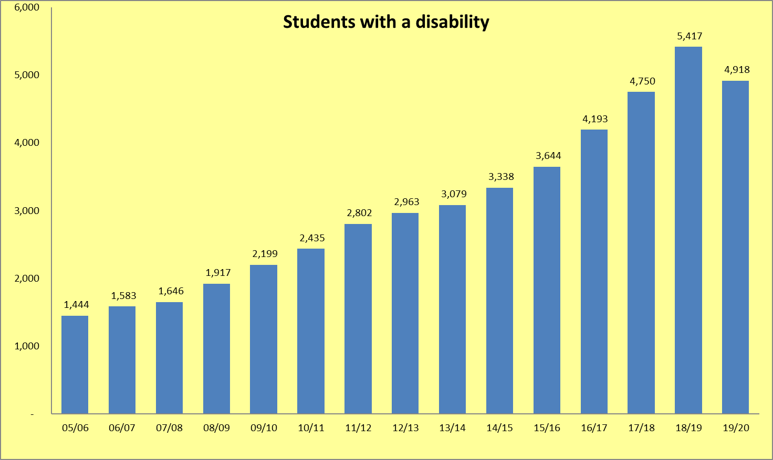

**Students with a disability – percentage of UoE student population**

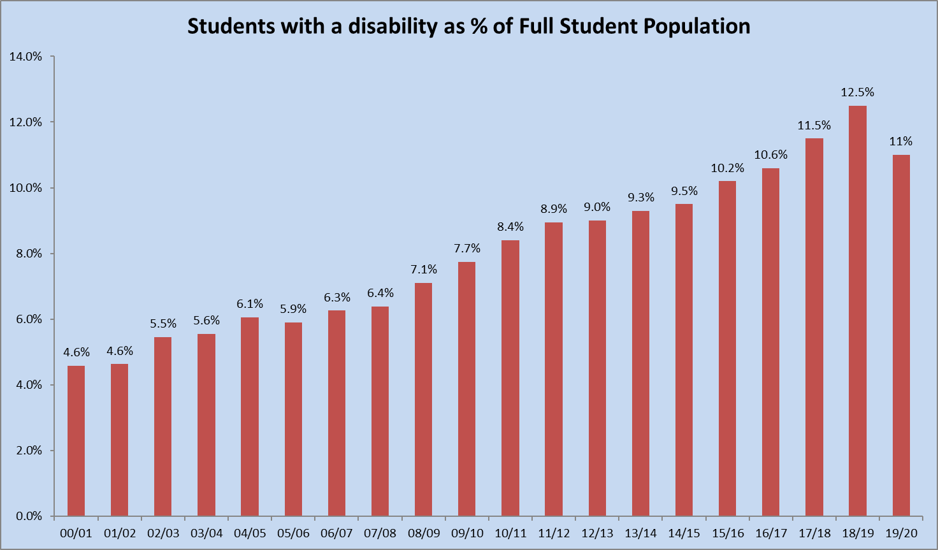

**Breakdown of students with a disability according to UCAS code (last 5 years)**

|  |  |  |  |  |  |
| --- | --- | --- | --- | --- | --- |
| **UCAS Categories (Code)** | **15/16** | **16/17** | **17/18** | **18/19** | **19/20** |
| SpLD (11) | 1,784 | 1,893 | 2,119 | 2,264 | 1,960 |
| Visual Impairment (2) | 49 | 61 | 75 | 62 | 50 |
| Hearing Impairment (3) | 78 | 91 | 106 | 91 | 90 |
| Mobility Impairment (4) | 92 | 99 | 81 | 105 | 80 |
| Autistic Spectrum Disorder (T) | 95 | 119 | 151 | 187 | 215 |
| Mental Health Problems (6) | 598 | 870 | 1,093 | 1,445 | 1,400 |
| Unseen Disability (7) | 546 | 613 | 595 | 632 | 545 |
| Multiple Disabilities (8) | 111 | 143 | 160 | 209 | 240 |
| A Disability not listed above (96) | 291 | 304 | 370 | 422 | 340 |
| **All Disabilities** | **3,644** | **4,193** | **4,750** | **5,417** | **4,920** |

**Breakdown of students with a disability by College**



**Breakdown of students by disability, School and College**



**Breakdown of students by disability and degree level**



**Breakdown of students by disability and degree level as a percentage of total disabled student population**



**Breakdown of students with a disability by domain**



**Number of Online Distance Learners by Disability**

