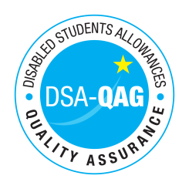
University of Edinburgh - NMH Rates

Period covered - 01/01/2018 through to 31/08/2018

The table below shows NMH rates. The greyed out cells indicate that the NMH provider does not offer these services.

Note: NMH Support Rates shown per hour in the table below.
 | Standard Rate (in-person) |  |  | Distance Learning only (in-person, in-home |  |  | Remote Delivery (e.g. Facetime/Skype or similar) Only
Band 1 Support Assistants | Net | VAT | Total | Net | VAT | Total | Net | VAT | Total
Practical Support Assistant | £22 | 0 | £22
Library Support Assistant | £22 | 0 | £22
Reader | £22 | 0 | £22
Workshop / Laboratory Assistant | £19 / £26 | 0 | £19 / £26
Proof Reader / text checker | £26 | 0 | £26 |  |  |  | £26 | 0 | £26
Band 2 Enhanced Support Assistants
Study Assistant | £32 | 0 | £32
Manual Note Taker | £22 | 0 | £22
Band 3 Specialist Enabling Support
Specialist Note taker (Deaf/Hard of Hearing students) including Electronic Note Taker and Speech to Text Reporter | £35 | 0 | £35
Band 4 Specialist Access and Learning Facilitators
Specialist Mentor – Mental Health | £55 | 0 | £55 |  |  |  | £55 | 0 | £55
Specialist Mentor – AS | £55 | 0 | £55 |  |  |  | £55 | 0 | £55
Specialist 1:1 Study Skills Support - SpLD | £55 | 0 | £55 |  |  |  | £55 | 0 | £55
Specialist 1:1 Study Skills Support - AS | £55 | 0 | £55 |  |  |  | £55 | 0 | £55

