Number of disabled students attending the University of Edinburgh
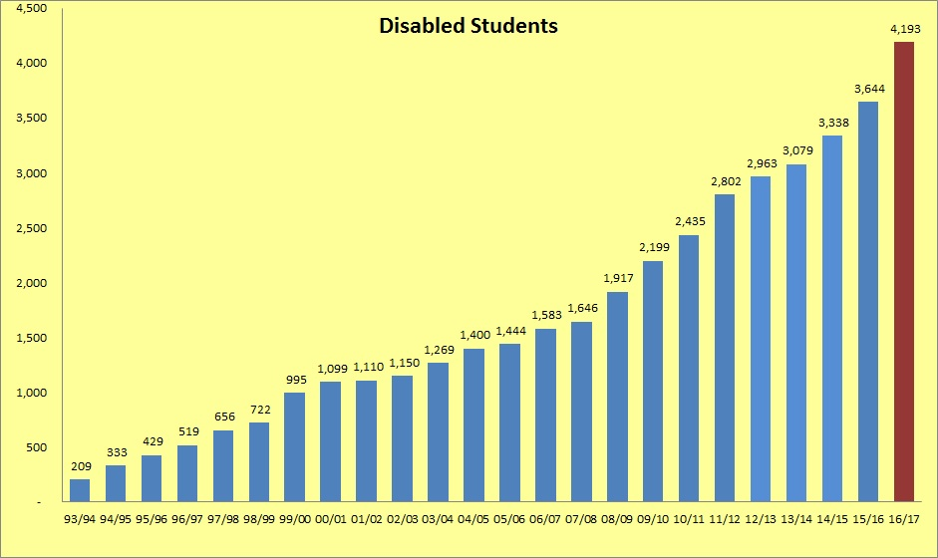

Disabled students – percentage of student population
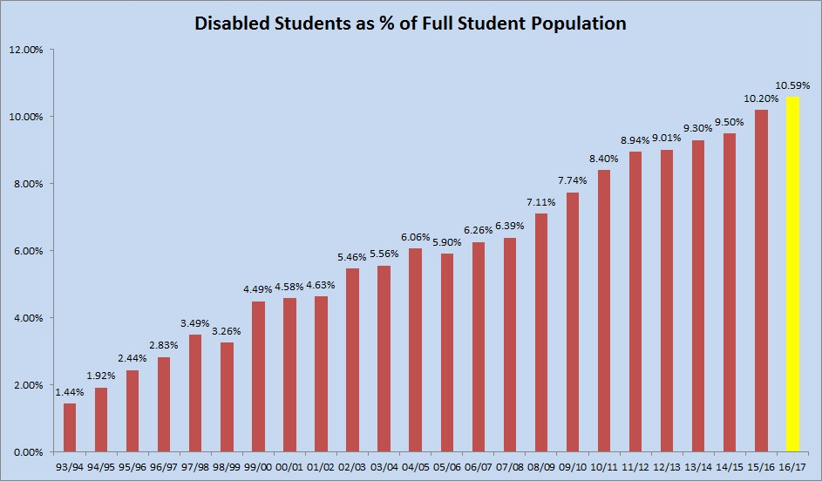

Breakdown of disabled students according to UCAS code

UCAS Categories (Code) | 12/13 | 13/14 | 14/15 | 15/16 | 16/17
SpLD (11) | 1,559 | 1,564 | 1,660 | 1,784 | 1,893
Visual Impairment (2) | 51 | 47 | 41 | 49 | 61
Hearing Impairment (3) | 78 | 82 | 80 | 78 | 91
Mobility Impairment (4) | 84 | 104 | 95 | 92 | 99
Autistic Spectrum Disorder (T) | 39 | 54 | 71 | 95 | 119
Mental Health Problems (6) | 302 | 358 | 495 | 598 | 870
Unseen Disability (7) | 491 | 513 | 535 | 546 | 613
Multiple Disabilities (8) | 78 | 79 | 92 | 111 | 143
A Disability not listed above (96) | 281 | 278 | 269 | 291 | 304
All Disabilities | 2,963 | 3,079 | 3,338 | 3,644 | 4,193

Breakdown of disabled students by College

College | SpLD | Visual | Hearing | Mobility | Autism | Mental Health | Unseen | Multiple | Not listed | Total | %
Humanities and Social Sciences | 1,239 | 42 | 67 | 70 | 63 | 620 | 410 | 102 | 175 | 2,788 | 66%
Medicine and Vet Medicine | 243 | 7 | 12 | 13 | 9 | 81 | 79 | 16 | 57 | 517 | 12%
Science and Engineering | 411 | 12 | 12 | 16 | 47 | 169 | 124 | 25 | 72 | 888 | 21%
Total | 1,893 | 61 | 91 | 99 | 119 | 870 | 613 | 143 | 304 | 4,193
% students by impairment | 45.1% | 1.5% | 2.2% | 2.4% | 2.8% | 20.7% | 14.6% | 3.4% | 7.3%

Breakdown of students by disability, School and College
College of Arts, Humanities & Social Sciences | SpLD | Visual | Hearing | Mobility | Autism | Mental Health | Unseen | Multiple | Not listed | Total
Business | 69 | - | 3 | 4 | 1 | 7 | 19 | 2 | 9 | 114
Edinburgh College of Art | 264 | 1 | 7 | 6 | 8 | 57 | 40 | 12 | 18 | 413
Divinity | 37 | - | - | 1 | 1 | 22 | 6 | 5 | 6 | 78
Economics | 45 | 4 | - | 2 | 1 | 11 | 15 | 1 | 5 | 84
Health in Social Science | 45 | 2 | 5 | 2 | 2 | 26 | 26 | 4 | 11 | 123
History and Classics & Archaeology | 130 | 1 | 4 | 5 | 14 | 59 | 31 | 8 | 22 | 274
Law | 56 | 9 | 13 | 6 | 2 | 45 | 29 | 13 | 8 | 181
Literature, Languages & Cultures | 104 | 6 | 7 | 5 | 13 | 107 | 65 | 11 | 20 | 338
Philosophy, Psychology & Language Sciences | 109 | 3 | 3 | 10 | 7 | 84 | 40 | 11 | 19 | 286
Moray House School of Education | 175 | 6 | 16 | 7 | 4 | 39 | 46 | 6 | 14 | 313
Social & Political Sciences | 149 | 4 | 4 | 14 | 2 | 104 | 53 | 15 | 19 | 364
Centre for Open Learning | 26 | 4 | 4 | 7 | 8 | 33 | 25 | 9 | 11 | 127
HSS General Degree or Visiting Student | 33 | 2 | 1 | 1 | - | 26 | 15 | 5 | 13 | 93
College Total | 1,239 | 42 | 67 | 70 | 63 | 620 | 410 | 102 | 175 | 2,788
College of Medicine and Veterinary Medicine | SpLD | Visual | Hearing | Mobility | Autism | Mental Health | Unseen | Multiple | Not listed | Total
Medicine (SBCLS, SCSCH, SMCM) | 58 | 2 | 1 | 3 | 1 | 9 | 13 | 2 | 9 | 98
Biomedical Sciences | 71 | 2 | 3 | 5 | 3 | 31 | 19 | 6 | 17 | 157
Royal (Dick) School of Veterinary Studies | 80 | - | 4 | 2 | 4 | 27 | 27 | 4 | 14 | 162
Clinical Sciences | 23 | 2 | 2 | - | - | 7 | 12 | 4 | 14 | 64
Molecular & Clinical Medicine | 11 | 1 | 2 | 3 | 1 | 7 | 8 | - | 3 | 36
College Total | 243 | 7 | 12 | 13 | 9 | 81 | 79 | 16 | 57 | 517
College of Science and Engineering | SpLD | Visual | Hearing | Mobility | Autism | Mental Health | Unseen | Multiple | Not listed | Total
Biological Sciences | 64 | 1 | 2 | 3 | 7 | 35 | 23 | 2 | 13 | 150
Chemistry | 32 | 2 | 2 | 1 | 2 | 20 | 13 | 2 | 10 | 84
Engineering | 80 | - | 3 | 3 | 4 | 24 | 22 | 2 | 9 | 147
Geosciences | 110 | 4 | 4 | 3 | 5 | 31 | 26 | 6 | 14 | 203
Informatics | 47 | 2 | - | 4 | 11 | 25 | 16 | 7 | 14 | 126
Mathematics | 18 | - | 1 | 1 | 5 | 7 | 11 | 2 | 3 | 48
Physics & Astronomy | 51 | 3 | - | 1 | 13 | 25 | 13 | 2 | 8 | 116
CSE General Degree or Visiting Student | 9 | - | - | - | - | 2 | - | 2 | 1 | 14
College Total | 411 | 12 | 12 | 16 | 47 | 169 | 124 | 25 | 72 | 888
Total for all Schools | 1,893 | 61 | 91 | 99 | 119 | 870 | 613 | 143 | 304 | 4,193
Percentage students by impairment | 45.1% | 1.5% | 2.2% | 2.4% | 2.8% | 20.7% | 14.6% | 3.4% | 7.3%

Breakdown of students by disability and degree level

UCAS Categories (Code) | UG | PGT | PGR | Total
SpLD (11) | 1,484 | 276 | 133 | 1,893
Visual Impairment (2) | 29 | 22 | 10 | 61
Hearing Impairment (3) | 39 | 44 | 8 | 91
Mobility Impairment (4) | 60 | 24 | 15 | 99
Autistic Spectrum Disorder (T) | 87 | 20 | 12 | 119
Mental Health Problems (6) | 631 | 162 | 77 | 870
Unseen Disability (7) | 397 | 139 | 77 | 613
Multiple Disabilities (8) | 85 | 36 | 22 | 143
A Disability not listed above (96) | 162 | 103 | 39 | 304
All Disabilities | 2,974 | 826 | 393 | 4,193

Breakdown of students by disability and degree level as a percentage of total disabled student population

UCAS Categories (Code) | UG | PGT | PGR | Total
SpLD (11) | 35% | 7% | 3% | 45%
Visual Impairment (2) | 1% | 0.5% | 0.2% | 1%
Hearing Impairment (3) | 1% | 1.0% | 0.2% | 2%
Mobility Impairment (4) | 1% | 0.6% | 0.4% | 2%
Autistic Spectrum Disorder (T) | 2% | 0.5% | 0.3% | 3%
Mental Health Problems (6) | 15% | 4% | 2% | 21%
Unseen Disability (7) | 9% | 3% | 2% | 15%
Multiple Disabilities (8) | 2% | 1% | 1% | 3%
A Disability not listed above (96) | 4% | 2% | 1% | 7%
All Disabilities | 71% | 20% | 9% | 100%

Breakdown of international and EU disabled students (last 5 years)

Undergraduate
 | 2012/13 | 2013/14 | 2014/15 | 2015/16 | 2016/17
EU | 98 | 108 | 125 | 126 | 142
Overseas | 266 | 293 | 305 | 314 | 393

Taught Postgraduate
 | 2012/13 | 2013/14 | 2014/15 | 2015/16 | 2016/17
EU | 68 | 34 | 34 | 51 | 92
Overseas | 96 | 67 | 75 | 120 | 204

Research Postgraduate
 | 2012/13 | 2013/14 | 2014/15 | 2015/16 | 2016/17
EU | 30 | 30 | 27 | 38 | 43
Overseas | 52 | 53 | 58 | 67 | 74

