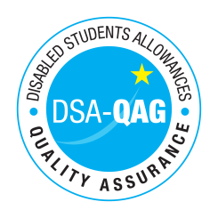
University of Edinburgh, Student Disability Service - NMH Rates

Period covered - 01/08/2016 through to 31/07/2017

Effective Date (e.g. 1 July 2016): 1 August 2016
The table below shows NMH rates. The greyed out cells indicate that the NMH provider does not offer these services.

Note: NMH Support Rates shown per hour in the table below. All quoted rates are VAT exempt.
Band 1 Support Assistants | Net | VAT | Total
Practical Support Assistant |  |  | £22
Library Support Assistant |  |  | £22
Reader |  |  | £22
Scribe |  |  | -
Workshop / Laboratory Assistant |  |  | £19 / £22
Sighted Guide |  |  | -
Proof Reader |  |  | £26
Band 2 Enhanced Support Assistants
Study Assistant |  |  | £30
Examination Support Worker |  |  | -
Manual Note Taker |  |  | £22
Band 3 Specialist Enabling Support
Communication Support Worker |  |  | -
Lip Speaker |  |  | -
Electronic Note taker including Specialist Note Taker, Speech to Text Reporter |  |  | £35
Electronic Notetaker for VI students requiring Braille |  |  | -
Specialist Transcription Services |  |  | -
Mobility Trainer |  |  | -
Band 4 Specialist Access and Learning Facilitators
Specialist Mentor |  |  | £56
Specialist One to One Study Skills Support |  |  | £59
BSL Interpreter |  |  | -
Language Support Tutor for deaf students |  |  | -
Assistive Technology Trainer |  |  | £31

