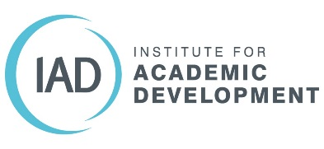

What have you done and what does it mean?
This worksheet provides a basic structure and a prompt for you to record your previous experience and what it means in terms of skills and achievements. It will help you to identify areas of strength and possibly areas you would like to develop during postgraduate study.
If you already have a well-developed curriculum vitae (CV) you may find you have already considered many of the questions below. Further reflection on your experience may help you to identify what you would like to get out of postgraduate study.

Highlights of your employment, education, and extra-curricular activities

If you don’t already have a CV then start by noting down the main activities you have been involved in in recent years. Give dates, location, and a brief outline of your role / involvement.
Dates | Name of Employment / Education, etc. | Location | Brief outline of role / involvement
For each experience highlighted, reflect on the questions below

What were your main successes or achievements?

These could be a direct impact of something you did at work; an essay, presentation, or project that went particularly well during previous study; or something you’ve contributed to outside work and study.

What were your main strengths in terms of skills demonstrated?

These could be specific technical or subject related skills, or more general skills such as communication, team work, problem solving, negotiation, organisation, etc. Note not just the skills but brief examples of when and how you feel you have demonstrated them.

What were the main challenges?

Reflect on what you found difficult during your experience. What made it difficult? Was it an external factor that you couldn’t control or something else? A skill you felt less confident using, lack of experience?

After reflecting on the different aspects of your experience prior to starting your postgraduate studies, answer the question below.

Can you identify gaps in your skill set, or experience that you would like to address through postgraduate study or other activities during this time?

