Using mind maps

What are mind maps?
Mind maps are a way of generating content and ideas at the early stages of an assignment, or in preparation for meetings, projects and so on.
- Start with the main topic at the centre of the page or screen
- Think about important themes / issues / aspects related to it
- Put each one on a separate spoke, radiating out from the main topic
- Explore each individual 'spoke' by adding relevant issues, ideas, information thoughts, questions and so on
  - You can carry this to as many steps as you need.
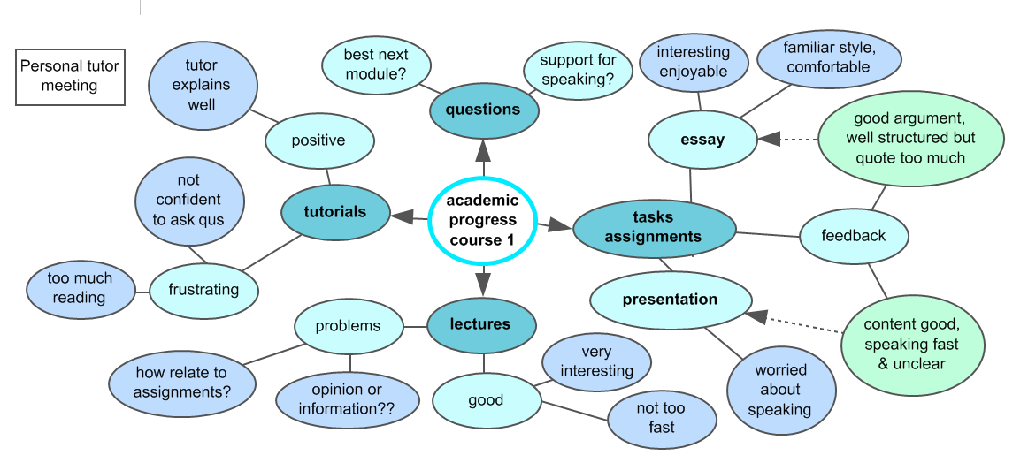
You can also use mind maps at the planning stage of an assignment to help organise, prioritise and structure what you want to say.
Two kinds of mind mapping software are available at Edinburgh. Read the guides to find out more about how they work and what you can use them for:
Inspiration
The University of Edinburgh IS iskills guide is available at: http://www.docs.is.ed.ac.uk/skills/documents/3719/3719.pdf
MindGenius
The University of Edinburgh IS iskills guide is available at: http://www.docs.is.ed.ac.uk/skills/documents/3716/3716.pdf

