Consider some of the processes involved in reaching for that higher level of analysis.
How do you do it?
Consider an every-day situation, such as buying a Laptop, car or holiday, what do you do?
Do you take the first one that is offered or do you take some time to think logically, look at the background information and consider all aspects before making the purchase?
You probably do the latter, you don’t just accept, you consider.
This is the process that you should apply throughout your dissertation. Try relating these aspects/processes to your dissertation. Use the grid on the next page to get you thinking about how you can employ these processes.

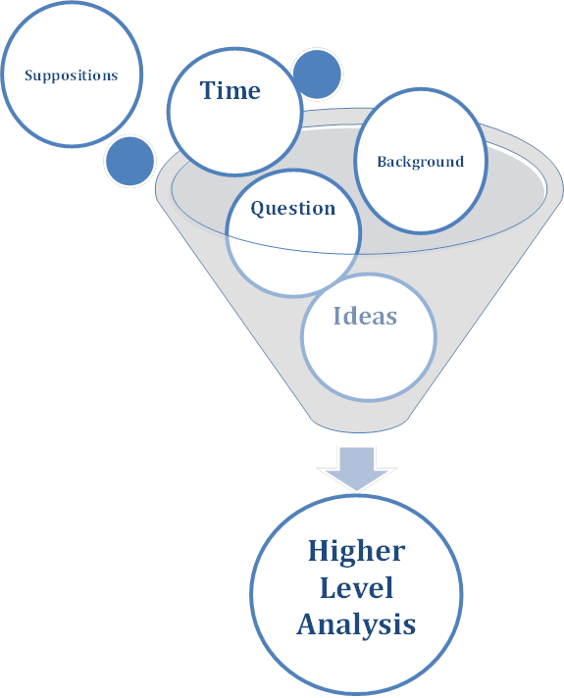

Remember, allowing time to consider questions will aid in reaching a higher level of analysis.

Aspect | Specific For Your Dissertation | Notes – now take it further, think a bit more!
Background – debate, controversies, paradigms |  | Why is this important?
Where could this research lead? |  | What impact will this have?
What questions are important? |  | Justify using these questions
Suppositions- musing - pondering |  | Where could these lead?
Context |  | Why is this relevant?
What assumptions have I made? |  | Understanding the assumptions – how does this affect my work?
Are there holes in my work/argument/thought? |  | How do these affect my results?
Time Allocation |  | Have I left enough time for thinking!

