External Examiners

ACADEMIC RESPONSE COORDINATOR

Index

- Role
- Homepage
- Reports Requiring Response
- Issue Response
- Suggestion Response
- Commendation Response
- Submitting Response and E-mail
- Completed Responses
- Guidance
- Upcoming Reports
- Viewing this Document

Role
The Academic Response Coordinator is responsible for the reviewing, collating feedback prepared by designated readers and responding to External Examiner reports. They can also monitor upcoming reports due to be submitted by the External Examiner, requiring their response.

Homepage
When Logging into EERS, your homepage is displayed. The information available is presented in several containers
- Reports With potential Data Protection Breaches
- Guidance
- Reports Requiring a Response
- Upcoming Reports
- Completed Responses

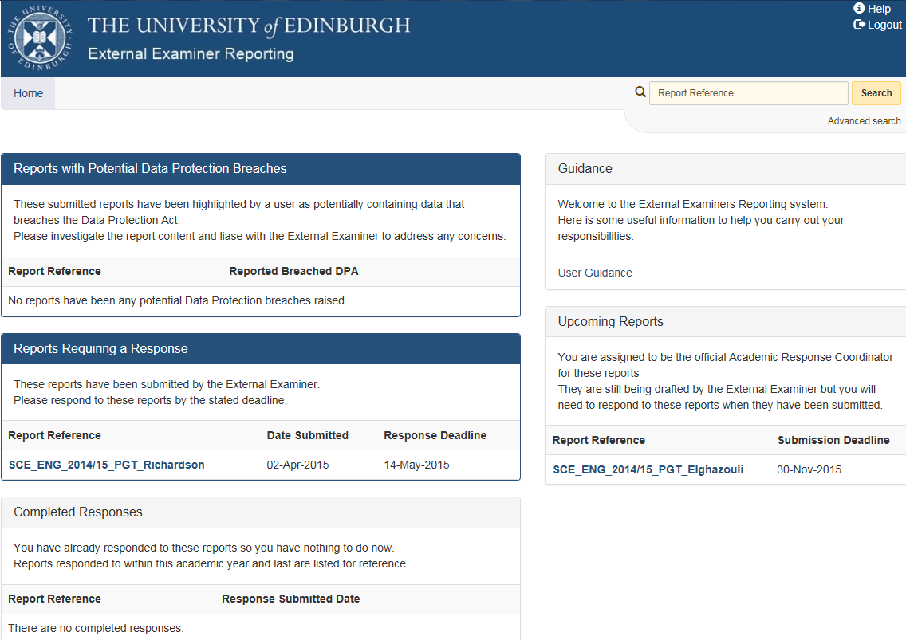

The guidance container contains a link to the Student Systems support pages for the External Examiners reporting System.

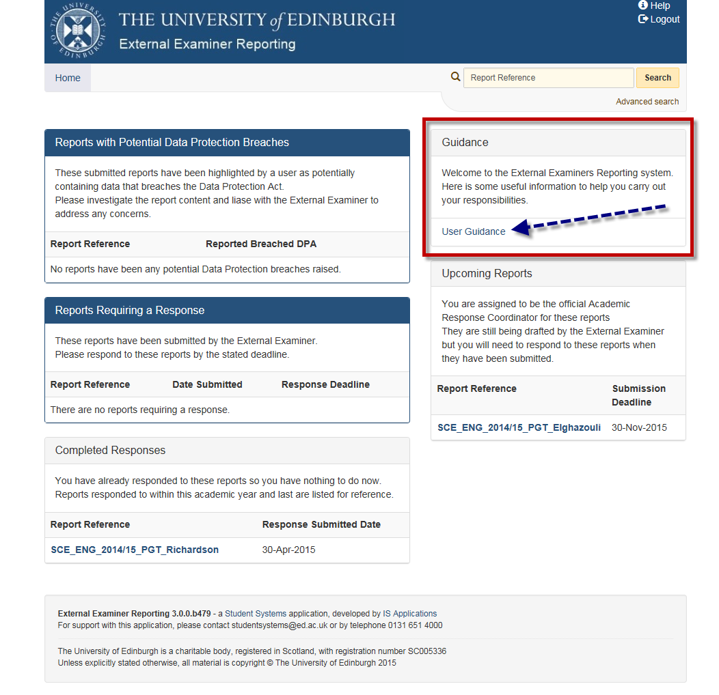

The Reports with Potential Data Protection Breaches
- Any EERS user has the ability to flag possible data protection breaches when viewing a submitted report.
- Reports with possible data protection breaches are listed here.
- Academic response coordinators along with key school contacts, school contacts and college contacts have access to review these flagged reports
- Guidance on data protection issues can be found via the following link:
Data Protection Issues Guide
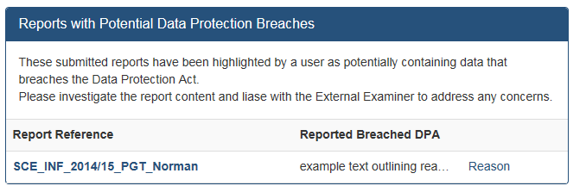

Responses to External Examiner Reports that have been completed are available to review.

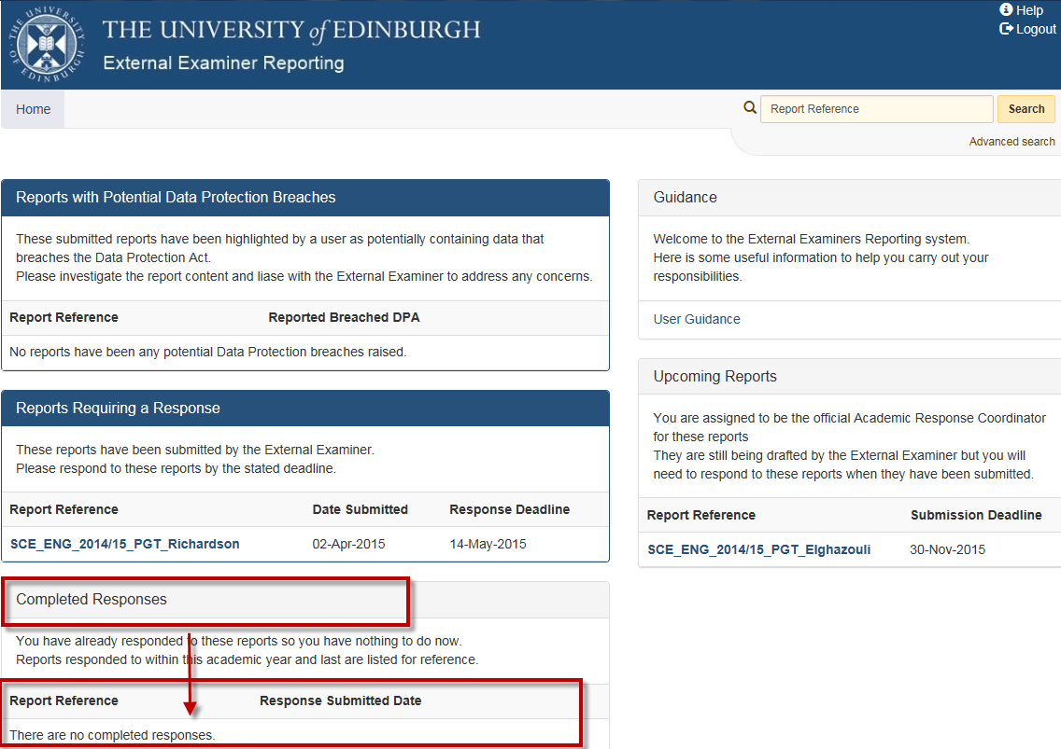

Reports Requiring Response

List of reports submitted by External Examiners are listed here in the form of report links.
- Information on reports is displayed under Report reference, Date Submitted, Response Deadline
- To complete your responses to the External Examiners report click the report reference link highlighted by Red arrow.

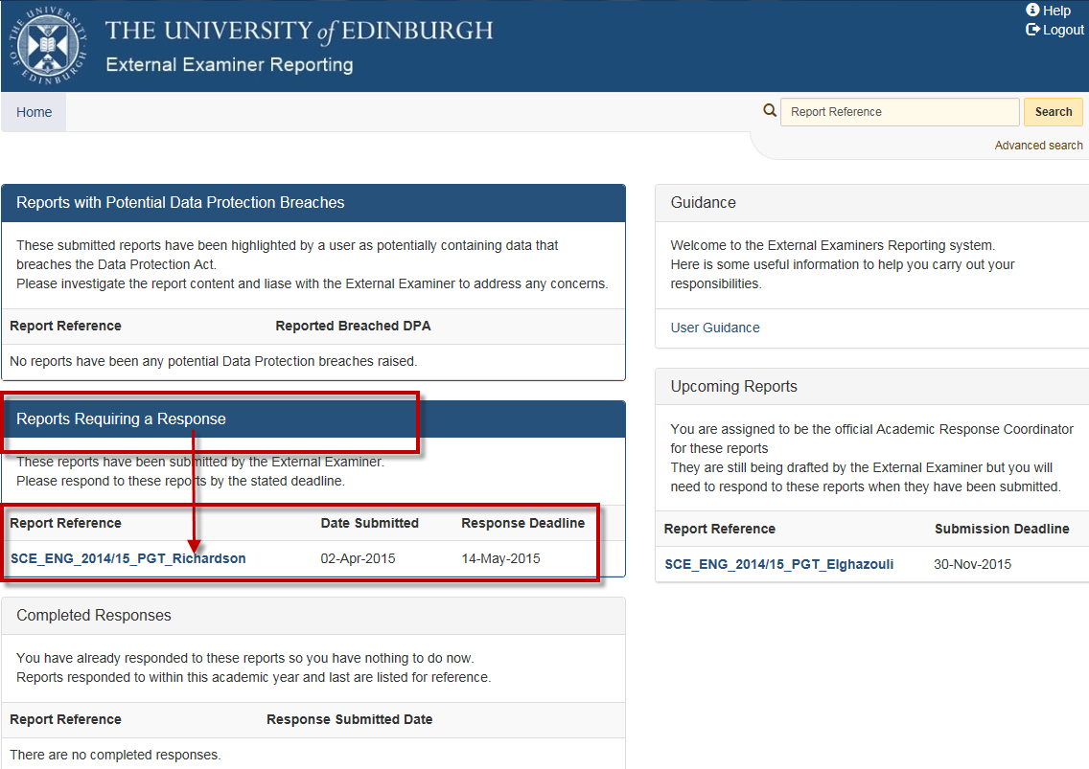

The Draft Response page is displayed -
You are presented with:-
- details of all programmes and courses examined during the report period
- An extract of all issues, suggestions and commendations from the report. To view the complete report click on the ‘view original report’
- issues are displayed in red, suggestions in yellow and commendations in green
- a response submission email which may be personalised before EERS sends to the examiner with your responses
It is recommended that you provide responses to all issues, suggestions and commendations raised by the examiner, however responses to issue and suggestions are mandatory.
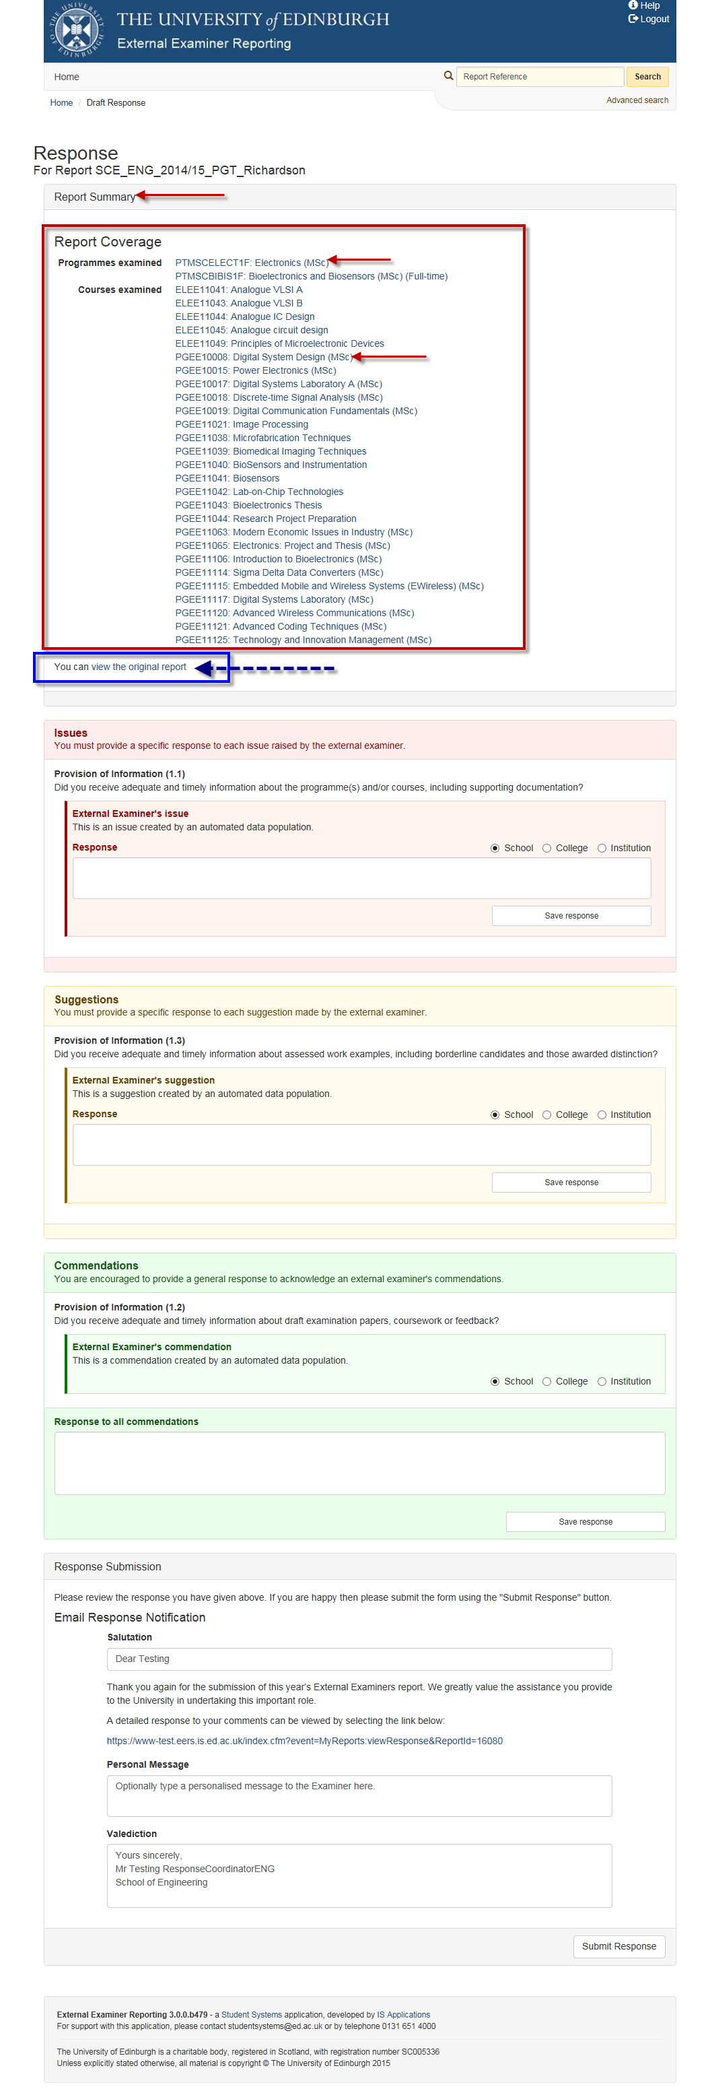

Issue Response
The draft response page will display any issues from the External Examiners Report. Issues are displayed as follows
- Issues are highlighted red. A note advises that you must provide a specific response to the external examiner
- Highlighted by blue rectangle, the area of the external examiners report that a issue has been raised against.
- Highlighted by red rectangle, the external examiners issue text will be displayed for you to reference
- Collate responses from your colleagues and enter the response in the free text container, this has a 4,000 character limit.
- Highlighted by green circle, the radio button you use to can designate whether the issue is a school issue, college issue or institutional issue
- Where you believe that the issue or suggestion is relevant not only to the school but to the College or Institution, please use the radio buttons available to escalate further.
- Click “Save Response” when response has been written.

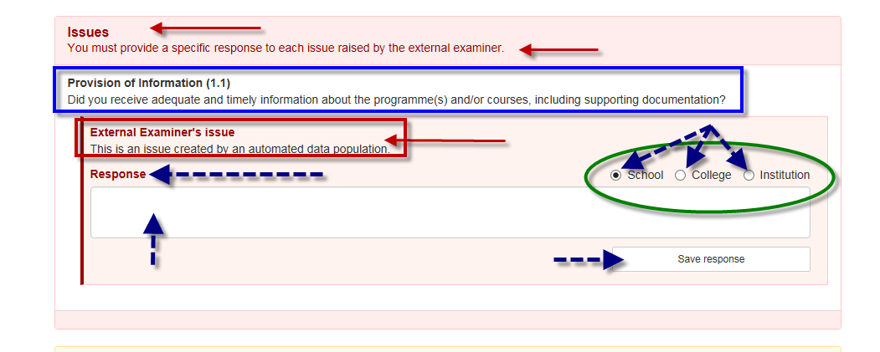

Suggestions Response

The draft response page will display any “Suggestions” from the External Examiners Report. Suggestions are displayed as follows
- Suggestions are highlighted yellow. A note advises that you must provide a specific response to the external examiner to each suggestion made
- Highlighted by blue rectangle is the area of the external examiners report that a Suggestion has been noted against.
- Highlighted by red rectangle, the external examiners suggestions text will be displayed for you to reference
- A free text field is available to write your response, 4,000 character limit
- Highlighted by green circle, using the radio button you can designate whether the suggestion is at school level, college level or institutional level
- Click “Save Response” when response has been written.

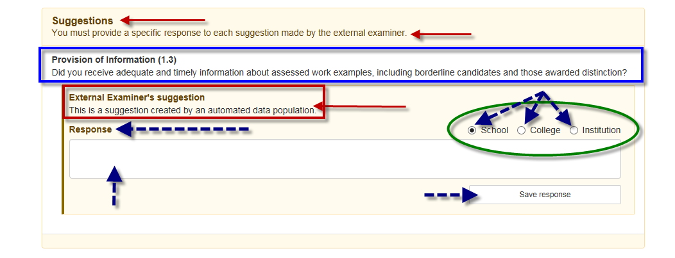

Commendations Response
The draft response page will display any “Commendations” from the External Examiners Report. Suggestions are displayed as follows
- Commendations are highlighted green. A note advises that you are encouraged to provide a specific response to the external examiner to each commendation made
- Highlighted by blue rectangle is the area of the external examiners report that a commendation has been noted against.
- Highlighted by red rectangle, the external examiners commendation text will be displayed for you to reference
- A free text field is available to write your response, 4,000 character limit
- Highlighted by blue circle, using the radio button you can designate whether the commendation is at school, college or institutional level
- Click “Save Response” when response has been written.

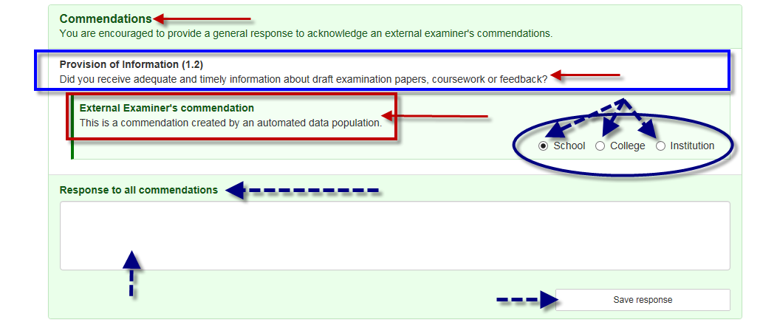

Response Submission and Email
Scrolling down to the very bottom of the draft response page, we see the section for writing a response e-mail and submitting the response to the report.
Note: External examiners can also be e-mailed outwith the system for other matters.
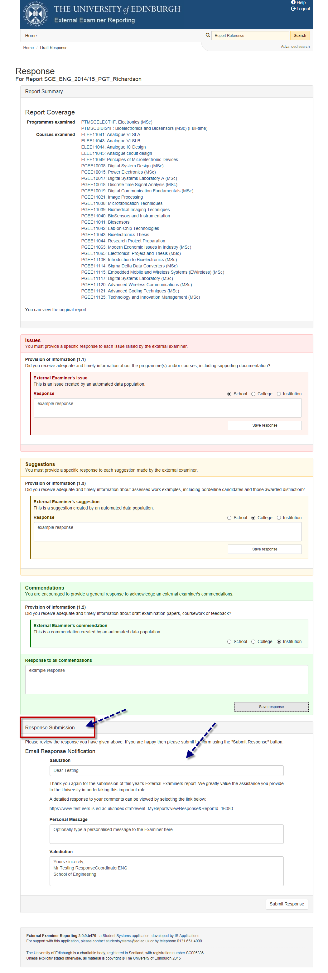
The Email Response Notification has several fields of interest for making theemail more personal
- In the Salutation field you may input the name of the External Examiner
- The paragraph below reflects the University’s thanks whilst providing a link to the full submitted external examiners report

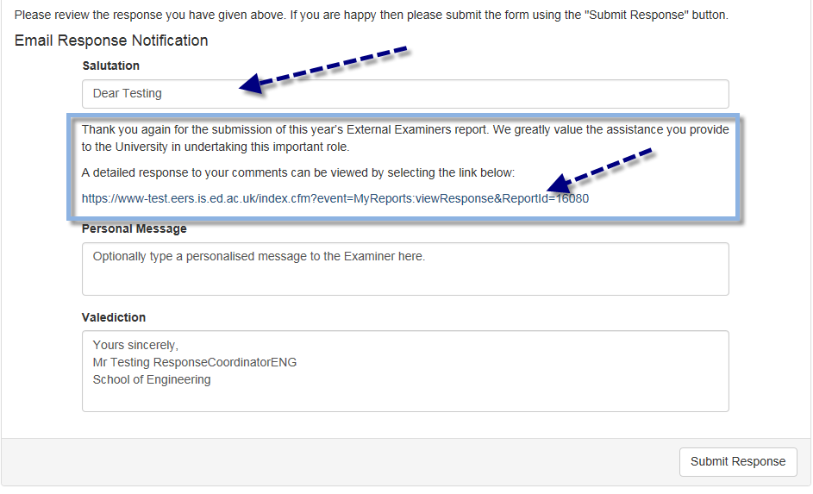

A personal message field is provided to allow you to personalise your email if you wish.
- Valediction is available to amend to make more a personal signoff.
- Finally the “Submit Response” button is available to submit the report with all the saved responses to the Issues, Suggestions, Commendations

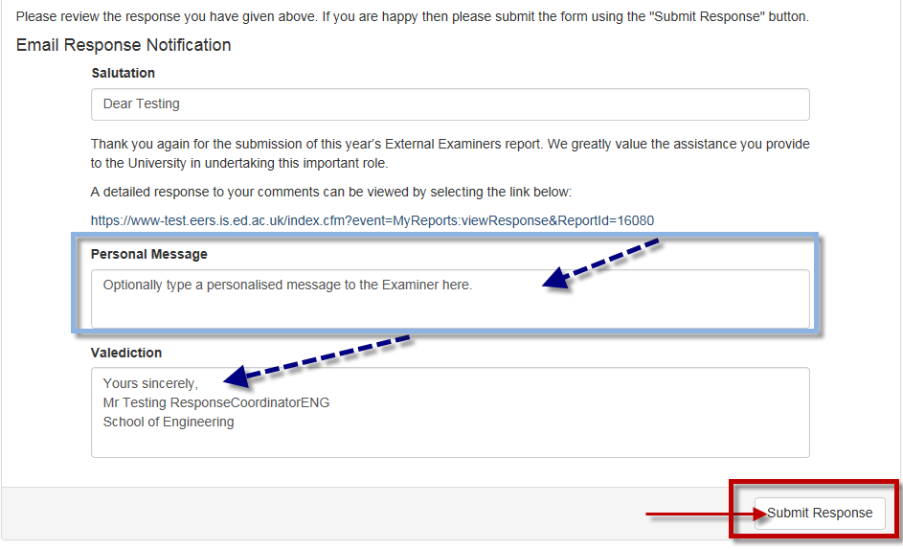

Completed Response
You as the Academic Reponse Coordinator have now completed and saved the reponses required and now the full report response has been submitted
- From the homepage we can now see the report has moved from the “Reports Requiring a Response” container to the “Completed Responses” container.
- The Completed Responses container will list the reports that you have responded to and have nothing further to action.
- The reports are listed are here for reference and each report is still an active link to the report should you require revisiting a report for information
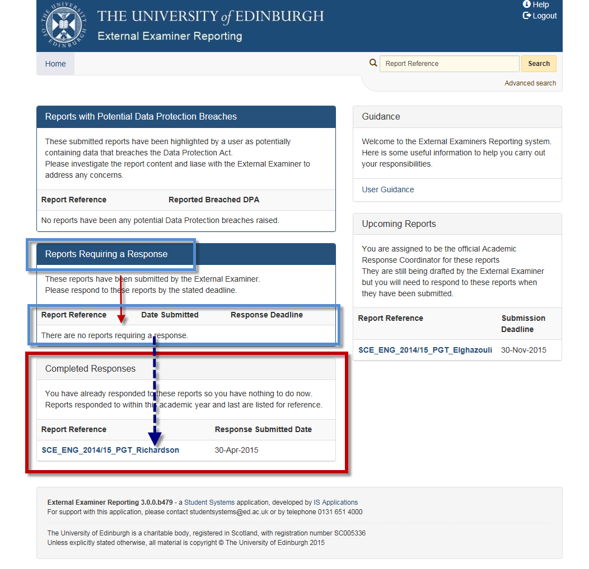

Guidance
A guidance section is available with a link to the Student Systems Userguide webpages
- Click the User Guidance link to access the Userguide pages
The Userguide page will display with links to all the guidance documents and tutorials for each role in the system
- The guidance material for each role in the system is open to view for everyone so as to allow users to see each others view in the system
- http://www.studentsystems.ed.ac.uk/staff/User_Guides/External_Examiners/online_tutorials.htm

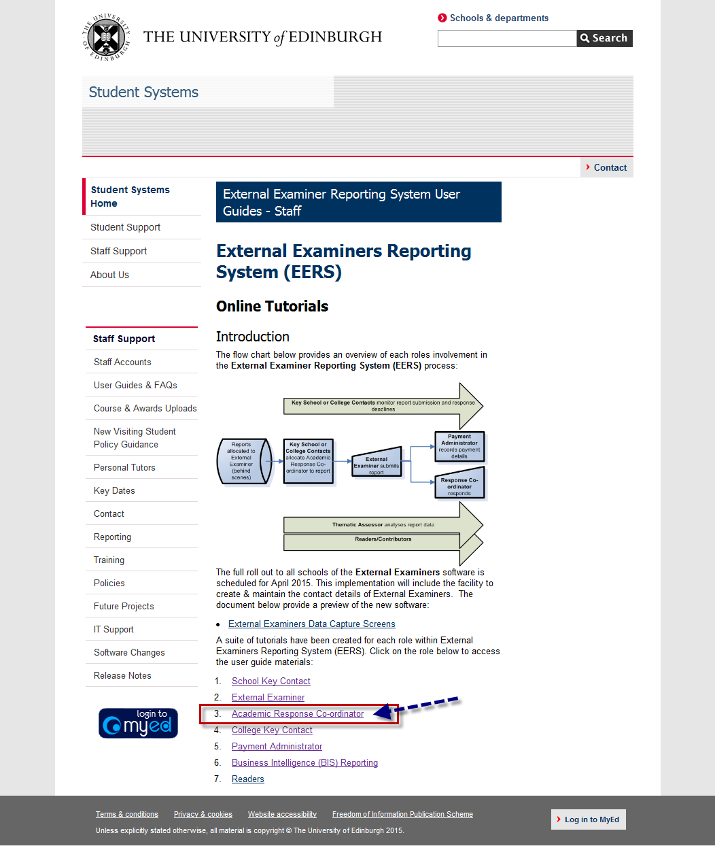

Upcoming Reports

The “Upcoming Reports” container holds a link to all the reports still being drafted by external examiners. These reports are not ready for response yet but can be monitored via this container
- Submission deadline is displayed beside each report
- Reports will move from “Upcoming Reports” container to the “Reports Requiring a Response” container along to the “Completed Responses” container as we move through the processes
- Click the active Report link to view report summary information

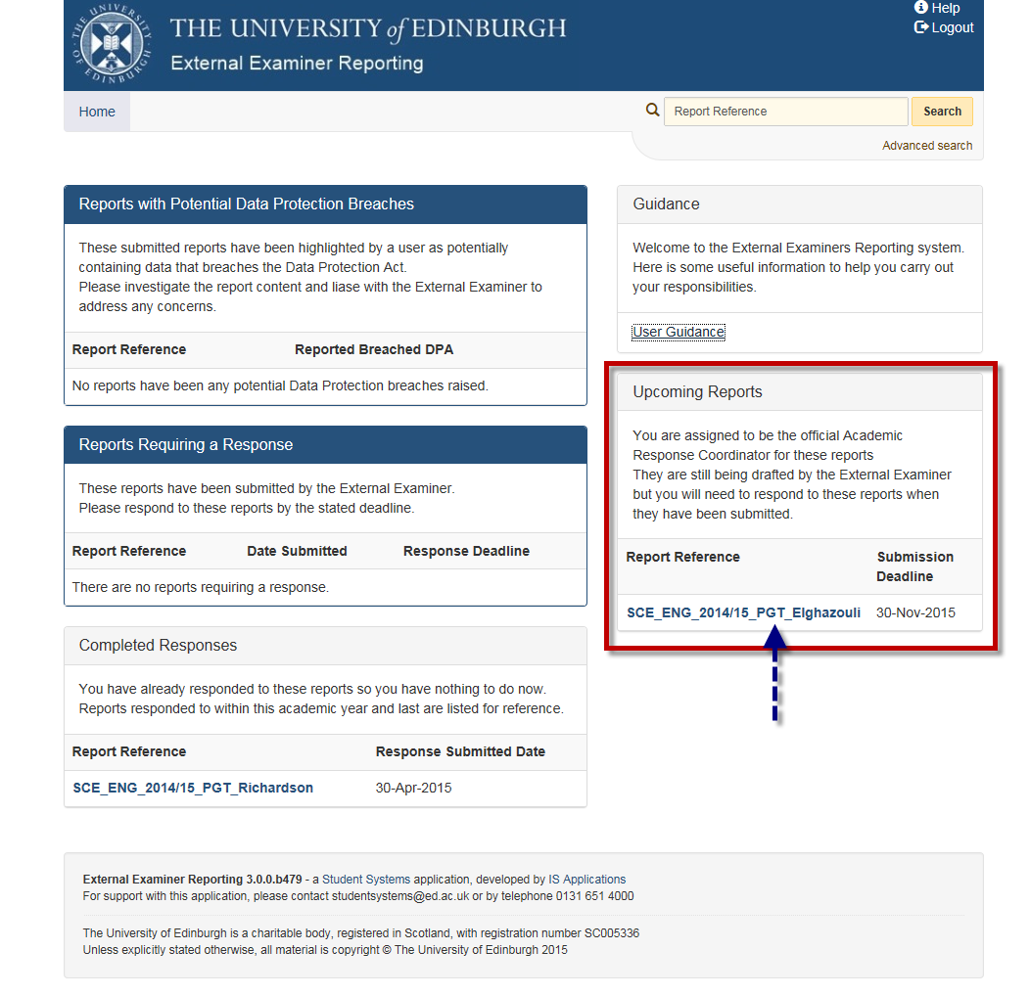

The Report Details page is displayed. Information is broken into four sections
- Summary: Basic summary information regading college and school where report is based along with appointment information.
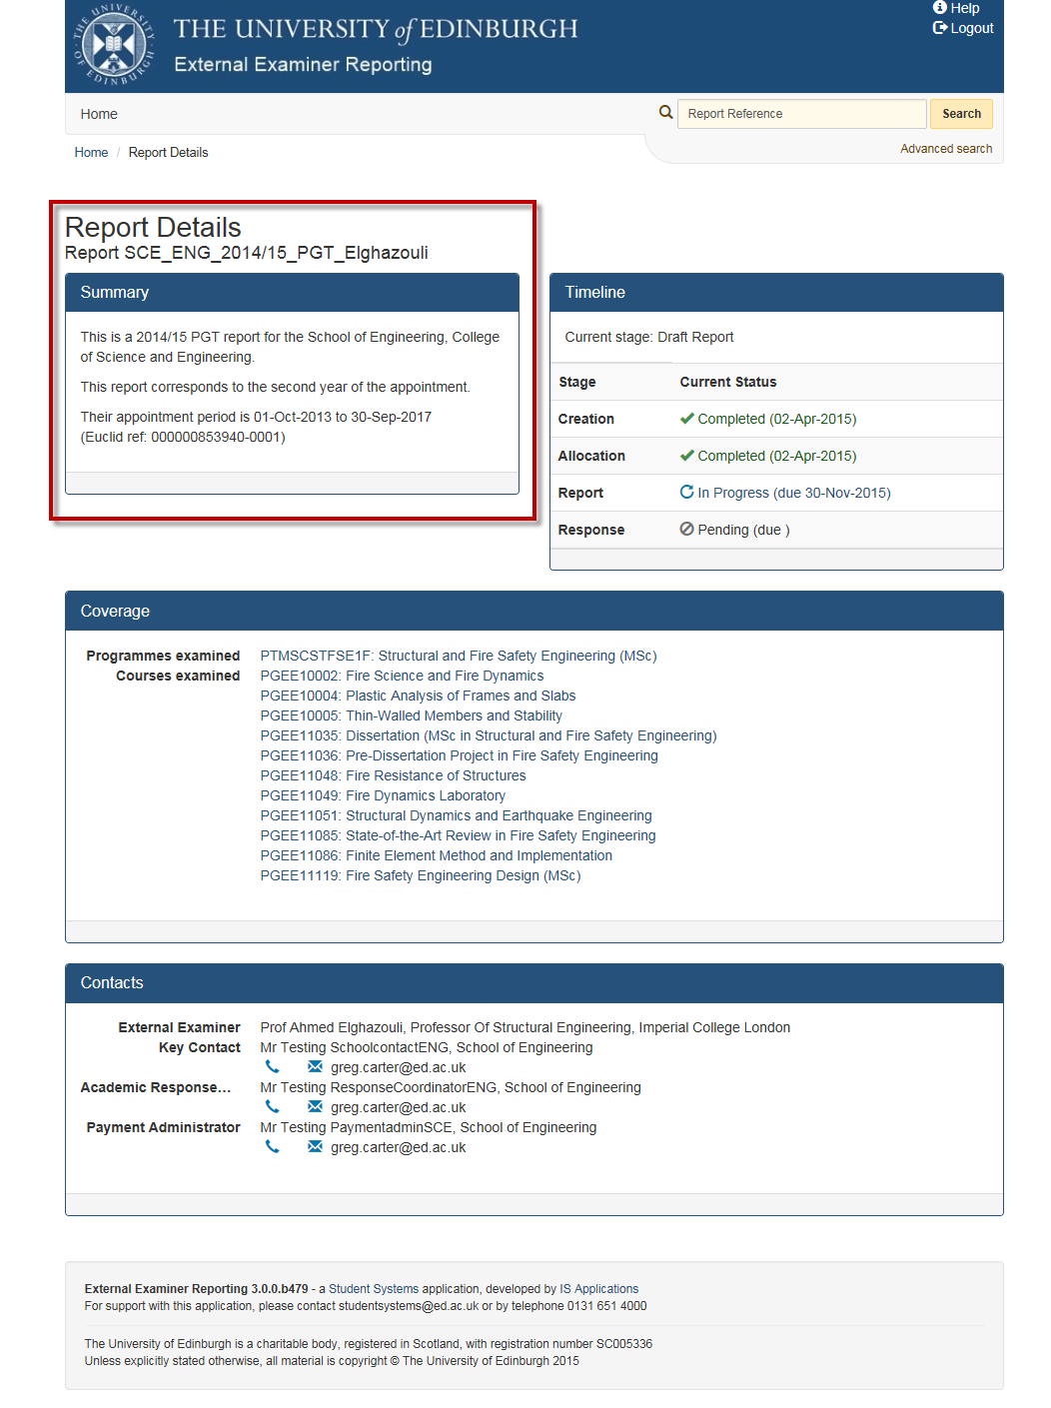
- Timeline: Current status of report along with relevant dates that report has changed status status or is due to change status

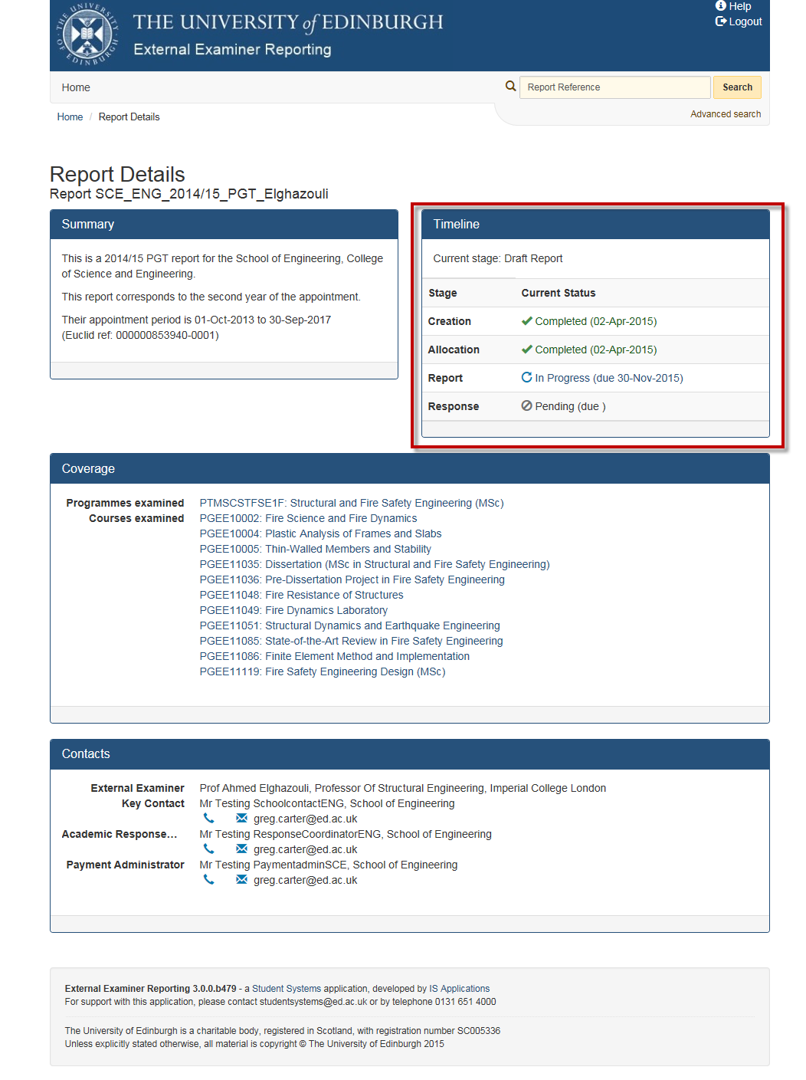

- Coverage: Programmes examined, courses examined

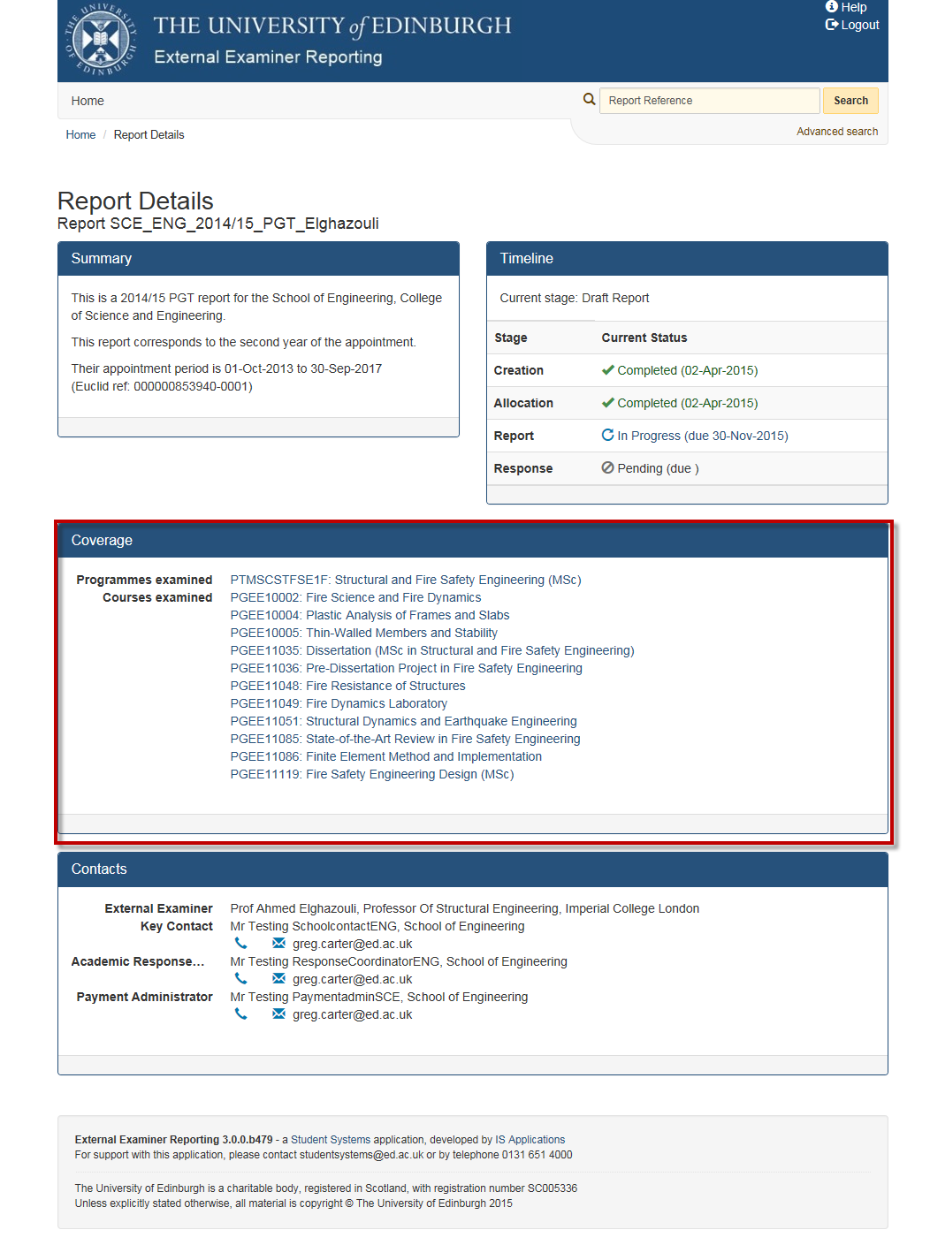

- Contacts: Contact information of all relevant staff and there role to this report

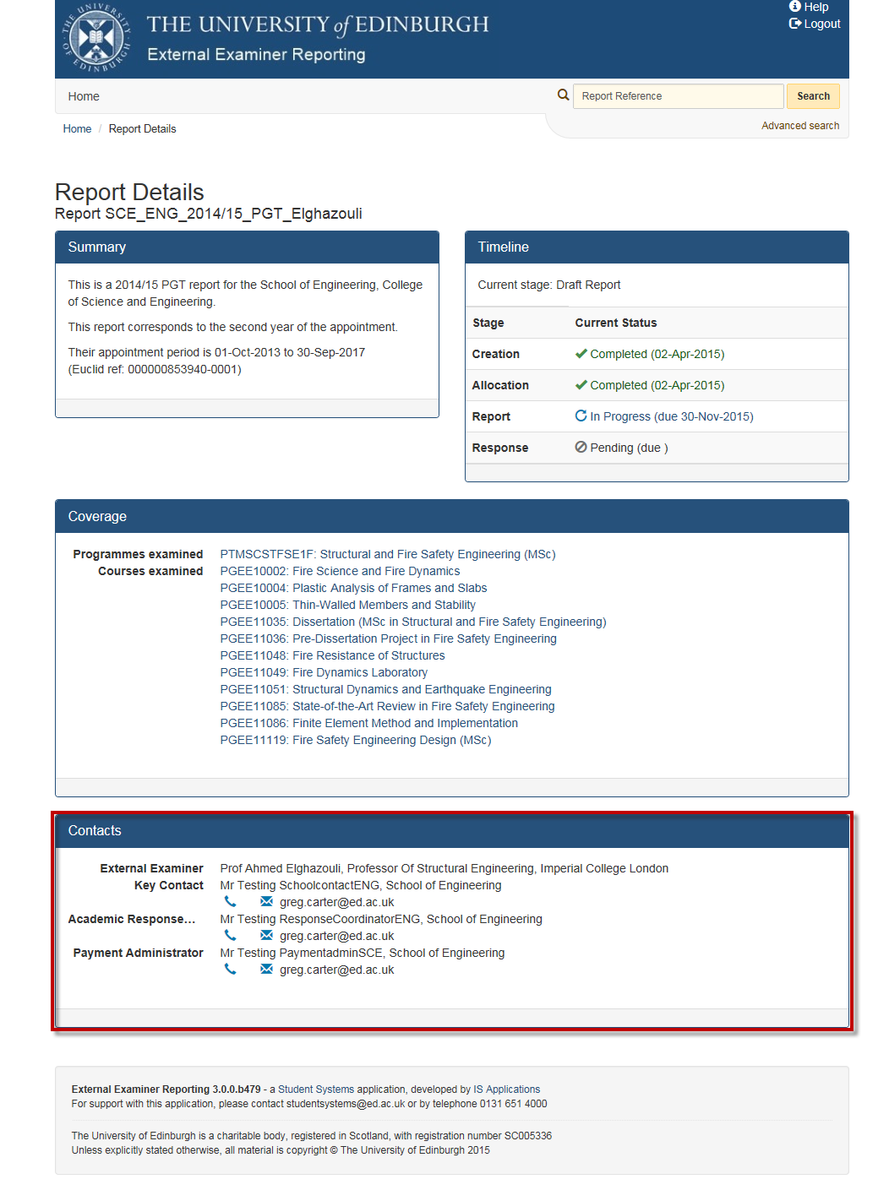

Viewing this Document
Should the images in this Word document appear too small, please adjust the view by completing the following steps:
- In the Banner at the top of your word document click The “View” Tab
- Click the “Zoom” button

Zoom options will be displayed
- Select the “Zoom To” option “ 200% ”
- Click “OK” button to apply
- Larger view of document will be displayed

