You should take time to consider your dissertation choice. Think about the aspects involved in producing a dissertation.
Also consider the practicalities – be realistic, is it achievable?

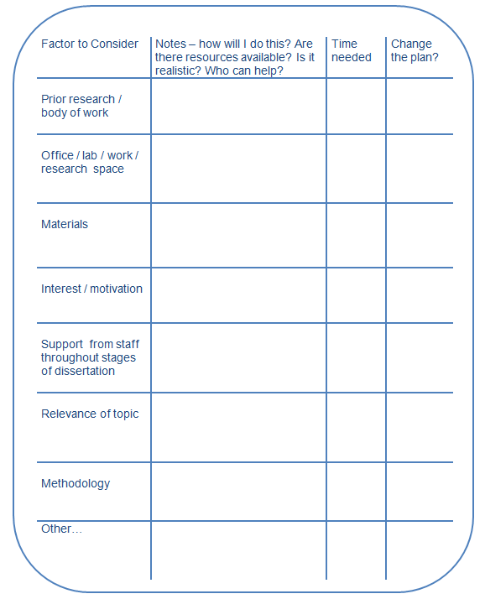

To get you started thinking about your dissertation choice use the dissertation choice table provided (please find on next page).
Every dissertation is different, so use it as a guide or prompt to get you thinking about your dissertation. Perhaps you may want to produce your own guide specific to your dissertation.

Remember one of the best sources of advice and support throughout your dissertation are your supervisors. They have a wealth of experience in the practicalities of students’ masters dissertations. Other members of staff from your programme may also be able to help – check with your course handbook.

Factor to Consider | Notes – how will I do this? Are there resources available? Is it realistic? Who can help? | Time  needed | Change the plan?
Prior research / body of work

Office / lab / work / research space

Materials

Interest / motivation

Support from staff throughout stages of dissertation

Relevance of topic

Methodology
Other…

