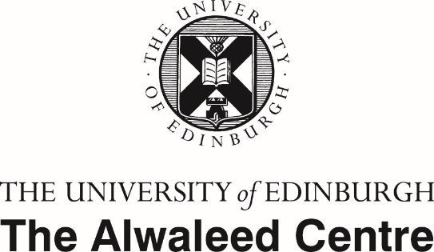
Thank you for entering our photography competition!
- Please provide us with your details in the box below.
- Please read the terms & conditions carefully.
- If you agree to the terms and conditions, please make sure you electronically sign and date this document on page 3.
- Once you have done this, please email this document, along with your picture(s) to: thealwaleedcentre.ed.ac.uk

First name:

Surname:

Location (town/city/country) where the picture(s) were taken:
Caption per photos (up to 2 photos can be entered per person): | Caption photo 1:
 | Caption photo 2:

TERMS AND CONDITIONS:
COMPETITION ENTRY REQUIREMENTS:
- A maximum of two photographs may be submitted per person. However, only one cash prize will be awarded per individual.
- The deadline for submissions is midnight on Friday 30th September 2016. Entries received after this deadline will not be considered by the panel.
- No third party entries, bulk entries or entries submitted by agents will be accepted.
- We cannot be held responsible for entries which are lost or corrupted nor for any entries to the competition which the University of Edinburgh (UoE) does not receive as a result of any technical error, however caused. In addition UoE cannot accept any liability for any difficulties experienced in submitting an entry. Proof of entry or submission will not be deemed to be proof of receipt.
- Photographs must be at least 1800 x 1200 pixels to be considered and they must be saved in a JPEG format. Photographs which are not submitted in this format may not be accepted.
- Any photographs submitted must be the entrant’s own. If it is discovered that a photograph submitted for this competition is not the original work of the entrant, then the photograph will be disqualified. If prize money has been awarded for a photograph which is later discovered to not be the original work of the entrant, the UoE reserves the right to reclaim the prize money.
- By entering a photograph into this competition, entrants agree that the photograph may be used by the UoE for online promotion, social media, PR, marketing and exhibitions.
- Selected entries may be reproduced in various publications and outlets to promote the work of UoE.
- The successful entries may be displayed indefinitely on a UoE website.
- UoE reserves the right to display all the successful images on their website and archive for an indefinite period unless the entrant requests otherwise. The photographer will be credited whenever the work is published or displayed.
- No copyright is transferred to UoE in respect of any works entered or accepted.
- UoE reserves the right to reject any photographs it deems to be either obscene or inappropriate.
- Prior to submitting a photograph of any identifiable individual, entrants should obtain the written consent of such person and advise them of the purpose of the submission.
ELIGIBILITY:
- This competition is open to anyone living in the UK.
- Entrants must be living in the UK at the time their photographs are submitted.
- The competition is not open to employees of The Alwaleed Centre (or to members of their immediate families), but it is open to UoE students and to other UoE members of staff.
- There are no age limits for entrants.
SELECTION OF WINNERS:
- The cash prizes will be as follows: 1st prize will win £300, 2nd prize will win £200 and 3rd prize will win £100. These amounts will be transferred to each individual winner by bank transfer only. If one of your photographs is selected for any of the three prize categories, we will contact you separately for you to provide us with your bank details.
- If you win one of the three cash prizes available, we will notify you by e-mail (if you have provided us with it).
- Winners will be notified up to one calendar month after the closing date of the competition.
- If you fail to claim your prize by the time specified we reserve the right to offer the prize to another competition entrant.
- The UoE reserves the right to amend these rules at any time.

FINAL DECISION:
- In all matters, the UoE’s decision will be final and no correspondence or discussion shall be entered into with any entrant or third party regarding the process or details of any such decision.
LIMITATION OF LIABILITY:
- We cannot be held responsible for any costs incurred by you in entering the competition (whether or not such entry is successful) or in relation to you taking part in the competition.
- For the avoidance of doubt, UoE will not be liable to you, in contract, tort (including, without limitation, negligence) or otherwise in connection with the competition for:
  - Loss of revenues, profits, contracts, business or anticipated savings or loss of data.
  - Any loss of goodwill or reputation.
  - Any special or indirect or consequential losses; however caused.
- We will not be liable for any damages or losses as a result of failure by UoE to deliver the competition, the prize or any other prizes as a result of any circumstances outside of UoE’s direct and reasonable control.
GOVERNING LAW:
- These Terms and Conditions are governed by and construed in accordance with Scottish law and any dispute arising from them shall be subject to the non-exclusive jurisdiction of the Scottish courts.
By electronically signing below, I hereby agree to all the above terms and conditions:
Signature: |  | Date:

For all enquiries, comments, feedback or further information please contact: thealwaleedcentre@ed.ac.uk.

