Number of disabled students attending the University of Edinburgh
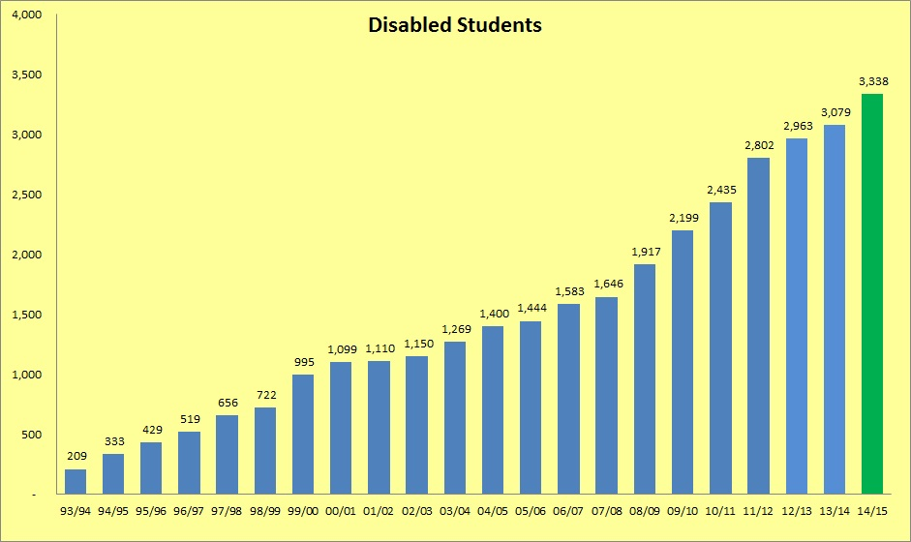

Disabled students – percentage of student population
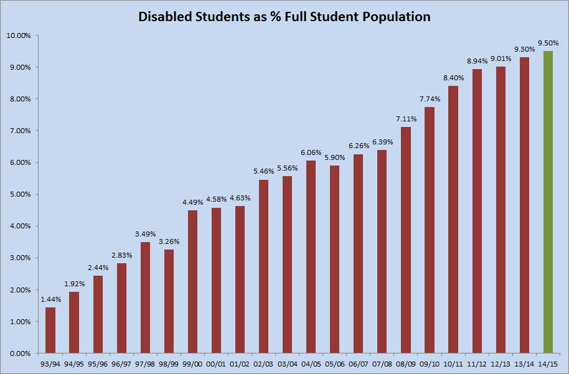

Breakdown of disabled students according to UCAS code

UCAS Categories (Code) | 10/11 | 11/12 | 12/13 | 13/14 | 14/15
SpLD (11) | 1,226 | 1,531 | 1,559 | 1,564 | 1,660
Visual Impairment (2) | 57 | 53 | 51 | 47 | 41
Hearing Impairment (3) | 57 | 67 | 78 | 82 | 80
Mobility Impairment (4) | 80 | 83 | 84 | 104 | 95
Autistic Spectrum Disorder (T) | 36 | 43 | 39 | 54 | 71
Mental Health Problems (6) | 205 | 237 | 302 | 358 | 495
Unseen Disability (7) | 491 | 489 | 491 | 513 | 535
Multiple Disabilities (8) | 69 | 69 | 78 | 79 | 92
A Disability not listed above (96) | 214 | 230 | 281 | 278 | 269
All Disabilities | 2,435 | 2,802 | 2,963 | 3,079 | 3,338

Breakdown of disabled students by College

College | SpLD | Visual | Hearing | Mobility | Autism | Mental Health | Unseen | Multiple | Not listed | Total | %
Humanities and Social Sciences | 1,106 | 31 | 55 | 66 | 37 | 368 | 363 | 68 | 178 | 2,272 | 68%
Medicine and Vet Medicine | 183 | 3 | 14 | 11 | 5 | 46 | 66 | 8 | 43 | 379 | 11%
Science and Engineering | 371 | 7 | 11 | 18 | 29 | 81 | 106 | 16 | 48 | 687 | 21%
Total | 1,660 | 41 | 80 | 95 | 71 | 495 | 535 | 92 | 269 | 3,338
Percentage students by impairment | 49.7% | 1.2% | 2.4% | 2.8% | 2.1% | 14.8% | 16.0% | 2.8% | 8.1%

Breakdown of students by disability, School and College
College of Humanities and Social Sciences
School | SpLD | Visual | Hearing | Mobility | Autism | Mental Health | Unseen | Multiple | Not listed | Total
Business | 46 | - | 1 | 4 | 2 | 9 | 15 | 2 | 10 | 89
Edinburgh College of Art | 236 | 1 | 6 | 10 | 5 | 39 | 39 | 3 | 16 | 355
Divinity | 29 | - | 1 | 5 | 2 | 13 | 7 | 3 | 6 | 66
Economics | 46 | 2 | 1 | 2 | 3 | 6 | 15 | - | 5 | 80
Health in Social Science | 34 | 1 | 2 | 6 | 2 | 5 | 19 | 2 | 9 | 80
History & Classics & Archaeology | 127 | 4 | 6 | 4 | 5 | 34 | 26 | 12 | 21 | 239
Law | 50 | 3 | 3 | 1 | - | 16 | 26 | 2 | 15 | 116
Literature, Languages & Cultures | 92 | 6 | 7 | 4 | 7 | 78 | 55 | 7 | 20 | 276
Philosophy, Psychology & Language Sciences | 103 | 3 | 1 | 4 | 2 | 47 | 52 | 8 | 16 | 236
Moray House School of Education | 168 | 5 | 16 | 10 | 1 | 20 | 32 | 6 | 20 | 278
Social & Political Sciences | 140 | 3 | 3 | 9 | 3 | 67 | 50 | 8 | 19 | 302
HSS General Degree or Visiting Student | 35 | 3 | 8 | 7 | 5 | 34 | 27 | 15 | 21 | 155
College Total | 1,106 | 31 | 55 | 66 | 37 | 368 | 363 | 68 | 178 | 2,272
College of Medicine and Veterinary Medicine
School | SpLD | Visual | Hearing | Mobility | Autism | Mental Health | Unseen | Multiple | Not listed | Total
Medicine (SBCLS, SCSCH, SMCM) | 51 | 1 | 4 | 2 | - | 9 | 14 | 1 | 13 | 95
Biomedical Sciences | 29 | 2 | 1 | 2 | - | 8 | 15 | 1 | 6 | 64
Royal (Dick) School of Veterinary Studies | 73 | - | 3 | 1 | 5 | 19 | 22 | 1 | 13 | 137
Clinical Sciences & Community Health | 18 | - | 3 | 1 | - | 6 | 11 | 2 | 10 | 51
Molecular & Clinical Medicine | 12 | - | 3 | 5 | - | 4 | 4 | 3 | 1 | 32
College Total | 183 | 3 | 14 | 11 | 5 | 46 | 66 | 8 | 43 | 379
College of Science and Engineering
School | SpLD | Visual | Hearing | Mobility | Autism | Mental Health | Unseen | Multiple | Not listed | Total
Biological Sciences | 70 | - | 3 | 3 | 4 | 15 | 17 | 4 | 11 | 127
Chemistry | 26 | 1 | 1 | 1 | 1 | 7 | 11 | - | 5 | 53
Engineering | 81 | 1 | 3 | 6 | 1 | 9 | 25 | 2 | 4 | 132
Geosciences | 112 | 2 | 2 | 2 | 6 | 15 | 28 | 2 | 10 | 179
Informatics | 25 | 1 | 1 | 4 | 8 | 20 | 8 | 6 | 5 | 78
Mathematics | 18 | 1 | - | 1 | 1 | 4 | 5 | 2 | 4 | 36
Physics & Astronomy | 39 | 1 | 1 | 1 | 8 | 11 | 12 | - | 9 | 82
College Total | 371 | 7 | 11 | 18 | 29 | 81 | 106 | 16 | 48 | 687
Total for all Schools | 1,660 | 41 | 80 | 95 | 71 | 495 | 535 | 92 | 269 | 3,338
Percentage students by impairment | 49.7% | 1.2% | 2.4% | 2.8% | 2.1% | 14.8% | 16.0% | 2.8% | 8.1%

